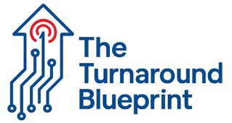

FORM 2.2
OPERATIONAL BREAKDOWN ASSESSMENT

Department: _________________ Assessment Period: _____________

STAFFING CONSISTENCY CHECK
- Same procedures across all shifts: ☐ Yes ☐ No
- Consistent documentation methods: ☐ Yes ☐ No
- Standardized training materials: ☐ Yes ☐ No
- Clear escalation procedures: ☐ Yes ☐ No
MOST COMMON STAFF FRUSTRATIONS IDENTIFIED
1. ____________________________________________________
2. ____________________________________________________
3. ____________________________________________________
MAINTENANCE "BROKEN WINDOWS" AUDIT
Walk through community and document:
- Burned out light bulbs: Location(s): ___________________
- Carpet stains/damage: Location(s): ____________________
- Paint touch-ups needed: Location(s): __________________
- Other visible maintenance issues: ______________________
Priority level: ☐ Critical ☐ High ☐ Medium ☐ Low
Timeline for completion: ________________________________

