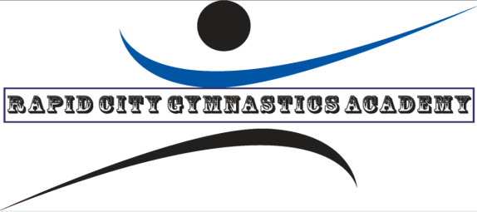

WELCOME TO MONKEY BUS-iness

We are happy to have you join our gymnastics facility! You have at least 4 kids to start your tumble bus, here is what you do next:

* All parents need to complete the registration/waiver paperwork. This can be located on our website, rapidcitygymnastics.com under the Monkey Bus-iness tab. Or we can email to you!
* Payment information is also on the website. All payments are due the first week of each month and payment is required for participation. $40 per month per child with an annual registration fee of $15 (per family and applies to classes at RCGA as well).
* We accept cash, check (written to RCGA) or credit card (can be taken via phone or autopay). Parents can also choose autopay option (please contact Sarah or Tim at 605-791-2151 to set this up). We now accept Paypal as well. You can pay to [strimble169@hotmail.com](mailto:strimble169@hotmail.com)
* Each payment includes 4 classes and these are done consecutively—so if there are five weeks in the month, there will not be class held during the fifth week of the month (however, if we are closed for a holiday, the fifth week will be the 4th day of that class). If we close due to inclement weather, there will not be a make-up added or if your child misses due to absence from daycare, there will not be a make-up offered.
* Payments are month to month. Notice must be given to RCGA before the 1st of the month when a child is dropping for any reason (otherwise, payment is still due that month). This is a firm policy with the only exception being injuries that require no physical activity.

Thank you for business and welcome to RCGA!!!!

Tim and Sarah Trimble