You’re Invited to the…

Rapid City Invite

December 6th-8th

2024

Xcel Bronze-Platinum

Level 2-8

$100 per athlete

Registration will be available through the USAG portal

Held at Rapid City Gymnastics Academy

2025 Samco Road, Rapid City, SD 57702

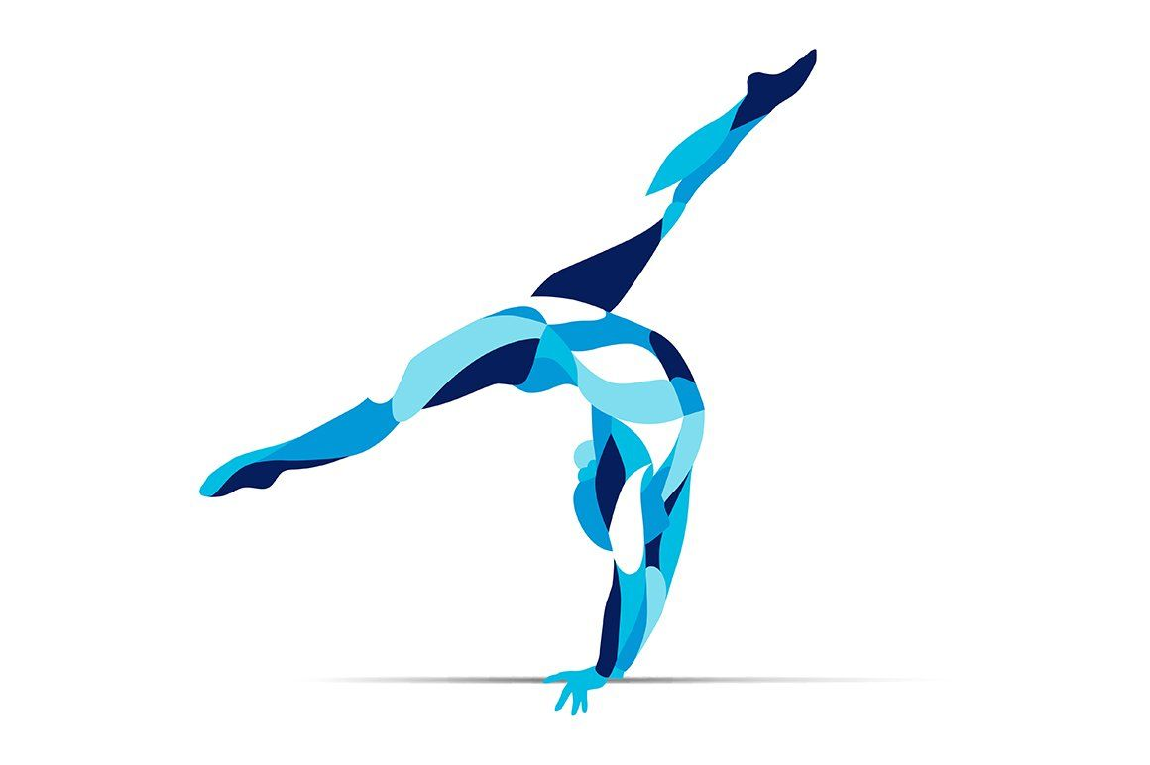

Hosted by Rapid City Gymnastics Academy