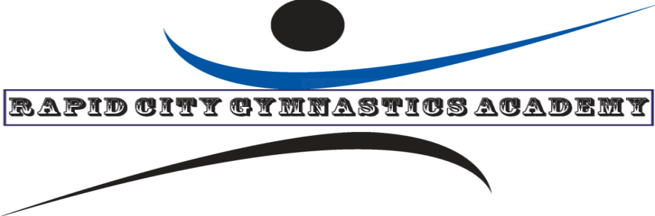
RCGA GYMNASTICS AT THE POWERHOUSE!!!
The Rapid City Gymnastics Academy will be offering three 10 week (Fall/Winter/Spring) sessions of gymnastics classes at the Power House in Wall, starting Friday, September 13th , 2019 and continuing on selected Fridays until Friday, May 22, 2020. Kids 4 through 7 years old will check in at 9:00 am on Fridays and practice from 9:00 am-10:15 am. Kids 8 through 18 yrs. old will check in at 10:00 am on Fridays and practice from 10:00 am- 11:15 am. We can be flexible on placement if the exact age split doesn’t fit your child/children.
The 10 week session cost is $150 per student or $20 per drop-in student. Payments can be made by phone (605-791-2151) or check made to RCGA or cash. If anyone wants to buy all three 10 week sessions (whole school year) the cost is $400.
We will need a one-time registration form and waiver when you come to your first session. You can go to our website and print these forms at www. Rapidcitygymnastics.com and we will also have some forms available on site.
This will be a great opportunity for boys and girls to receive an introduction to basic gymnastics and continue progress on their already established basics or work toward their competitive goals.
The Friday Schedule for the Winter Session:
November 29
December 6 13 20 27
January 3 10 17 24 31
Sincerely,
Tim Trimble
Owner Rapid City Gymnastics Academy
(605) 791-2151
rapidcitygymnastics.com

