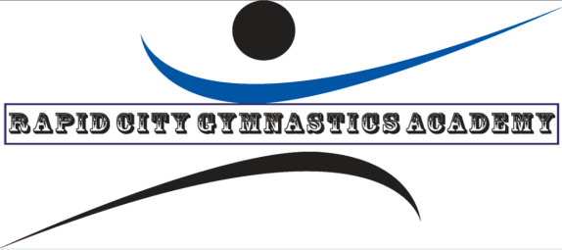
WELCOME TO MONKEY BUS-iness
We are happy to have you join our gymnastics facility! You have at least 4 kids to start your tumble bus, here is what you do next:

- All parents need to complete the registration/waiver paperwork. This can be located on our website, rapidcitygymnastics.com under the Monkey Bus-iness tab. Or we can email to you! Or drop off hard copies!
- Payment information is on our registration paperwork. All payments are due the first week of each month and payment is required for participation. These payments are $35 per month per child with an annual registration fee of $15/$105 per session for 3 sessions(includes reg fee)/$300 per school year Sept to May (includes reg fee).
- We accept cash, check (written to Sarah Trimble). Parents can also choose Paypal as well. You can pay to strimble169@hotmail.com
- If your daycare is closed for any reason, there will not be a make-up added or if your child misses due to absence from daycare, there will not be a make-up offered.
- Our school year schedule runs in 10 week sessions starting September 3^{rd.}
We do have shutdowns over the Thanksgiving and Christmas holidays and these are listed on our registrations forms as well (November 26-December 1st for Thanksgiving and December 23rd- January 3rd for Christmas). At the end of our three 10 week sessions we will have the month of May remaining due to extra days in some months (such as 5 Tuesdays in October). We will use these extra weeks for makeups due to any mechanical issues with the bus or closures due to inclement weather.

Thank you for business and welcome to RCGA!!!!

Tim and Sarah Trimble

