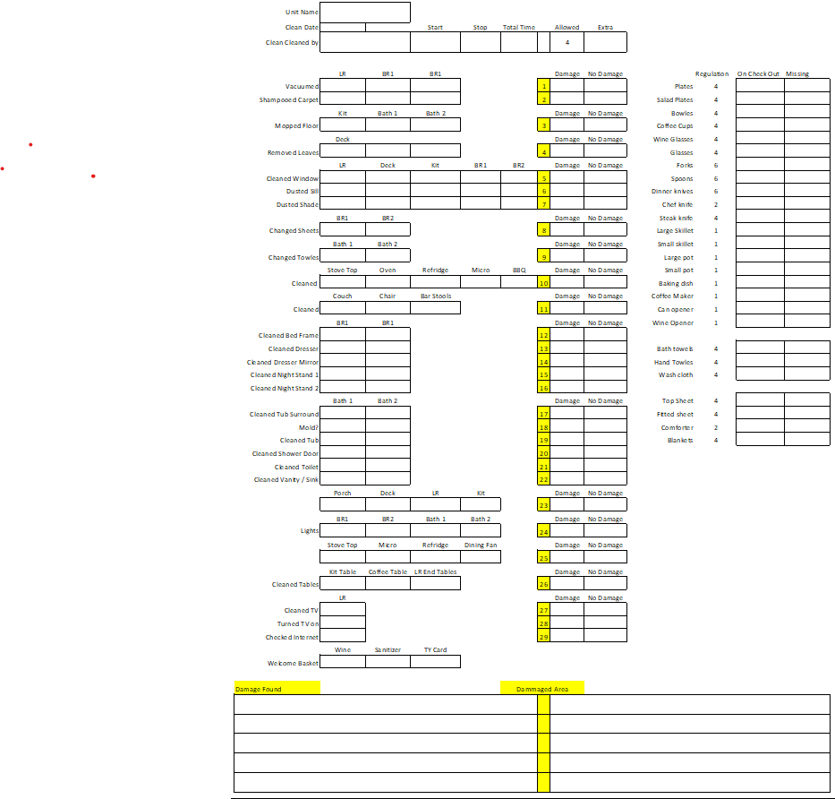
Attachment A – Check In
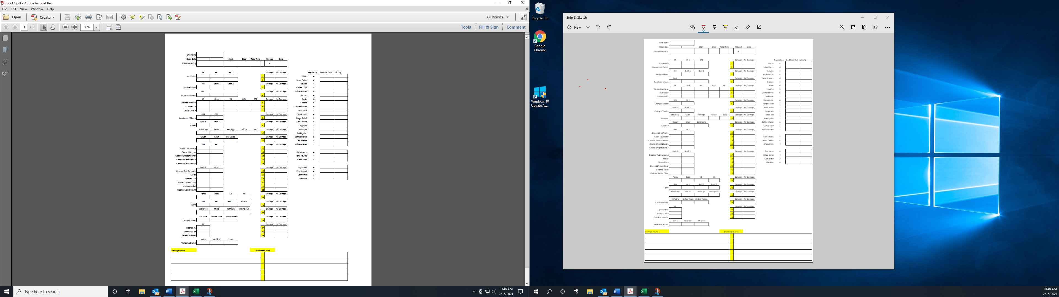
Attachment B – Check Out

