


Financial Services Guide Issued 11/2024

Superannuation Growth Direct is a Corporate Authorised Representative Number: 1310382

of
Lifestyle Asset Management Pty Ltd, a privately owned holder of
Australian Financial Services Licence No. 288421

This Financial Services Guide is not complete without the Adviser Profile of the person providing advice, which must be read conjointly.

- info@superannuationgrowthdirect.com.au
- superannuationgrowthdirect.com.au
1300533915

THIS DOCUMENT IS A FINANCIAL SERVICES GUIDE (“FSG”).
This FSG contains information that we are legally obliged to provide, to give you a better understanding of Superannuation Growth Direct Pty Ltd (“SGD”) to enable you to make an informed decision on whether to engage us to provide financial services to you.
This FSG contains important information about:
The financial services that we provide
- General advice warnings
- Information you will be asked to supply
- Information you will receive
- Privacy
- How we and our associates are remunerated
- Dispute Resolution System
- Financial relationships with related entities

FINANCIAL SERVICES THAT SGD PROVIDES
Under the Corporations Act financial product advice is classified as:
- Personal Advice that takes into account your personal objectives, financial situation or needs, or
- General Advice, that does not.
SGD provides General Advice as a Corporate Authorised Representative (“CAR”) of Lifestyle Asset Management Pty Ltd (“LAM”) under its Australian Financial Services Licence (“AFSL”) to provide general financial product advice to wholesale and retail clients on behalf of LAM or its Authorised Representatives.
SGD does not provide personal advice that takes into account your personal details. If you request Personal Advice, SGD will arrange that with a Financial Adviser licensed by LAM to provide personal advice. To understand what is in your best interests, a Financial Adviser is required to have a comprehensive picture of your personal and financial circumstances, goals and needs.
The services that SGD provides include communicating with people interested in obtaining information about their investments, usually in superannuation, and personal insurances, to compare their current arrangements with other options.
After you consider information provided by SGD, if you decide to request personal advice, SGD will gather the detailed information a Financial Adviser needs in order to provide personal advice that is in the client’s best interests. SGD provides that information to a Financial Adviser licensed by LAM to provide personal advice.

GENERAL ADVICE WARNINGS
When SGD or its representatives provide information, it is required to give the following warnings:
To Retail Investors
The financial product information provided to you is general in nature and has been prepared without taking into account your personal objectives, financial situation or needs.
Therefore, before acting on the advice provided, you should consider the appropriateness of the advice, having regard to your personal objectives, financial situation and needs.
When the advice relates to acquisition of a particular financial product, if you are considering acquiring the product, you should obtain and read thoroughly any PDS or IM for that product before deciding whether to acquire it.
To Wholesale Investors
The information provided to you is intended for use only by Wholesale Investors and must not be made available to any Retail Investor

INFORMATION YOU WILL BE ASKED TO PROVIDE
Initially SGD will request:
- information required under financial and Anti-Money Laundering and Counter Terrorist Funding (AML/CTF) legislation as evidence of identity, usually copies of licence, passport, perhaps supported by Medicare card or utility bills.
- information about your current investments, superannuation and insurances to enable comparisons between your existing circumstances and alternatives.
If you decide to obtain Personal Advice, SGD will ask you for comprehensive information and documentation about your assets, liabilities, family, financial goals, personal preferences and any other information needed to give a Financial Adviser a clear and documented view of your overall circumstances.
Financial Advisers are required to have comprehensive information about you to ensure that advice provided is in your best interests. This can include copies of documents and communications in emails or other online systems that we will give you information about when required.

INFORMATION THAT YOU WILL RECEIVE
Initially you will receive a General Advice comparison of your current and alternative situations.
If you request us to arrange Personal Advice, the Financial Adviser will provide recommendations in a Statement of Advice (“SoA”) with supporting information to enable you to make an informed decision about the appropriateness and suitability of that advice. Subsequent advice on actions recommended in an SoA may be provided in a Record of Advice (“RoA”)

PRIVACY
We are committed to ensuring the privacy and security of your personal information.
SGD keeps records of your personal profile, including information supplied by you and third parties. If you request us to arrange Personal Advice we will record and provide to the adviser information relating to investment and insurance objectives, financial position and personal needs. Personal information supplied may be stored electronically.
All information, however obtained, will be handled in accordance with SGD Privacy Policy and Australian Privacy Principles administered by the Office of the Australian Information Commissioner (OAIC).
A copy of our Privacy Policy can be downloaded from our website or requested from your adviser or LAM’s Compliance Officer on 1300 226 271.

REMUNERATION AND BENEFITS
SGD does not charge you directly for its services. Only if you request Personal Advice and implement that advice will SGD receive part of the initial advice fee for its services in gathering the personal information on which Personal Advice is based.
The amount of that initial advice fee and the amount or percentage of that fee payable to SGD will be disclosed in the SoA.
The basis and amount of all fees, commissions and amount payable to SGD will be fully disclosed in your SoA and explained by your Financial Adviser prior to the implementation of any advice.
An explanation of the fees and charges for recommended products will be set out in the relevant PDS.
The SoA provided by the Financial Adviser will detail fees, commissions or benefits that relate to your specific matter.

DISPUTE RESOLUTION SYSTEM
SGD is committed to providing a high level of client satisfaction and maintaining our reputation for honesty and integrity.
If you feel that we have fallen short of our commitment we would like you to:
- bring it to the attention of your adviser or SGD.
- If you feel this is not adequately addressed by the adviser or SGD, you can notify our licensee, LAM. LAM is committed to resolving any concern a client has quickly, fairly and in the strictest confidence. You can notify it to Lifestyle Asset Management
  - by phone to the Compliance Officer on 1300 226 271, or
  - by mail or email to the contact addresses below.
- If you are dissatisfied with the above options to resolve the dispute or query, LAM is a member of Australian Financial Complaints Authority (AFCA) and you have recourse free of charge to that organisation:
  - by phone on 1800 931 678
  - online at www.afca.org.au.
  - by mail to Australian Financial Complaints Authority, GPO Box 3, Melbourne Vic 3001
  - by email to info@afca.org.au
LAM has Professional Indemnity Insurance for compensation claims by clients against LAM and its representatives and advisers.

FINANCIAL RELATIONSHIPS
SGD’s authorisation is restricted to providing General Advice on behalf of LAM and its Authorised Representatives and the Financial Advisers that SGD arranges to provide Personal Advice will be authorised by LAM.

CONTACT DTAILS
ADVICE AND SERVICES PROVIDED UNDER THE LICENCE OF | Lifestyle Asset Management Pty Ltd (LAM)  Australian Financial Services Licence 288421
LAM CONTACT DETAILS | Lifestyle Asset Management Pty Ltd  ABN 58 113 067 968  Level 35 Tower One, 100 Barangaroo Avenue,  BARANGAROO NSW 2000  Tel: 1300 226 271  Email: erm@lifestyleam.com.au  Website: www.lamfs.com.au
SGD CONTACT DETAILS | Superannuation Growth Direct Pty Ltd (SGD)  Authorised Representative Number 1310382  ABN: 16 645 481 143  Ste 1002, Level 1, 128 Bundall Road,  BUNDALL Qld 4217  Tel:  Email: info@superannuationgrowthdirect.com.au  Website:

GENERAL ADVISER PROFILES

These Adviser Profiles must be read in conjunction with the Financial Services Guide (FSG) provided by
SUPERANNUATION GROWTH DIRECT PTY LTD AFS Representative Number 1310382 of
LIFESTYLE ASSET MANAGEMENT PTY LIMITED, Australian Financial Services Licensee Number 288421
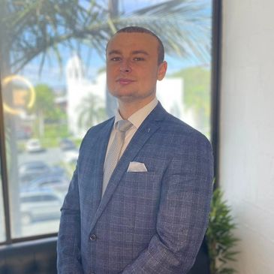
Jonathan Rogers - AFS Representative Number: 1310206
Director & Operations Manager Superannuation Growth Direct Pty Ltd
RG146 Diploma General Knowledge & Superannuation
Jonathan holds a dual honours degree in Law and Psychology from UK. Jonathan's career in financial services began with Deloitte, one of the Big 4 accounting firms in London. He then transitioned to Lloyds Banking Group, where he focused on insurance and risk management in the banking sector. For the past five years, Jonathan has been working in the superannuation industry in Australia

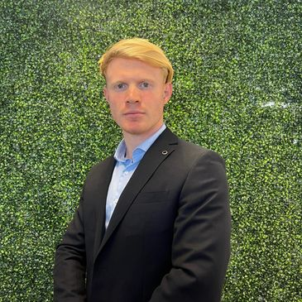
Toby Brazier - AFS Representative Number 1310207
Senior Client Manager Superannuation Growth Direct Pty Ltd
RG146 Diploma General Knowledge & Superannuation
Toby's career in financial services began with helping everyday Australians overcome credit defaults and improve their financial standing. In his current role, Toby excels at connecting with clients with the ability to translate complex financial concepts into easily understandable terms, ensuring that clients feel informed and confident in making decisions.

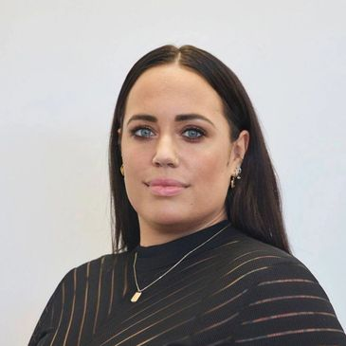
Kate Mason - AFS Representative Number: 1293540
Senior Client Manager Superannuation Growth Direct Pty Ltd
RG146 Diploma General Advice
Kate Mason has extensive experience in superannuation, prioritising clients’ interests and working diligently to connect them with the appropriate resources and strategies. Kate has a keen analytical ability that allows her to assess financial scenarios and connect clients to Financial Advisers to provide tailored and build long-lasting relationships

Marshall Lategan - AFS Representative Number: 001318285
Senior Client Manager Superannuation Growth Direct Pty Ltd
RG146 Diploma General Advice
Marshall brings a wealth of knowledge graduating with a dual honours degree in Investment management and financial trading. Marshall has 5 years of financial services experience in super and brings an enjoyable client centric approach which makes the process enjoyable for clients as well as educational.

