ADDITIONAL ANNOUNCEMENTS
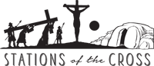
Stations of the Cross at Barona at 5:00 PM beginning Friday, February 27 and every Friday thereafter.

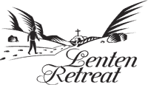
“Becoming Human with Jesus: How to Live Like the Saints”
March 8 – 10, 2026
6:30 PM at Barona Clubhouse
Speaker: Juliet Mousseau, RSCJ


Saint Kateri Tekakwitha Parish invites you for a Seder Meal on Wednesday, April 1, 2026 at 5:00 PM at the Kateri Hall at Viejas celebrating the Jewish Passover meal.
Please rsvp to bktparish@aol.com or to church office (619-443-3412) by March 20th in preparation for the amount of food.

