**Charanga Unit Coverage**:

|  |  |  |  |
| --- | --- | --- | --- |
|  | **AUTUMN** | **SPRIMG** | **SUMMER** |
| **Year 1** | **Hey You!**  **Hip Hop** | **In the Groove**  **Blues/ Baroque/ Latin/ Bhangra/ Folk/ Funk** | **Your imagination**  **Pop** |
| **Year 2** | **Hands, Feet, Heart**  **South African music** | **Friendship Song**  **Pop**  **/ Ukele- Shropshire Music Service** | **I wanna be in a band**  **Rock** |
| **Year 3** | **Glockenspiel skills 1** | **Three Little Birds- Bob Marley**  **Reggae** | **Bringing us together**  **Disco** |
| **Year 4**  **Ukele to commence 2023-2024** | **Glockenspiel Skills 2**  **Mixed Styles** | **Lean on Me**  **Gospel** | **Blackbird- Beatles**  **Pop** |
| **Year 5** | **Classroom Jazz 1**  **Bossa Nova and Swing** | **Fresh Prince of Bel Air**  **Old-School Hip Hop** | **Dancing in the Street**  **Motown** |
| **Year 6** | **You’ve got a friend**  **70’s Ballad**  **/ Ukele- Shropshire Music Service** | **Classroom Jazz 2**  **Bacharach and Blues** | **Music & Me**  **Create your own music inspired by your identity and women in the music industry** |

**KS2- At KS2 I have ensured that each Year group completes a skill based unit. Glockenspiel skills is progressive across lower KS2 and Classroom Jazz is progressive across upper KS2.**

**By including a unit from Autumn/Spring/Summer consecutively we are ensuring progression in skills across the year within a spiral curriculum where skills will be revisited and built upon. Currently we are only completing 3/6 units and therefore I have excluded the summer review units as this revisits work from all 6 units.**

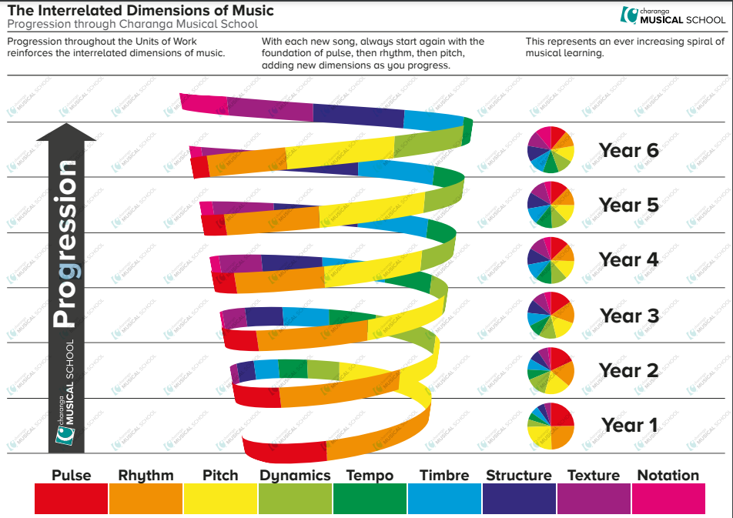

**FILES CAN BE LOCATED ON SERVER- CURRICULUM- MUSIC- CHARANGA UNIT OVERVIEW**

**I have saved the knowledge and skills progression overview for each year group. For each unit, I have saved a knowledge organiser. Please ensure that when completing a unit, that all of the focus criteria is covered. It is important that across each unit we address the skills identified in all key areas-**

**Listening and Appraising – Within this, scroll through the slide show provided. This gives prompt questions for discussion and also provides answers – E.g. What instruments can be heard? Further support with appraising the songs can be found in the individual lesson plans. These can be accessed on Charanga.**

**Singing – Try to build progressively. You may want to focus initially on the chorus and then build in verses as the weeks progress. Some units may extend to 2 part singing. Vocal warm up activities will be available within the unit.**

**Performing – This will be a final performance which usually includes vocals and an instrumental section. The instrument section usually provides an Easy and Medium part. As a challenge to pupils who are confident and able players of the glockenspiel, there is also a melody part that can be added. This does not appear on the play along screen, but is available as a printable in the tabs at the top of the interactive screen. The melody part presents further challenge by widening the range of notes explored and varying the note durations. It would be beneficial to consider possible audiences E.g. parents, other classes, assemblies.**

**Improvisation- This can be through rhythm clap back, vocal activities, lyrics and also through opportunities to play their own rhythms using selected notes. This does not need to be recorded. It is exploration in the moment.**

**Composition- Composition does need to be recorded. There is an interactive tool where the class can compose together, settings can be adjusted to set expectations for notation. This could be whole class, or perhaps as confidence grows, pupils could also work in groups with laptops to create their own compositions to then share/ perform as an ensemble.**

Please refer to lesson plans when progressing through the units. This gives an overview of what activities to complete. This will include listen and appraise. Most sessions start with listening to a piece of music. Here you can find useful information to help discuss the music such as the structure, instruments, stylistic features, tempo etc.

Throughout a unit, the class should aim in the flexible games section to be progressing through bronze, silver and gold challenges.

When identified in planning, please do watch videos or complete interactive activities that may introduce musical vocabulary, notation and key dynamics of music such as tempo, pitch, pulse, volume etc.