**Charanga Unit Coverage**:

|  |  |  |  |
| --- | --- | --- | --- |
|  | **AUTUMN** | **SPRIMG** | **SUMMER** |
| **Reception** | **Following all 6 units throughout year.** | | |
| **Year 1** | **Hey You!**  **Hip Hop** | **In the Groove**  **Blues/ Baroque/ Latin/ Bhangra/ Folk/ Funk** | **Your imagination**  **Pop** |
| **Year 2** | **Hands, Feet, Heart**  **South African music** | **Friendship Song**  **Pop**  **/ Ukele- Shropshire Music Service** | **I wanna be in a band**  **Rock** |
| **Year 3/4**  **CYCLE A**  **(Year 4 will be repeating Glock 1)** | **Glockenspiel Skills 1**  (Year 3 Autumn unit) | **Lean on Me**  **Gospel**  (Year 4 Spring Unit) | **Living on a Prayer**  **Rock**  (Year 4 Autumn Unit) |
| **YEAR ¾**  **CYCLE B** | **Glockenspiel Skills 2**  **Mixed Genres**  (Year 4 Autumn unit) | **Three Little Birds- Bob Marley**  **Reggae**  (Year 3 Spring Unit) | **Bringing us together**  **Disco**  (Year 3 Summer Unit) |
| **Year 4/5**  **CYCLE A** | **Classroom Jazz 1**  **Bossa Nova and Swing**  (Year 5 Autumn unit) | **Mama Mia**  **Pop**  (Year 4 Autumn Unit) | **Dancing in the Street**  **Motown**  (Year 5 Summer Unit)  **/ Ukelele- Shropshire Music Service** |
| **CYCLE B** | **Glockenspiel Skills 2**  **Mixed Genres**  (Year 4 Autumn unit) | **Blackbird- Beatles**  **Pop**  (Year 4 Summer Unit) | **Fresh Prince of Bel Air**  **Hip Hop** |
| **Year 5/6**  **CYCLE A**  **(Year 5 will be repeating Jazz 1)** | **You’ve got a friend**  **70’s Ballad**  (Year 6 Autumn unit)  **/ Ukele- Shropshire Music Service** | **Classroom Jazz 1**  **Bossa Nova and Swing**  (Year 5 Autumn unit) | **Music & Me**  **Create your own music inspired by your identity and women in the music industry**  (Year 6 Summer Unit) |
| **CYCLE B** | **Make you feel my love**  **Pop Ballad**  (Year 5 Spring unit)  **/ Ukele- Shropshire Music Service** | **Classroom Jazz 2**  **Bossa Nova and Swing**  (Year 6 Autumn unit) | **Developing Ensemble Skills**  **Model Music Curriculum**  **Year 6- Unit 2** |

**KS2- At KS2 I have ensured that each Year group completes a skill based unit. Glockenspiel skills is progressive across lower KS2 and Classroom Jazz is progressive across upper KS2.**

**By including a unit from Autumn/Spring/Summer consecutively we are ensuring progression in skills across the year within a spiral curriculum where skills will be revisited and built upon. Currently we are only completing 3/6 units and therefore I have excluded the summer review units as this revisits work from all 6 units.**

**Shropshire Music Service will support throughout the Year allowing for one term each with Years 2,4 and 6- If the music service is in, this replaces the Charanga unit currently outlined. If for any reason we do not continue using the Shropshire Music service, then Charanga units will resume. Some classes may opt to do Charanga in addition to Ukelele if preferred.**

**With initial adaptations to mixed year groups, the Glockenspiel unit will repeat.**

**Ways to extend this unit for those repeating could be:**

* **To play with increasing accuracy**
* **To practice to perform in small group or solo**
* **Focused work on reading notation and extending into recording notation**

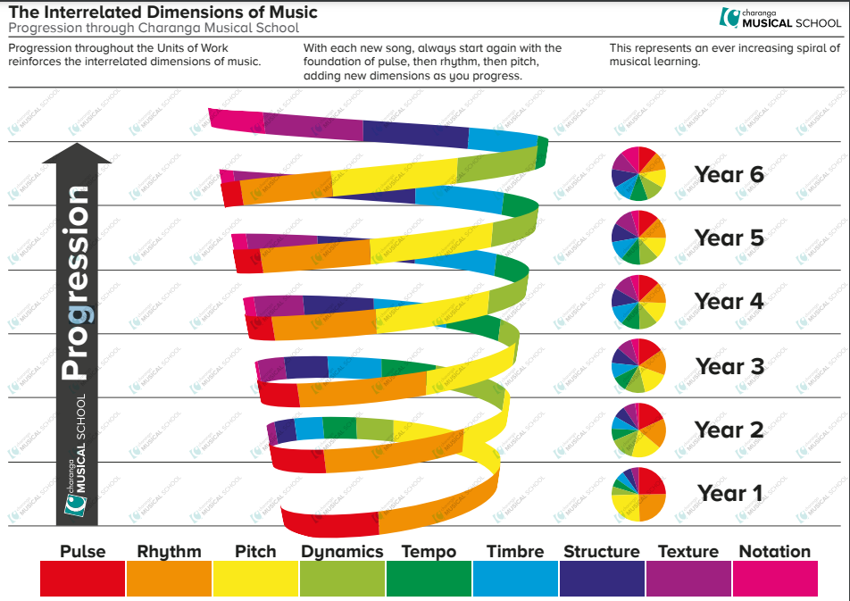

**FILES CAN BE LOCATED ON SERVER- CURRICULUM- MUSIC- CHARANGA UNIT OVERVIEW**

**I have saved the knowledge and skills progression overview for each year group. For each unit, I have saved a knowledge organiser. Please ensure that when completing a unit, that all of the focus criteria is covered. It is important that across each unit we address the skills identified in all key areas-**

**Listening and Appraising – Within this, scroll through the slide show provided. This gives prompt questions for discussion and also provides answers – E.g. What instruments can be heard? Further support with appraising the songs can be found in the individual lesson plans. These can be accessed on Charanga.**

**Singing – Try to build progressively. You may want to focus initially on the chorus and then build in verses as the weeks progress. Some units may extend to 2 part singing. Vocal warm up activities will be available within the unit.**

**Performing – This will be a final performance which usually includes vocals and an instrumental section. The instrument section usually provides an Easy and Medium part. As a challenge to pupils who are confident and able players of the glockenspiel, there is also a melody part that can be added. This does not appear on the play along screen, but is available as a printable in the tabs at the top of the interactive screen. The melody part presents further challenge by widening the range of notes explored and varying the note durations. It would be beneficial to consider possible audiences E.g. parents, other classes, assemblies.**

**Improvisation- This can be through rhythm clap back, vocal activities, lyrics and also through opportunities to play their own rhythms using selected notes. This does not need to be recorded. It is exploration in the moment.**

**Composition- Composition does need to be recorded. There is an interactive tool where the class can compose together, settings can be adjusted to set expectations for notation. This could be whole class, or perhaps as confidence grows, pupils could also work in groups with laptops to create their own compositions to then share/ perform as an ensemble.**

Please refer to lesson plans when progressing through the units. This gives an overview of what activities to complete. This will include listen and appraise. Most sessions start with listening to a piece of music. Here you can find useful information to help discuss the music such as the structure, instruments, stylistic features, tempo etc.

Throughout a unit, the class should aim in the flexible games section to be progressing through bronze, silver and gold challenges.

When identified in planning, please do watch videos or complete interactive activities that may introduce musical vocabulary, notation and key dynamics of music such as tempo, pitch, pulse, volume etc.