**Music Policy**

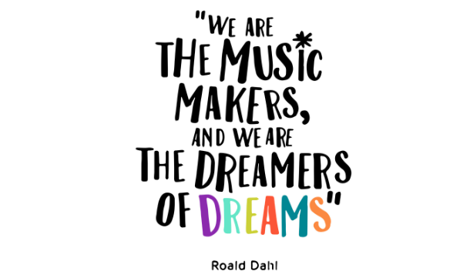

***Reviewed: Nov 2024***

***Next review date: Nov 2025***

***By Subject Co-ordinator: Miss Vickie Wilson***

***Rationale***

* ***Music is a powerful, unique form of communication that can change the way pupils feel, think and act.***
* ***Listening to and making music fulfils an instinctive human need for self expression and creativity. It stimulates responses both on emotional and intellectual levels.***
* ***Music can be a lifelong source of pleasure. It is education for life****.*

***Intention (Why do we teach what we teach?)***

*Our music curriculum is intended to ensure that our children****:***

* *Develop musical skills and concepts through listening, appraising, performing and composing.*
* *Develop social skills through co-operation with others in the shared experience of music making.*
* *Develop an understanding of musical traditions and developments in a variety of cultures.*
* *Experience a range of different musical genres and develop an understanding of the history of music.*
* *Are motivated to enjoy and succeed in music.*
* *Celebrate our musical achievements.*
* *Have the opportunity to share and appreciate music with others, explore how music makes them feel and explore their own preferences as musicians.*

***Music and the National Curriculum***

* *Music contributes to the wider aims of Primary Education including, Literacy, Maths, ICT, P.E, Art, P.S.H.E. and citizenship.*
* *Music can develop skills, attitudes and attributes that can support learning in other subject areas that are needed for life and work skills – e.g. listening skills, concentration, creativity, intuition, perseverance, self-confidence and sensitivity towards others.*
* *This school policy is based on objectives outlined in the 2014 Primary Curriculum.*

***Implementation (How do we teach it?)***

* ***Music curriculum- Following Charanga Music Scheme***

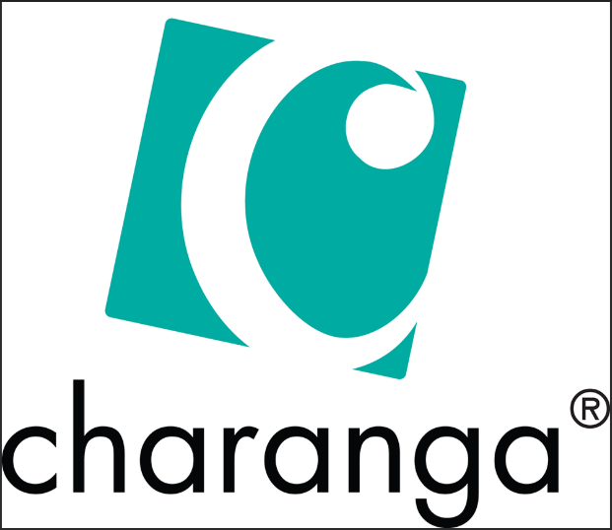

* *All years groups have 1 hour weekly music blocked half termly*
* *Charanga units have been selected to ensure that a range of musical genres are explored and allow for progression across the core areas: Listening and appraising, Interrelated dimension of music, Singing, Playing instruments, Improvisation, Composition and Performance*
* *Charanga also allows for progression in glockenspiel and recorder*
* *Shropshire Music Service teaches whole class ukelele to Yr2, 4/5 and 5/6 for a term each throughout the school year*
* *Opportunities to experience live music performances (E.g. Live Music Week)*
* *Weekly whole school singing assemblies*
* *Assemblies encourage listening to and discussing a diverse range of musical genres and cultures*
* *KS2 choir*
* *Performance opportunities- E.g. Christmas Concert, Choir performances, Spring Concerts and end of unit performances*
* *After school music club will also run for 1 term a year for those who may have an interest in further exploring music. Activities will incorporate building on understanding of music including notation, exploring a range of tuned and untuned instruments, opportunities to sing and musical games.*

***ICT and Music****:*

* *Charanga allows for interactive music sessions. Children can listen to example music, play interactive music games, follow lyrics as they appear on screen, compose electronically and play along to sequenced notes and scored notation.*
* *Charanga ‘Yumu’ provides extra units that create a progression in learning a range of instruments including recorder, violin, fiddle, keyboard, djembe, ukulele, guitar and glockenspiel.*

***Equal Opportunities***

* *We aim to give every pupil the opportunity to enjoy a variety of musical activities.*
* *Music will encourage appreciation and respect for the traditions of other cultures.*
* *All pupils will have an equal opportunity to reach their full potential across the music curriculum regardless of their race, gender, cultural background or special needs.*
* *‘Anyone can play’ is a SEND scheme created by Charanga. This includes units that cover the basic principles and dynamics of music. This is available to all pupils and teachers can choose to differentiate using ongoing assessment of pupils.*

**Assessment and Record keeping**

* *Termly assessment is completed for each year group. Children are assessed as greater depth, expected or working towards across key areas of music.*
* *These judgements are met through use of skills progression documents that provide a summary of age related objectives and ensure that our curriculum builds on prior learning.*
* *Annual reports for parents – A statement for music is based on the extent to which a pupil has achieved against N.C. Attainment Targets.*
* *As advised by Music Service, where any children are assessed as higher ability or who are developing mastery of an instrument, secondary schools will be informed to support transition.*
* *Subject coordinators complete 2 subject reviews throughout the academic year. This allows opportunities to observe music lessons, gain pupil voice, explore opportunities for CPD and contribute towards annual review of school music development plan.*

**Resources**

* *Instrument resource area including:*
* *Glockenspiels- Whole class set*
* *Xylophones*
* *Drums*
* *Tambourine*
* *Cymbals*
* *Rattles*
* *Wooden block*
* *Rhythm sticks*
* *Chime bars*
* *Triangles*
* *Recorders*
* *Ocarinas*
* *Bells*
* *Keyboards and selection of song books.*
* *Selection of books in school library, including cross-curricular links*
* *Charanga online music school.*

**Health and Safety Issues**

* *Using instruments appropriately.*
* *Managing Noise level*
* *Care needs to be taken around any electrical wires.*
* *Adults will need to assist in lifting and carrying any heavy instruments or equipment.*
* *Electrical equipment will be inspected regularly.*

**Role of Music Co-ordinator**

* *The Subject lead will monitor the implementation of the policy and review annually.*
* *The music co-ordinator will complete a music development plan to be reviewed and updated annually and shared with the Shropshire Music Service.*
* *To review medium term plans, ensuring that Charanga units and whole class instrumental sessions are allowing for wide range of musical opportunities and skill progression.*
* *To organise and maintain resources*
* *To attend available subject network meetings and share any updates to staff*
* *To support staff in delivering music and provide opportunities for CPD*
* *To ensure music provision meets the requirements of the National Curriculum*
* *To facilitate where possible musical experiences for pupils such as visitors, workshops and Shropshire music services such as tutoring and whole class instrument skills sessions.*

***Impact (What has been the impact and how do we know?)***

* *Our children are engaged and excited by our music curriculum*
* *Our children show an appreciation and respect for music from a diverse range of genres and cultures*
* *Our children are developing confidence as performers, composers and listeners who are able to express themselves musically*
* *Our children progress throughout the music curriculum which enables them to meet the expectations outlined at the end of each key stage for the national curriculum*
* *We are a musical school, and Martin Wilson enjoys opportunities to sing and perform together.*
* *We are proud of our children and enjoy watching them grow as musicians.*