Yellowstone Trail fest Vendor Form
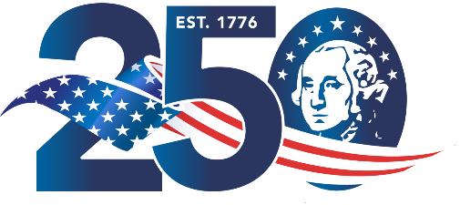
Starke County Fairgrounds
October 17th 2026
400 Division Street, Hamlet, Indiana 46532
Find us at www.Yellowstonetrailfest.com

Vendor Director
P.O. Box 72
Hamlet, In.46532

The theme for the 2026 year is U.S.A. 250th Celebration. Please Print the following information.
Business Name:
Person to contact:
Billing Address, City, State, Zip

Cell Phone #________________
Email:____________________________
Products for Sale/Activity:
Direct Sales Company?
If yes, the Direct Sales Company Name:

~~ 2026 Vendor Rates ~~ Rate: $20-10’x10’ Outside space
Festival Hours: Saturday 9 AM to 9pm
Set Up: Friday 9am to 4pm

____________ TOTAL ENCLOSED or sent by PAYPAL.
If you are writing a check or using PayPal please send/write your payment to” Yellowstone Trail Fest(@HamletYTF for PayPal) and please add a message along with your payment indicating your intention for Vending.

Your PayPal ID: ____________

Date of Payment: ____________
There is primitive camping allowed in the lot northwest of the town park free for our vendors Also please keep animals on a leash or confined to your space.
Please indicate in the space provided how you became aware of our festival. For example: radio, committee members, Facebook website, or similar sources.

