ADVERTISING AGENCY AND IN-HOUSE DEPARTMENT ANALYSIS

Prepared for
Folsom Lake College
Professor Lance Kolleda

Prepared by
Danielle Miranda
Business 310
Folsom Lake College

November 24, 2019

Folsom Lake College
6699 Campus Drive
Placerville, CA 95667

November 24, 2019

Professor Lance Kolleda
Folsom Lake College
6699 Campus Drive
Placerville, CA 95667

Dear Professor Kolleda:

The attached report analyzes the advantages and disadvantages between an advertising agency and in-house advertising departments. This report contains valuable insight to determine which option will be most beneficial for growing small businesses.

The purpose of the report was to provide breakdowns of each option. In this report we discuss:

- Advantages and disadvantages of both advertising agencies and in-house departments
- Comparisons, similarities and differences, each option provide
- Recommendations for small businesses and independent sellers for future growth

Primary research for this report was a ten-question survey of twenty-five participants. It targeted what small businesses currently use for advertising and what their preferred advertising methods are. Secondary research included four peer-reviewed articles on agency structure and additional industry articles about in-house department development.

Please feel free to contact me to discuss this reports recommendation further. I am confident the findings of the report will provide convincing detail about how in-house departments benefit small company growth.

Sincerely,

Danielle Miranda
Student

DM

Enclosure

TABLE OF CONTENTS

TABLE OF CONTENTS iii
LIST OF ILLUSTRATIONS iv
EXECUTIVE SUMMARY v
INTRODUCTION 1
PURPOSE 1
IN-HOUSE DEPARTMENTS AND ADVERTISING AGENCIES 1
Advertising agencies 1
Advertising agency structure and design 2
Advertising agency expectations 3
Agency selection 4
Alternative selection 4
In-house advertising departments 5
Department integration 5
Advantages of in-house advertising breakdown 6
Unique in-house departments 6
Comparison of agency and in-house advertising 7
SURVEY RESULTS 7
CONCLUSIONS 14
RECOMMENDATIONS 14
APPENDIX 16

LIST OF ILLUSTRATIONS

Figure 1 – Advantages and disadvantages of advertising agencies (LearnMarketing.net) 2
Figure 2 – Advantages and disadvantages of in-house advertising departments 5
Figure 3 – Comparison of agency and in-house agencies (Sabkepasand) 7
Figure 4 – Most companies are proficient in advertising 8
Figure 5 – Companies utilize in-house departments the most 8
Figure 6 – In-house departments have been used the most 9
Figure 7 – Companies would and would not continue using an advertising agency 10
Figure 8 – Companies would continue using an in-house department 10
Figure 9 – The amount of advertising is dependent on the size of company 11
Figure 10 – Companies use print and social media advertising the most 11
Figure 11 – Companies base their advertising on budget, experience and needs 12
Figure 12 – Companies value the cost of advertising the most 13
Figure 13 – Companies believe in-house departments suit their needs best 13

EXECUTIVE SUMMARY

The purpose of this report is to educate small businesses and individual sellers on their advertising options – specifically targeting the use of advertising agencies and in-house departments. This report provides an analysis and evaluation of the benefits and drawbacks of each option. It divides agency research into sections consisting of: advantages and disadvantages, structure and design, and expectations and selection. Additionally, in-house departments are broken into sections consisting of: advantages and disadvantages, department integration, and advantage breakdown.

A survey of 25 small businesses and individual sellers concludes that in-house departments meet advertising needs. It also indicates businesses that have an established in-house department will continue using that option over using an advertising agency. From the survey three major topics were analyzed:

  - Most used style of advertising
  - How advertising is chosen
  - Most important features for an advertising team

Based on the results it is recommended that small businesses and individual sellers should develop an in-house advertising team. Secondary research supports this claim by identifying the following areas to be most beneficial:

- Turnaround time: In-house departments are easier to maintain, as they are on-site and dedicated solely to the company.

- Brand integration: This department focuses on how the brand is viewed both internally and externally.

- Cost savings: By keeping continual advertising, i.e. social media, in-house, there are no rush fees for small jobs. Advertising agencies are best used for large jobs which may not be beneficial to a small business or individual seller.

While advertising agencies are tailored to be adaptable to client needs, in-house departments can become industry specialist which is an overall benefit a growing company. An in-house team takes time to build, however, once fully established the business can make future growth efforts with a well-balanced team.

INTRODUCTION

Advertising is an essential part of business growth. Small businesses need to establish strong advertising abilities as they expand. Since all businesses have their own advertising requirements, small businesses need to decide which advertising option, or options, works best for them. Advertising agencies and in-house advertising departments are two common choices.

When a business understands the benefits of agency and in-house advertising the correct options for their situation will become apparent. It is not uncommon to start out using a mixture of options to find what fits; not all businesses will gain the benefits of a single option. The exploration of possibilities has its own benefit of teaching a business more about advertising. While this can be an expensive option, there is more learned throughout the process.

When a business is deciding to stick with one option, in-house or agency, they will look at their requirements of budget, needs, risk, turnaround and creativity. Advertising agencies and in-house options will provide various solutions to meet these requirements. Comparing these options and requirements lead to businesses making their ultimate choice.

PURPOSE

This report will investigate the advantages and disadvantages of in-house and outsourced advertising. This information will be essential in providing a recommendation to small businesses looking to expand. It will examine agency flexibility and adaptation and how it pairs with small businesses. This report will also provide information about agency structure and how this effects agency abilities. The analysis of agency expectations and the selection process will be included for further research.

In addition, published research from previous in-house versus agency topics will be interpreted and included in the findings. In-house advertising department structure and its functions will be included for support of the recommendation at the end of this report. A survey will be conducted to draw conclusions based on a collection of small businesses’ advertising history and preference. The report will offer recommendations and solutions for small businesses expecting to meet their advertising needs.

IN-HOUSE DEPARTMENTS AND ADVERTISING AGENCIES

Advertising agencies

Businesses use outside companies to gain additional services. The action of hiring an outside company or independent contractor is called outsourcing. The use of an advertising agency falls within this definition. Agencies cater to a business’ desire to outsource marketing and advertising needs. They gain a team of advertisers without hiring them directly into the company. Additionally, many outsourced services can be found domestically or internationally. Online sites such as Fiverr give direct access to contractors across the globe (Fiverr). These sites offer competitive pricing, varying services, and content curation. Using an online service to meet advertising requirements can work to an individual sellers’ benefit as they can focus their attention on more immediate needs.

Figure 1 shows the most common advantages and disadvantages of using an advertising agency. Specialized services is the most important benefit agencies provide. Employees working at these agencies are typically well versed in advertising trends and the highest payoffs. Agencies contain extensive amounts of resources used for providing advertising solutions. Outsourcing to an advertising agency is a popular option for this reason. Additionally, agency functions are tailored to be flexible and adaptable to their client’s needs. This ensures that the client will receive higher quality content that suits their requirements.

Figure 1 – Advantages and disadvantages of advertising agencies (LearnMarketing.net)

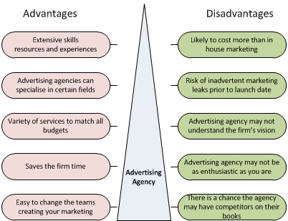

Moorman and Day state “the relationship marketing tradition has examined trust, commitment, and relational norms that make partnerships more beneficial to the firm over the long run” (2016). If long term relationships are a selling factor for a business, partnering with another company will expand a business’ network.

The disadvantage of advertising agencies is their higher cost. This may be the deciding factor for some businesses on a tight budget. There are also longer turnaround times due to the competition of other clients (O’Connor, 2018). Large companies using advertising agencies can provide larger budgets for their projects. Small businesses will find their projects are not accepted or are not high priority for agencies who cater more to large projects. Some agencies will also put other customer’s first due to deadlines or relationship status.

Advertising agency structure and design

Agency-client relationships end due to dissatisfaction in agency performance (O’Connor, 2018) Agencies steward customer relationships by providing a structure built to cater to the client’s needs, thus avoiding client dissatisfaction. Agencies benefit from continued patronage from clients. The longer a client works with an agency, the more knowledgeable the agency becomes about the client’s industry. A structure that adapts to clients is one that meets the client expectations and builds a stronger relationship.

Customizable client involvement also enhances the experience clients have. Huw O’Connor states the goal of agency structure “is to provide systems that enable creative idea and development processes to occur while ensuring that the objectives of the client are met” (2018). Specialized structural design permits agency creative personnel to create unique advertising solutions while still meeting client project criteria. This flexibility is a benefit because of the varying levels of advertising knowledge small businesses and individual sellers have.

Three main systems in agency structure can be identified:

  - Professional systems
  - Client-centered systems
  - Organization systems

These systems provide an organization the process of checks and balances. The professional systems main goal is to develop and maintain the specialized expertise of employees. How an employee is hired and trained needs to fit within the professional systems standard. This part of agency structure also supports creative staff and protects them from the damaging effects of criticism (O’Connor, 2018). Client-based agency employees are chosen using the professional system. Creative staff who do not handle damaging criticism can focus on the various client solutions requirements.

When professional systems are paired with the client-centered systems which facilitate the relationship with clients (O’Connor, 2018), creative staff can develop ideas that meet client expectations. Client support roles focus the creative teams on client expectations by gathering required criteria. The communication channels between creative teams and client allow for refined project details and needs. Unfortunately, this adds extra turnaround time on projects. The addition of communication channels and a lack of industry knowledge increases issues that client-centered systems aim to fix.

The organization systems give structure to communication lines and control (O’Connor, 2018). These elements of structure are essential for protecting agency staff and maintaining client needs. It also identifies the chain of control for projects. Being able to adapt to client needs requires flexible control. Creative teams are required to shift between projects to meet deadlines. This is efficiently achieved if control of teams is flexible and adaptable.

Advertising agency expectations

The selection of an agency comes with the client’s understanding what their own expectations are. Original content is a large requirement for clients using advertising agencies. However, clients are prone to being risk-averse. O’Connor identifies small businesses as more likely to accept highly original work (2018). This is due to their goal being focused on awareness. Larger businesses typically have an established, well-recognized brand. The amount of risk a large versus small company is willing to take is drastically different. This shows small businesses will benefit more from an agency’s unique solutions.

Sarah Turnbull found three sources of expectations:

            - Word-of-mouth
            - Advertising or personal selling
            - Individual and previous experiences (2016)

Word-of-mouth is a very popular way of advertising. Previous clients tell potential future clients of their experiences. This comes in the form of satisfaction and dissatisfaction. Word-of-mouth marketing can be done in person or online through reviews. From this, clients can draw their expectation of services and quality. Word-of-mouth advertising is favorable to agencies that promote this form of marketing due to it being one of the most efficient ways of creating realistic expectations.
Agencies who use personal selling may only tailor to a specific niche, which may not fill all the expectations a client expects. Agencies strive to establish transparency with clients so they can better meet the client’s expectations.

To ensure expectations stay realistic “advertisers need to be clear and explicit about what type of relationship they are looking for” (Turnbull, 2016). Agencies should not have to guess what their clients are expecting. Client’s should rely on an agencies flexibility to meet their needs. Small businesses can profit on agency adaptability by being upfront with what they need and how much involvement they require.

Some small businesses do not need to be involved in the entire creative process. If they lack advertising knowledge, they may benefit by giving full control to the agency. The involvement a business wants will modify the expectations the business will desire of the agency. Simply put, the involvement level they want will change what they expect of the agency.

Agency selection

According to findings by Turnbull and Wheeler, there are four main criteria for agency selection: craft, affinity, functionality, and perspective (2016).

Turnbull and Wheeler state an “agency’s creative skill has a significant influence on the advertiser’s selection” (2016). Clients will choose an agency with a strong portfolio. Based on the portfolio provided, the client will have a set of expectations the agency will be expected to meet. If the creative expectations cannot be met by an agency, clients will switch to an agency that meets their needs.

Cost is another deciding factor in the selection of an agency. Clients expect for agency solutions to fit within their budget. Advertising funds are carefully budgeted. If an agency is too expensive, a business will not give their patronage. One of the disadvantages of utilizing advertising agencies is they can be costly. If an agency can meet the cost expectations of a client, then it may be a viable solution for advertising needs. If the creative solutions succeed expectations, a business may decide to increase their budget.

Alternative selection

There are alternative ways of selecting an agency. An “advertising agency selection contest has become similar to a procurement score auction in which the pitch involves not only the creative idea but also a proposed price for buying the media” (Horsky, Horsky, & Zeithammer, 2016). While more efficient for large businesses with a substantial budget, small businesses may benefit from bids and contests from freelancers or contract workers.

Fiverr works on a bid system where freelancers send in their project solutions and clients choose which option they like best. Small businesses find this efficient if they know their creative needs. With this type of selection, extra costs can accrue from providing stipends – a payment given to participants who provided solutions but were not ultimately chosen.

Hiring a contract or freelancer directly works similarly. Businesses reach out to a variety of freelancers or open a contract job. This option may meet the lower budget restrictions of small businesses and individual sellers. Freelancers are an in-between to hiring an agency and having an in-house department. They can be integrated into the company for a short time or work remotely. There is no requirement to completely integrate them into the business. They can be hired on an as-needed basis, much like advertising agencies.

In-house advertising departments

An in-house advertising department is defined as an individual or team that works within the company to create marketing and advertising solutions. An advertising agency can hire out individuals for these needs. Alternatively, a company can hire an employee on their own. Having an in-house advertising team allows the company to have direct control over advertising personnel. Small businesses may have one designated employee for this position, while larger companies will have various sized teams. Deciding to build an entire team or just hire a single employee is dependent on business finances and overall growth goal. Figure 2 identifies the most common advantages and disadvantages of in-house departments.

Figure 2 – Advantages and disadvantages of in-house advertising departments (LearnMarketing.net)

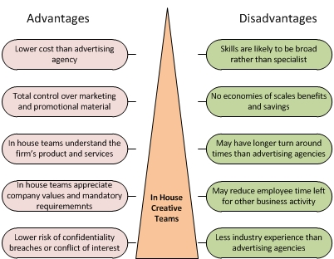

A major benefit of an advertising department is company integration. Establishing an advertising department can be one of the most visual identifiers of growth. Individual sellers can significantly benefit from an additional partner in the business if they lack advertising knowledge. Additionally, adding a department will begin integrating the brand identity into future departments. These teams have increased value for the company. They also respect mandatory requirements more than an agency would. With a dedicated in-house team, there is more control of the content created.

One of the biggest drawbacks to hiring an advertising team is less advertising industry experience. Agencies benefit from being able to tap into more resources due to their larger employee pool. With single employee or small internal team, businesses will need to output more costs to gain additional resources their team cannot provide (Moses, 2019). Upfront costs to onboarding employees can be devastating, however, long-term commitment and dedication is gained.

Department integration

Developing a strong advertising department can take time for a growing business. However, this department can be integral to future growth. Moorman and Day researched how businesses organize for market excellence. Marketing is not limited to advertising alone. Advertising can be the building block to creating strong marketing leaders in the business. Moorman and Day propose that marketing leaders have a critical role in the company to facilitate employee internalization of the firm’s brand identity (2016). When a business contains an advertising department that understands the business’ mission, not only does it advertise better, but it also conveys that knowledge to other departments.

For individual sellers ready to expand, having a single employee to control advertising efforts will begin the process of brand integration. This employee would also build strong industry knowledge, significantly benefiting an independent seller with minimum advertising knowledge. A marketing or advertising employee would allow the seller to focus on other growth procedures or product/service development.

Advantages of in-house advertising breakdown

Advantages of in-house advertising begin with an understanding of the company’s brand. When brand integration is present from a marketing team or leader, the entire business benefits. This also comes the benefit of faster communication. “Campaigns are developed hand-in-hand with the people who will ultimately approve the project, so this cuts down on wasted time and miscommunication (Duncan, 2019). When communication is strong, advertising team members maintain motivation; an important building block for any growing business.

Soukaina El Gharbaoui thinks an in-house team will benefit a business that desires long-term strategy (n.a.). When in-house personnel are dedicated to their work and the mission, these adjustments happen quicker. This pairs with faster communication and turnaround times as in-house teams have immediate access to other departments. Even if an employee is working remotely, they will still receive a swift response. (Gharbaoui, 2019). Unlike agencies, an internal team works only on projects for the company. Their focus is not taken away by other company’s projects. It eliminates project competition and increases project turnaround.

Growing businesses hire who they need and train new employees to suit their company. “The client is getting 100% dedication, no overtime or rush charges, subject matter experts, and employees who directly benefit from the company doing well” (Duncan, 2019). Signs of company growth are not only shown by employee numbers, but also from company culture and employee loyalty.

Unique in-house departments

The interesting aspect of in-house advertising departments is their ability to become their own entity. Instead of being called the “creative department”, they don their own branding and name. Some examples are:

- Fidelity Communications & Advertising (Fidelity Investments)
- Content Factory (​Coca-Cola)
- Yellow Tag Productions (​Best Buy)
- Yellow Fan Studios (Sprint Communications)
- BBC Creative (​BBC) (Duncan, 2019)

These creative departments offer the unique ability to gain benefits from both agency and in-house advertising. Being their own brand, they can act as their own business within the parent company. They may offer their services to other companies needing advertising services. Fidelity Investments saves “an estimated $20 million a year” by owning an in-house department (AdAge, 2011).

Best Buy’s internal creative agency, Yellow Tag Productions, offers unique resources for external agencies. They can produce co-op advertising, which is an efficient way of building partnerships and increasing revenue (AdAge, 2011). These unique internal advertising departments require dedicated employees and strong leaders. While small businesses will not have this as a viable option, looking at future business expansion is a notable way to set business growth goals.

Comparison of agency and in-house advertising

Common features can be found within in-house and agency advertising. Cost can be tailored to business needs. Agencies adapt to client expectations and criteria which lower costs. In-house employees are available for quick reoccurring projects which saves money and time. The level of project determines what resources are needed to fit within a business’ budget, thus determining which advertising option best fits the business’ need.

Project control is also dependent on project criteria. Brand redesign and large advertising campaigns require significant attention. Because a business can choose how involved they want to be with a project, internal advertising integration and advertising agencies both adapt as needed.

Figure 3 – Comparison of agency and in-house agencies (Sabkepasand)

Figure 3 shows a breakdown of advantages and disadvantages of both an advertising agency and an in-house department (Note: this figure uses “in-house agencies” as the term for “in-house departments”). A company will need to decide which advantages are most important to the business. Immediate growth in a business can come from hiring a new employee. This exceeds the benefits of an agency in that the employee becomes, or is already, specialized in the industry. Adversely, agencies contain expertise and resources businesses lack. They can also provide varying results that can improve a business’ advertising.

SURVEY RESULTS

A survey was held to determine which method of advertising would benefit small businesses and individual sellers. The targeted businesses contained 1-15 employees. Diversity in business was obtained by including individual contractors and freelancers to the evaluation. Ten questions were asked to determine what these businesses desired in advertising. It also asked what businesses base their advertising on and which option between in-house personnel or an advertising agency best suited their needs. The survey answers and solution can be found in the Appendix.

Figure 4 – Most companies are proficient in advertising

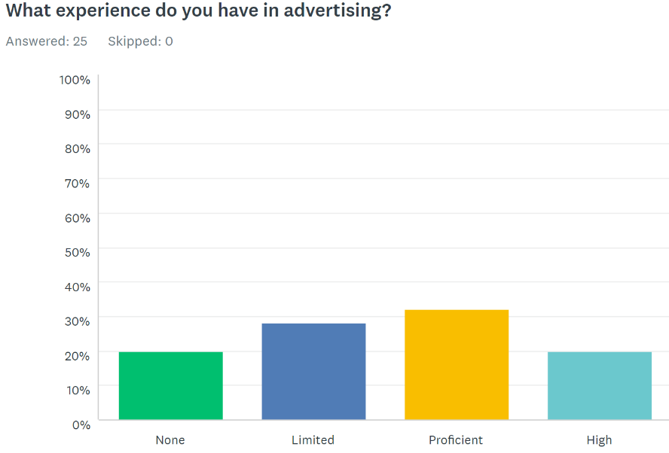

The first question analyzed what experience companies or individuals have in advertising (Figure 4). This question gives insight as to how knowledgeable companies are with their own marketing and advertising needs. The results show many are proficient. It also shows the respondents came from a variety of backgrounds, as the results distributed evenly. This variety in results concludes that the level of advertising knowledge may have little in determining which solution is best for these businesses. However, it does show that experience level can affect what advertising they use and what features they find valuable.

Figure 5 – Companies utilize in-house departments the most

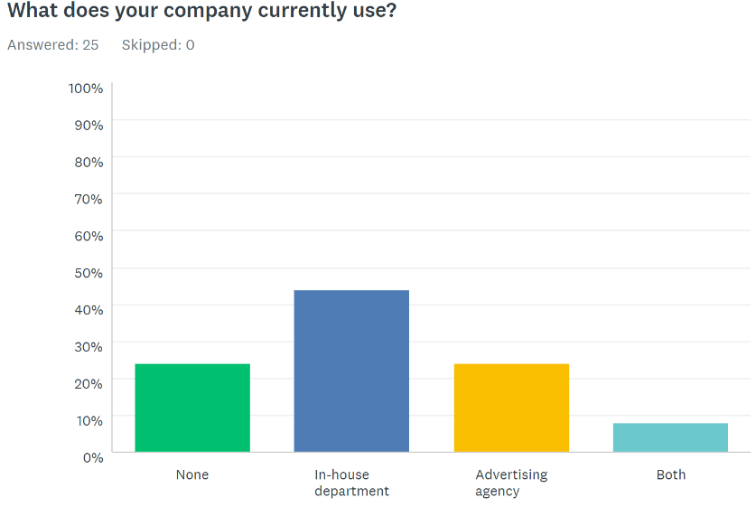
The second question asked “What does your company currently use?” (Figure 5). The purpose of this question was to figure out how companies are creating their advertising. The current use of advertising puts an emphasis on what works for the company. The results indicate that using an in-house department is utilized the most. There was emphasis in this survey that indicated an in-house department could be a single person. This can be the individual seller or another employee.

Figure 6 – In-house departments have been used the most

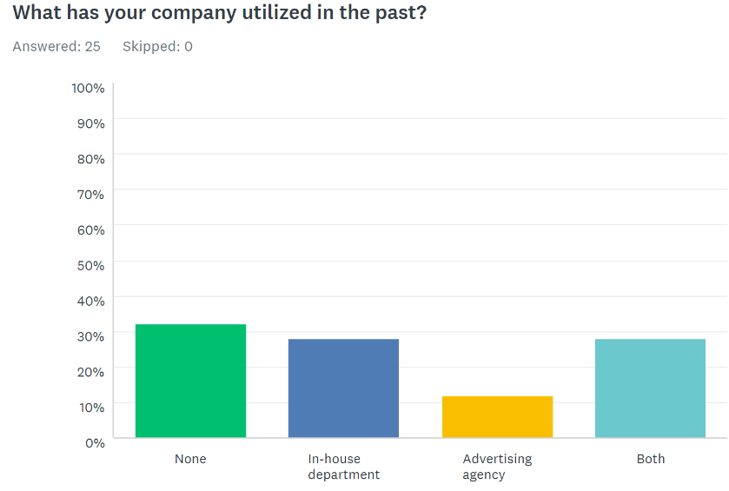

The third question explores the history of company advertising (Figure 6). It asked “What has your company utilized in the past?” The results show many respondents have not used agencies or in-house personnel before. Paired with the second question, this indicates hiring in-house personnel may be a new development. Some companies still have a history of using an agency.

Figure 7 – Companies would and would not continue using an advertising agency

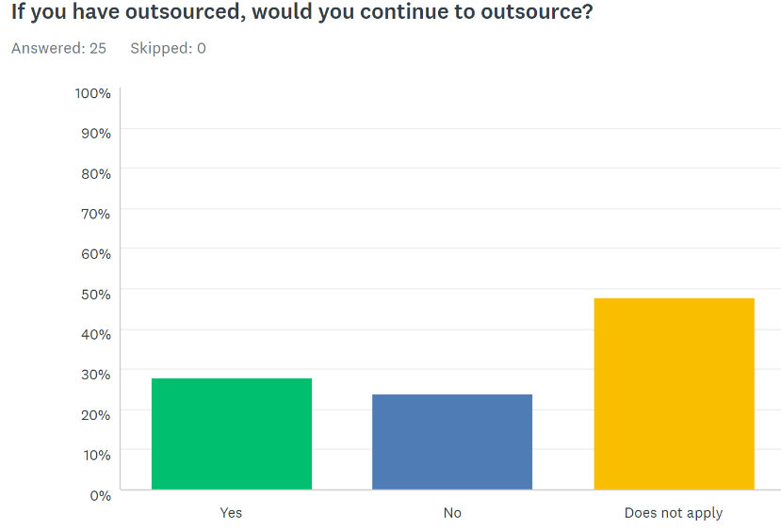

The fourth question relates a company outsourcing to an advertising agency (Figure 7). It asked “If you have outsourced, would you continue to outsource?” The goal of this question was to gather insight if companies would use these services again. This question applied to 13 of the 25 respondents.

Figure 8 – Companies would continue using an in-house department

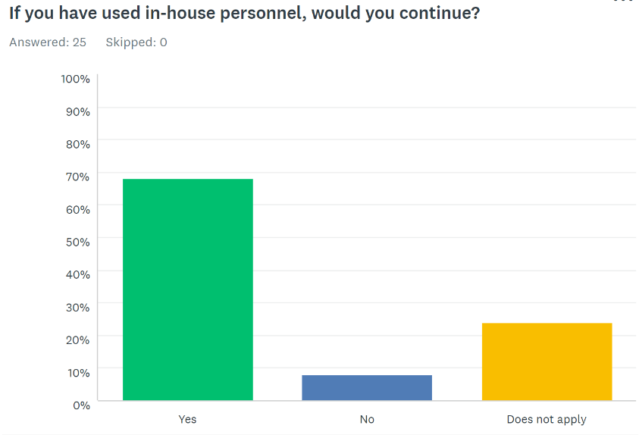

Similarly, the fifth question asked if the respondent would continue using in-house personnel (Figure 8). The results of this question, in contrast to the fourth question (Figure 7) showed a significant response in continuing use. Where the question of outsourcing showed almost equal responses of yes and no, more respondents would continue using in-house personnel; there is more satisfaction with this option.

Figure 9 – The amount of advertising is dependent on the size of company

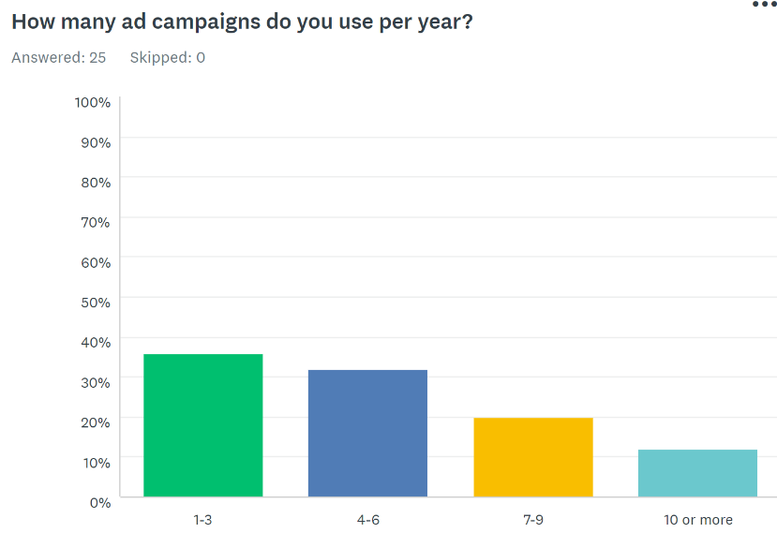

The sixth question refers to how many advertising campaigns the target companies launch (Figure 9). This question is important because it relates to the turnaround time advertising agencies and in-house personnel have. It also shows how often these businesses require advertising. Many responded between 1-6. The independent contractors and freelancers did not use as many advertisements as the small businesses. Using less advertisements also matches with the higher use of in-house personnel.

Figure 10 – Companies use print and social media advertising the most

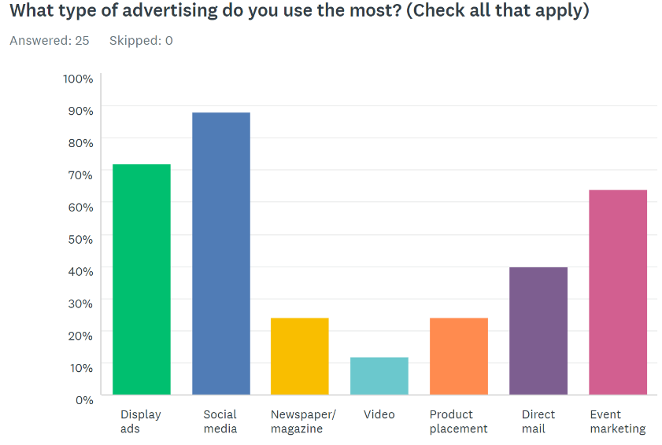

Knowing the type of advertising that is used the most between companies allows analysis of advertising efficiency. The seventh question of the survey demonstrates that almost all businesses use social media for advertising (Figure 10). Display ads, like business cards and event marketing were the second most popular forms of advertising. As in-house departments and advertising agencies are proficient in different areas, this information gives insight to what would be better for growing businesses to use.

Figure 11 – Companies base their advertising on budget, experience and needs

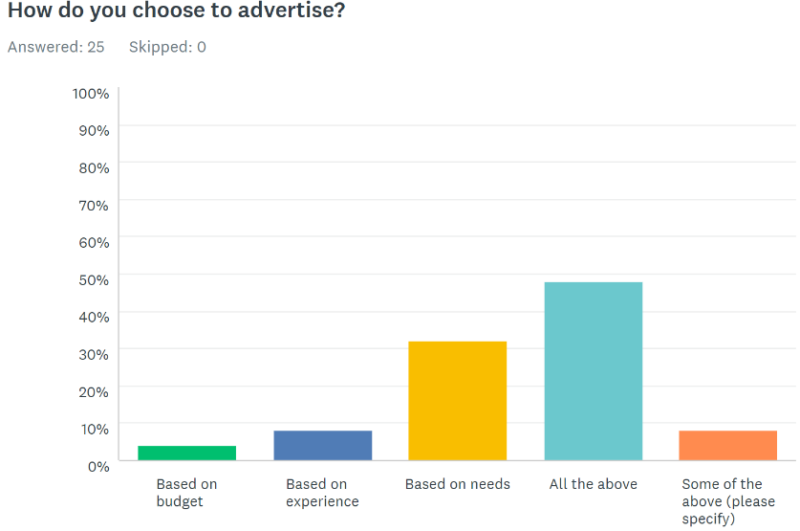

Question 8 investigates how these businesses choose to advertise (Figure 11). Finding the most important criteria on the business’ end indicates which solution best fits their needs. Many of the respondents answered that they advertise based on budget, experience and needs. All three are important for choosing how to advertise.

Figure 12 – Companies value the cost of advertising the most

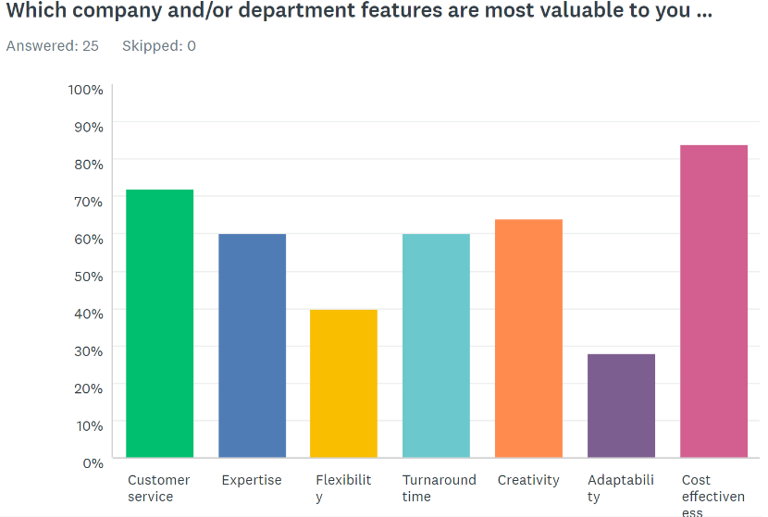

The ninth question asked the surveyors “Which company or department features are most valuable to you?” (Figure 12). In-house departments and advertising agencies offer different levels of features. The majority of respondents value cost effectiveness the most. Customer service quality, creativity, and turnaround time were also important to 60% of respondents. This information shows that businesses are needing fast response time but wanting creative results.

Figure 13 – Companies believe in-house departments suit their needs best

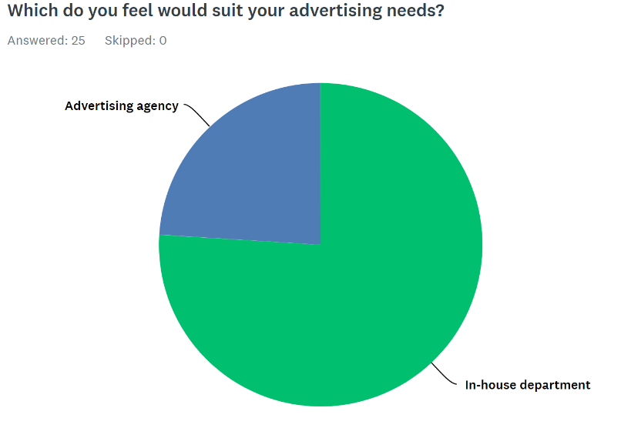

The final question was based on opinion (Figure 13). It asked the respondents to choose which option they believed would suit their needs best. Relating back to the second and fifth questions, an in-house department was the popular choice. Many companies already using, and continuing to use, an in-house department show that these businesses feel their needs are met.

CONCLUSIONS

Small businesses and individual sellers have varying needs for growth. Their own goals will change advertising requirements. Advertising provides the company the ability to grow brand awareness and integrate their brand in to the company. Moving forward small businesses will need to determine what they value most in advertising and if they are able to budget for the growth it brings.

Understanding what option will suit their needs best can be determined by looking at the unique set of advantages and disadvantages. Advertising agencies offer expertise and experience. Small businesses can benefit from their solutions if they lack knowledge in advertising. While there is more competition and higher costs, businesses who have established brands will find advertising agencies helpful in large projects.

In-house departments integrate brand identity into a growing business. These teams understand the brand vision and goals. The business also has direct control over the products created by the department. Small businesses who are trying to grow will find immediate results in hiring new personnel. They also benefit by saving money for reoccurring advertising needs.

RECOMMENDATIONS

Small businesses should establish an in-house department. For those that have an established brand, keeping reoccurring advertising in-house will save money. Social and print media require quick turnaround times that agencies may struggle with. Fast communication and dedicated employees are a massive benefit.

The advantage of department integration is also valuable to growth. It makes valued changes to culture and identity. Dedicated employees control how the business is marketed and viewed through advertisements increasing awareness. It takes pressure off other employees to control this part of the company.

Individual sellers who are looking to expand should investigate hiring a dedicated marketer or advertiser. Since these sellers are focused on their products and services, being able to rely on a dedicated employee for their advertising is a good first step. Individual sellers can still maintain close management of content being created. An advertising employee would significantly boost productivity and brand awareness.

There are benefits that come from combining advertising agencies and in-house departments. Small businesses and individual sellers may still need resources that internal personnel cannot obtain. Advertising agencies aid in that aspect and should not be ignored; they are still a viable option for specialized needs. Future research into the combination of these options should be done to establish if there is more money to be saved. Large businesses continue use a combination of services. Future research can look to their success in advertising and growth to determine if this is a step small business should take.

REFERENCES

AdAge (2011). Prominent in-house agencies: content factory, yellow tag productions, fidelity communications & advertising. Retrieved from: https://adage.com/article/agency-news/prominent-house-ad-agencies-coke-buy-fidelity/227146

Duncan, A. (2019). The in-house advertising agency system explained. The Balance Careers. Retrieved from: https://www.thebalancecareers.com/the-in-house-advertising-agency-model-38544

Fiverr. Retrieved from: https://www.fiverr.com/

Gharbaoui, S. (n.a.). The 9 pros and cons of in-house marketing vs ad agencies. Retrieved from: https://filestage.io/blog/in-house-marketing/#in-house-ad-agency

Horsky, D., Horsky, S., & Zeithammer, R. (2016). The modern advertising agency selection contest: A case for stipends to new participants. Journal of Marketing Research (JMR), 53(5), 773–789. doi:10.1509/jmr.14.0347

LearnMarketing.net (n.d.) Advertising agency advantages and disadvantages [Figure]. Retrieved from: https://www.learnmarketing.net/Advertising_Agencies_Advantages_and_Disadvantages.htm

In-house campaigns advantages and disadvantages [Figure]. Retrieved from: https://www.learnmarketing.net/In_house_campaigns_advantages_and_disadvantages.htm

Moorman, C., & Day, G. S. (2016). Organizing for marketing excellence. Journal of Marketing, 80(6), 6–35. doi:10.1509/jm.15.0423

Moses, S. (2019). In-house creative team or outside agency: what’s right for your business?. Business 2 Community. Retrieved from:https://www.business2community.com/marketing/in-house-creative-team-or-outside-agency-whats-right-for-your-business-02173350

O’Connor, H., Kilgour, M., Koslow, S., & Sasser, S. (2018). Drivers of creativity within advertising agencies: How structural configuration can affect and improve creative development. Journal of Advertising Research, 58(2), 202–217. doi:10.2501/JAR-2017-015

Sabkepasand (n.d.) Retrieved from: https://sabkepasand.wordpress.com/2012/10/07/chapter-3-belch-and-belch/

Turnbull, S., & Wheeler, C. (2016). Exploring advertiser’s expectations of advertising agency services. Journal of Marketing Communications, 22(6), 587–601. doi:10.1080/13527266.2014.920902

APPENDIX

Results of the survey can be viewed here: https://www.surveymonkey.com/stories/SM-7X8TCGW7/

List of survey questions and possible answers:

- What experience do you have in advertising?
  - None
  - Limited
  - Sufficient
  - High

- What does your company currently use?
  - None
  - In-house department
  - Advertising agency
  - Both

- What has your company utilized in the past?
  - None
  - In-house department
  - Advertising agency
  - Both

- If you have outsourced would you continue?
  - Yes
  - No
  - Does not apply

- If you have used in-house would you continue?
  - Yes
  - No
  - Does not apply

- How many ad campaigns do you use per year?
  - 1-3
  - 4-6
  - 7-9
  - 10 or more

- What type of advertising do you use the most? (Check all that apply)
  - Display ads
  - Social media
  - Newspaper/magazine
  - Video
  - Product placement
  - Direct mail
  - Event marketing

- How do you choose to advertise?
  - based on budget
  - based on experience
  - based on needs
  - all the above
  - some of the above (please specify)

- Which company and/or department features are most valuable to you? (Check all that apply)
  - Customer service
  - Expertise
  - Flexibility
  - Turnaround time
  - Creativity
  - Adaptability
  - Cost effectiveness

- Which do you feel would suit your advertising needs?
  - In-house department
  - Advertising agency

