JANUARY 2019
CARL DUFF MINISTRIES
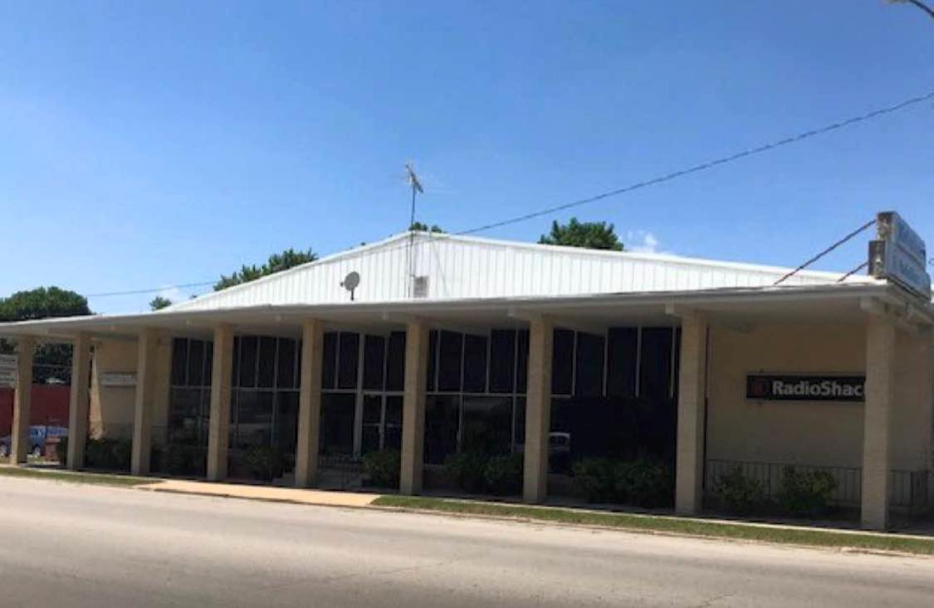
My family and I hope and pray you are doing well. These last few months have been very busy for us, so we apologize for not sending out newsletters. In case you do not know or haven’t seen on our Facebook page yet, we have begun purchasing a beautiful 12,500 sq. ft. building to be used for the kingdom. It is located at 235 N Clark St. Sullivan, Mo. Right now, we are still using the building across the street, known as The Rock Church to have services until we can get into our building. There is a lot of renovating that needs to be done before this can happen. We are constantly amazed by the many blessings God has shown us along the way and His faithfulness to make a way when there seems to be none! We know God is going to provide every need, and has for us thus far. Right now, we need about $20,000 to renovate the building just to get in and have services. We are moving along as the Lord provides and have already started tearing down on the inside. However, we cannot get in until all work is finished. We are excited for this new season with the Lord!
OUR MISSION

My heart’s desire is to see America on fire for God. I want to see people’s lives changed because of the gospel of Jesus Christ. Many people travel far and wide as missionaries to bring Jesus to a broken land, in a broken system. I feel God has called me to go to the streets of America and seek and find the lost, hurting, and hopeless families and show them the hope of Jesus.
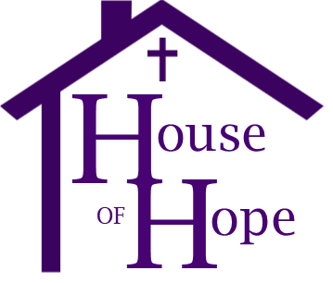
We have given our ministry a name; House of Hope. Because there are so many people today who have no hope for their future, we want to bring them the eternal hope in Jesus Christ and be a light to them. Jesus came to be the living hope in our lives and we want to show them this hope so they might find life in him.
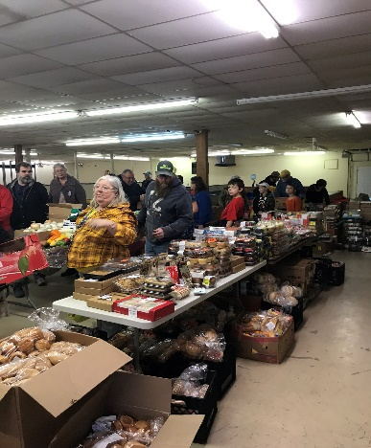
House of Hope Food Ministry
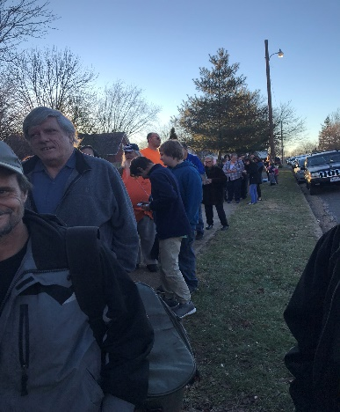
We are so blessed to be able to have our food ministry in the building. While we cannot hold services in the building yet, we are allowed to give out food in the back of the building. We have had so much food come in, in these last few weeks, and thankfully more people are beginning to show up. We have been able to feed 1000’s of people through this part of our ministry.
“Then the righteous will answer him, saying, ‘Lord, when did we see you hungry and feed you, or thirsty and give you drink?... And the King will answer them, ‘Truly, I say to you, as you did it to one of the least of these my brothers, you did it to me.’
If you would like to donate to the ministry you can by:
Mailing us at P.O. Box 722 St. Clair, Mo. 63077
Visiting our website at carlduffministries.com and scrolling down to the donate button at the bottom of the page
Visiting us on Facebook at Carl Duff Ministries, there is a donate button on there as well.
(Matthew 25: 37,40)
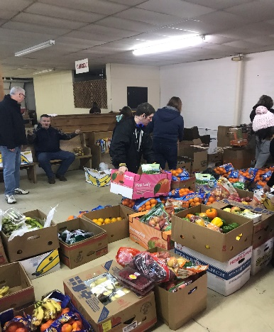
Our goal is to be more than a church. We want to bring hope to a lost and dying world. Right now, we only give out food, we are not giving out clothing. If you know someone who lives in the Sullivan area, and surrounding areas, that is in need of food for their family, we would love to help them. Our food loads are every 1st, 3rd, and 5th Wednesdays at 4pm, every Friday at 4pm, and every Saturday at 12pm. They do not need to bring anything with them, they can come and be blessed.

Thank you for your continued support. Please keep us in prayer as we venture forward.
- Pastor Carl Duff

