STATE OF LOC NATION
SOLN Community Lending & Grant Network
Loans, Grants and Back-End Financial Software Services
10-Year Strategic Forecast | Detailed Years 1-5 Operating Plan
Mission
Deliver accessible loans and grants to underfunded, underrepresented, and historically redlined communities, supported by accountable software, treasury controls and program-administration services.
Prepared for SOLN leadership, partners, funders, institutions, and pilot participants

Executive Summary
SOLN has two products. Product 1 is the primary business: loans and grants for qualified individuals, microbusinesses, small businesses, community organizations and institutional programs. Product 2 is the supporting business: back-end software and administration services for organizations that originate, distribute, account for and monitor loans and grants.
Base-case objective: reach 150,000 active consumers, 8,000 participating businesses, and 220 institutional partners by Year 5; expand to 1.5 million consumers, 90,000 businesses, and 1,400 institutions by Year 10.
Loan principal and grant disbursements are not revenue. Revenue consists of earned interest, permitted fees, program-administration income, software subscriptions, implementations and support. LND and USD are maintained as separate rails and may not be treated as interchangeable cash without a documented conversion and settlement mechanism.

Strategic Thesis
- Underserved communities do not lack economic activity; they often lack affordable infrastructure, trusted distribution, compliant onboarding, and bargaining power.
- A combined consumer-and-business network creates practical utility: demand, merchant acceptance, education, settlement records, and measurable community impact reinforce one another.
- The strongest early wedge is a controlled loan-and-grant pilot supported by documented eligibility, underwriting, agreements, disbursement, repayment, reconciliation and impact reporting.
- National density precedes global breadth. SOLN should prove repeatable operating units in selected U.S. corridors, then enter global markets through local institutional partners.

Company and Operating Model
Product layer | Primary customer | Core offer | Revenue engine
Loans | B2C/B2B | Emergency, development, microbusiness and growth financing | Interest and permitted origination/servicing fees
Grants | B2C/B2B/B2B2C | Relief, education, business development and community-program awards | Sponsor-funded administration and reporting
Software | Institutions/lenders | Application, workflow, ledger, servicing, reconciliation and dashboards | Subscription, implementation and support
Program administration | Institutions/sponsors | Cohort onboarding, disbursement controls, monitoring and impact reporting | Fixed fee or permitted percentage of program budget
Payment connectivity | Partner delivered | USD banking rails and LND account transfers; conversion only when documented | Partner revenue share where permitted

Product Portfolio

Product 1: Loans and Grants
- Emergency and household-stability loans
- Consumer-development and credit-building loans
- Microbusiness working-capital loans
- Small-business growth and equipment loans
- Sponsored relief, education and business-development grants
- Institutional loan/grant programs administered for community cohorts

Product 2: Back-End Software and Services
- Digital application and eligibility workflow
- Underwriting, approval matrix and agreement generation
- Loan amortization, servicing, repayment and delinquency tracking
- Grant award, milestone, restriction and closeout tracking
- Double-entry ledger, reconciliation, audit history and portfolio reporting
- Institutional cohort management, dashboards, integrations and support

LND and USD Distribution Model
Every award must identify its funding rail before approval. The recipient receives exactly what the agreement states: LND, USD or a defined dual-rail award. The two balances are recorded and reconciled separately.
Award type | Recipient receives | How it circulates | Repayment/closeout | USD consequence
LND grant | LND ledger credit | Transfers to participating LND merchants/accounts | No repayment; grant milestones and closeout | No USD moves unless separately funded
LND loan | LND ledger credit plus loan agreement | LND account/QR transfers within participating network | Principal and stated charges repaid in LND unless agreement says otherwise | Reference value is not USD cash
USD grant | USD through bank/payment partner | Normal USD payment rails | No repayment; grant milestones and closeout | USD cash and bank reconciliation
USD loan | USD through bank/payment partner | Normal USD payment rails | Scheduled USD principal, interest and fees | USD loan receivable and cash movement
Dual-rail award | LND plus documented USD settlement right | LND use or approved conversion | Terms specify repayment currency and conversion treatment | Requires identified liquidity, rate, limits and settlement provider

At the declared reference rate of 1 LND = $750, a $10,000-equivalent LND award is 13.3333 LND. That reference does not create $10,000 of available USD. USD is delivered only when a separate USD funding source and settlement process exist.

Operational Funds Flow
- Application identifies requested product, amount, purpose and requested currency rail.
- Eligibility, identity, underwriting or grant criteria are completed and evidenced.
- Authorized personnel approve the award under the approval matrix.
- The system creates the agreement and posts either an LND ledger credit or an instruction to the USD payment partner.
- The recipient or merchant receives the stated asset; confirmation and settlement evidence are attached.
- Loans enter servicing and repayment; grants enter milestone and closeout monitoring.
- LND and USD subledgers reconcile separately to their respective control accounts.

Target Market
Primary geography: U.S. communities with documented underinvestment, redlining history, low-to-moderate income conditions, limited banking access, weak small-business credit availability, or persistent representation gaps. Global expansion prioritizes African, Caribbean, Latin American, Indigenous, and diaspora markets where mobile-first distribution and trusted community institutions can support compliant adoption.
Segment | Need | Decision maker | Initial offer | Acquisition channel
Consumers | Emergency liquidity and development capital | Individual/household | Emergency/development loan or sponsored grant | Community partners, employers, events, referrals
Microbusinesses | Working capital, equipment and operating stability | Owner/operator | Microloan plus optional readiness support | Associations, chambers, accountants
SMEs | Growth capital and treasury discipline | Owner/CFO/controller | Growth loan plus software/servicing tools | Professional partners, direct sales
Nonprofits/associations | Grant and loan-program delivery | Executive/program director | Administered community cohort | Strategic partnerships and sponsored programs
Municipal/public-benefit partners | Inclusive capital delivery and reporting | Program/procurement leadership | Defined loan/grant pilot with controls | RFPs, MOUs, local anchor partners
Global institutions | Localized community-finance infrastructure | Country/region partner | Partner-led lending/grant program and software | Diaspora networks and institutional alliances

Market Evidence
- The U.S. Census Bureau reported about 201,000 Black-owned employer businesses with $249.0 billion in receipts, plus 4.4 million Black-owned nonemployer businesses with $128.7 billion in receipts in the latest cited release.
- The FDIC reported that 4.2% of U.S. households—about 5.6 million households—were unbanked in 2023.
- The World Bank reports roughly 1.3 billion adults globally remain unbanked and identifies mobile-enabled digital financial services as an important inclusion channel.
- Federal Reserve research continues to identify a financing-access gap between small businesses and larger businesses.
These statistics define a broad need population, not SOLN’s obtainable market. The forecast below uses bottom-up adoption targets rather than assuming a percentage of global need.

Go-to-Market Strategy
- Prove one repeatable U.S. pilot unit: 5-10 anchor merchants, a participant cohort, one institutional sponsor, documented onboarding, and weekly reconciliation.
- Create neighborhood density: expand to 50-100 merchants per launch corridor before opening another corridor.
- Activate associations and professional partners: accountants, chambers, nonprofits, educators, and community-development organizations become trusted distributors.
- Sell institutional cohorts: partners sponsor participant access, merchant readiness, and measurable outcome reporting.
- Expand nationally through a train-the-trainer and certified implementation-partner model.
- Enter global markets only with local legal, payments, identity, tax, data-protection, and consumer-protection workstreams completed.

Pricing Architecture
Offer | Illustrative price | Buyer | Notes
Emergency/community loan | $500-$5,000; 5%-10% APR | Consumer | Final terms based on underwriting and applicable law
Consumer-development loan | $5,000-$25,000; 6%-12% APR | Consumer | Purpose and affordability controls
Microbusiness loan | $2,500-$25,000; 6%-10% APR | Business | Working capital, inventory or equipment
Business-growth loan | $25,000-$250,000; 7%-12% APR | Business | Cash-flow underwriting and covenants as appropriate
Sponsored grant | Program-defined; no recipient price | Qualified participant | Sponsor funds award and administration
Software subscription | $39-$299/month | Business/institution | Application, ledger, servicing and reporting tiers
Institution implementation | $15,000-$150,000 | Institution | Scoped by users, integrations and geography
Program administration | 3%-8% or fixed fee | Sponsor/institution | Subject to agreement and funding restrictions
Enterprise support | $25,000-$250,000/year | Institution | Controls, dashboards, audit support and integrations

Five-Year Operating Plan
Year | Primary objective | Operating milestone | Geographic posture
1 | Pilot and control proof | 2,500 consumers; 150 businesses; 8 institutions | 1-3 U.S. corridors
2 | Repeatable local density | 10,000 consumers; 600 businesses; partner playbook | 5-8 U.S. corridors
3 | Regional scale and breakeven | 30,000 consumers; 1,800 businesses; enterprise integrations | Multi-state regions
4 | National distribution | 75,000 consumers; 4,200 businesses; certified implementers | National footprint
5 | National platform + first global nodes | 150,000 consumers; 8,000 businesses; 220 institutions | U.S. density + 2-4 partner-led countries

Years 6-10 Expansion Outlook
- Years 6-7: deepen national coverage, launch multilingual support, standardize institutional deployment, and establish regional compliance packs.
- Years 8-9: scale partner-led international deployments, strengthen interoperability, and expand enterprise reporting and procurement readiness.
- Year 10: operate a federated network with centralized standards, local execution, independent assurance, and diversified revenue by customer type and geography.

Base-Case 10-Year Forecast
All figures are illustrative planning assumptions in USD. Loan principal, grant awards, LND issuance, reference values, reserves and repayments of principal are balance-sheet or program-fund movements—not operating revenue. Revenue includes earned interest, permitted fees, administration, software and support.
Year | Consumers | Businesses | Institutions | Revenue | OpEx | EBITDA
Y1 | 2,500 | 150 | 8 | $0.55M | $1.20M | $-0.65M
Y2 | 10,000 | 600 | 25 | $1.80M | $2.30M | $-0.50M
Y3 | 30,000 | 1,800 | 60 | $5.40M | $4.80M | $0.60M
Y4 | 75,000 | 4,200 | 120 | $12.50M | $9.30M | $3.20M
Y5 | 150,000 | 8,000 | 220 | $24.50M | $16.50M | $8.00M
Y6 | 275,000 | 15,000 | 350 | $42.00M | $27.00M | $15.00M
Y7 | 475,000 | 26,000 | 525 | $68.00M | $40.00M | $28.00M
Y8 | 750,000 | 42,000 | 750 | $102.00M | $58.00M | $44.00M
Y9 | 1,100,000 | 65,000 | 1,000 | $145.00M | $79.00M | $66.00M
Y10 | 1,500,000 | 90,000 | 1,400 | $198.00M | $103.00M | $95.00M

Lending/grant scale | Y1 | Y2 | Y3 | Y4 | Y5
Loan originations | $2M | $8M | $25M | $60M | $125M
Ending loan portfolio | $1.5M | $6M | $18M | $42M | $85M
Grant disbursements | $0.5M | $2M | $5M | $12M | $25M
Primary funding need | Pilot facility | Facility + sponsor | Warehouse/institutional | Diversified facilities | National capital partnerships

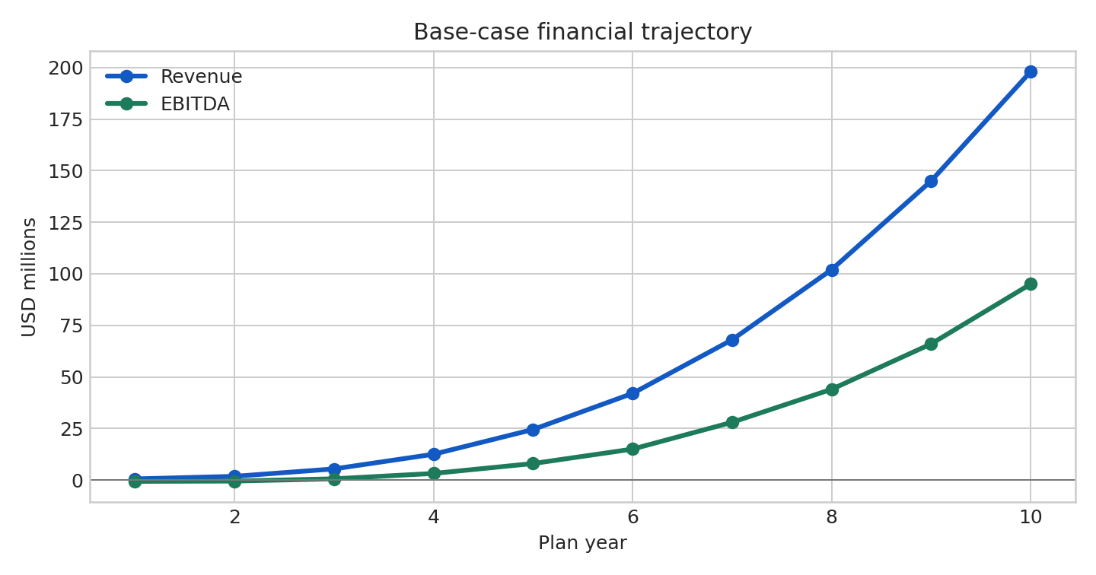
Base case reaches positive EBITDA in Year 3. Cumulative external funding need through the operating trough is approximately $1.15 million before contingency, working capital, reserves, and regulated-service capital requirements.

Revenue Composition Assumptions
Revenue stream | Year 1 | Year 5 | Year 10 | Scale logic
Interest and lending fees | 35% | 48% | 52% | Performing loan portfolio and permitted pricing
Grant/program administration | 30% | 20% | 15% | Sponsor-funded cohort delivery and reporting
Software subscriptions | 15% | 14% | 15% | Recurring business and institutional tiers
Implementation/onboarding | 15% | 8% | 5% | Declines as recurring base grows
Enterprise reporting/support | 5% | 10% | 13% | Controls, reporting, integrations and assurance support

Unit Economics and KPI Framework
Metric | Year 1 target | Year 3 target | Year 5 target | Management use
Consumer activation | 55% | 65% | 70% | Onboarding quality
90-day consumer retention | 50% | 60% | 68% | Utility and trust
Business 12-month retention | 65% | 75% | 82% | Product-market fit
Blended CAC | $95 | $62 | $45 | Channel efficiency
Annual gross margin | 48% | 63% | 70% | Scalability
Institution renewal | 60% | 75% | 85% | Contract quality
Reconciliation exceptions | <2.0% | <0.8% | <0.3% | Operational integrity
Material control breaches | 0 | 0 | 0 | Risk appetite

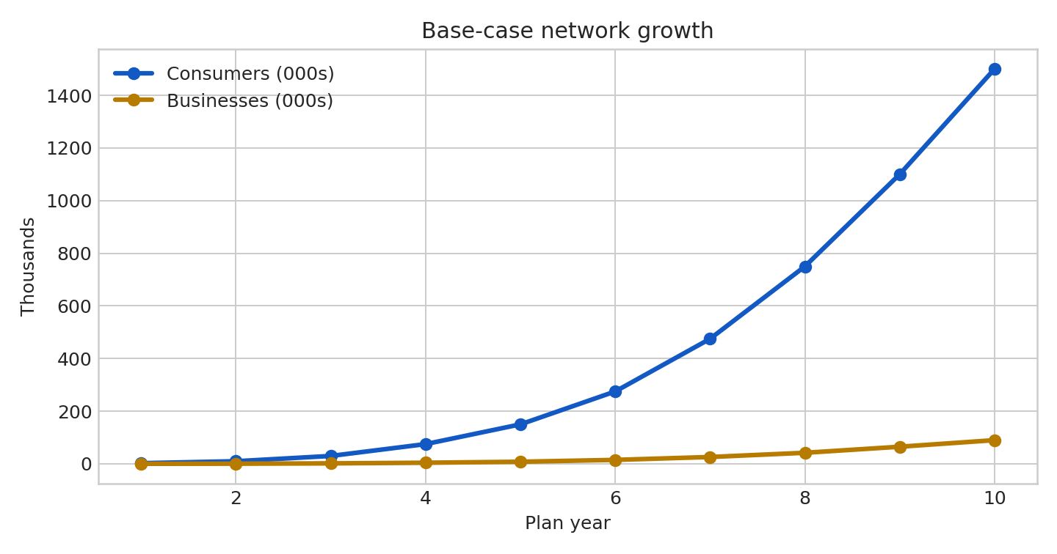

Scenario Analysis
Year 5 scenario | Consumers | Businesses | Revenue | EBITDA | Interpretation
Conservative | 75,000 | 4,000 | $12.5M | $1.0M | Slower partnerships; preserve core controls and corridor density
Base | 150,000 | 8,000 | $24.5M | $8.0M | Planned partner-led national scaling
Expansion | 275,000 | 14,000 | $42.0M | $15.0M | Faster institutional adoption; requires higher implementation capacity

Capital Plan and Use of Funds
Recommended operating capitalization: $2.5-$4.0 million for the first 24 months. Product capital is separate: an illustrative $5 million Year 1 loan facility plus sponsor-funded grant pools. Loan principal, grant funds, customer funds, LND balances and operating cash remain segregated.
Use | Share | Purpose
Technology and security | 28% | Ledger controls, participant portal, integrations, testing, cybersecurity
Compliance, legal, and assurance | 18% | Jurisdictional analysis, policies, independent reviews, contracts
Community and merchant growth | 20% | Pilot activation, training, partner support, accessibility
Operations and customer care | 18% | Reconciliation, support, complaint handling, implementation
Data, measurement, and evaluation | 6% | Impact metrics, dashboards, quality assurance
Working-capital contingency | 10% | Timing gaps and execution risk

Product Capital Structure
Capital pool | Purpose | Accounting treatment | Control
Operating equity/grants | Staff, technology, compliance and growth | Operating cash and expenses | Board budget and cash forecast
Loan capital facility | Fund approved USD loans | Cash converted to loan receivables at funding | Borrowing base, concentration and covenant reporting
Sponsored grant pool | Fund approved grants | Restricted/program cash and grant expense | Sponsor restrictions, milestone and closeout controls
LND issuance allocation | Fund approved LND awards | Separate LND subledger and program/loan accounts | Issuance authority, limits and daily reconciliation
USD settlement liquidity | Honor specifically approved USD settlements/conversions | Separate USD cash/liquidity account | Conversion rules, limits and settlement evidence

Treasury and Financial Management
- Maintain legal-entity, currency, customer-fund, program-fund, operating-cash, restricted-fund, and reserve separation.
- Use rolling 13-week cash forecasting, annual budgets, monthly variance analysis, liquidity-gap reporting, and board-approved minimum cash thresholds.
- Manage receivables by customer class, aging, concentration, dispute status, and expected-credit-loss policy; manage payables with approval limits and due-date discipline.
- Measure cash conversion cycle, working capital, burn multiple, gross margin, recurring revenue, renewal, and return on invested capital.
- Apply maker-checker-verifier-release controls, access reviews, independent reconciliation, exception management, and immutable audit evidence.
- Match asset liquidity and funding maturity; avoid funding long-term commitments with unstable short-term sources.

Governance, Risk, and Compliance Gates
Gate | Required evidence before scale | Owner
Entity and authority | Board approvals, delegated authorities, signing matrix | Board/General Counsel
Product classification | Jurisdiction-specific legal analysis for each service | Legal/Compliance
Funds flow | Documented custody, settlement, safeguarding, and reconciliation model | Treasury/Operations
LND/USD rail | Award currency, conversion rights, liquidity source and accounting treatment | Treasury/Controller
Customer protection | Disclosures, complaints, refunds, error resolution, accessibility | Compliance/Customer Care
KYC/AML/sanctions | Risk-based program and qualified vendors/partners where applicable | BSA/AML lead
Cybersecurity/privacy | Data map, access control, encryption, incident response, retention | Security/Privacy
Accounting/audit | Revenue policy, fund segregation, close checklist, independent assurance | CFO/Controller
Country launch | Local counsel, tax, FX, payments, data, consumer, and labor review | Country lead

Enterprise Risk Management
Risk | Leading indicator | Response
Liquidity | Runway, cash concentration, forecast variance | Liquidity floor, scenario plan, committed contingency
Credit/counterparty | Aging, defaults, partner exposure | Limits, collateral/guarantees where appropriate, diversification
Operational | Exceptions, failed reconciliations, access violations | Segregation of duties, testing, continuity plans
Cyber/fraud | Account takeover, anomalous transactions, phishing reports | MFA, endpoint hardening, monitoring, positive controls
Regulatory | Product or country changes, complaints, examinations | Change management, counsel, licensed partners
Reputation | Complaint trends, partner attrition, public claims variance | Evidence standards, transparent reporting, response protocol
FX/interest rate | Exposure by currency and repricing period | Natural hedges, limits, scenarios, approved derivatives only

Impact Measurement
- Households onboarded, activated, retained, and transitioned to lower-cost financial services.
- Businesses completing treasury-readiness training, adopting accrual accounting, and improving cash conversion cycles.
- Merchant revenue generated through SOLN-referred demand and procurement pathways.
- Capital, grants, and benefits delivered with complete traceability and reconciliation.
- Reduction in failed payments, fraud losses, reconciliation exceptions, and unresolved complaints.
- Geographic distribution by historically redlined, low-to-moderate income, rural, tribal, diaspora, and other defined priority areas.

First 12-Month Execution Agenda
Quarter | Priority | Completion evidence
Q1 | Governance, product definition, pilot design, control map | Approved charter, risk register, funds-flow map, pricing, pilot criteria
Q2 | Launch 5-10 anchor merchants and first participant cohort | Signed agreements, completed onboarding, live support, weekly reconciliation
Q3 | Institutional sponsor and second corridor | Cohort contract, impact dashboard, repeatable implementation playbook
Q4 | Scale decision and Year 2 financing | KPI review, independent control assessment, audited forecast refresh

Decision Rules
- Do not open a new geography until the current launch unit meets activation, retention, reconciliation, complaint, and liquidity thresholds.
- Do not recognize pledged, notional, disputed, or internally declared values as operating revenue without the applicable accounting evidence.
- Do not commingle operating cash, customer funds, sponsored-program funds, reserves, or restricted funds.
- Do not describe an LND reference value as available USD unless a documented USD liquidity source and settlement obligation exist.
- Do not launch a regulated service solely because the software is technically capable of performing it.
- Do not optimize growth at the expense of auditability, customer protection, or liquidity.

Sources and Planning Basis
- U.S. Census Bureau, business-owner characteristics release (Nov. 20, 2025) [source]
- FDIC, 2023 National Survey of Unbanked and Underbanked Households [source]
- World Bank, Global Findex Database 2025 [source]
- World Bank, Inclusive Digital Financial Services [source]
- Federal Reserve, remarks on small-business access to capital (May 15, 2025) [source]
Forecast methodology: management assumptions prepared September 2026. Reforecast quarterly using actual conversion, retention, pricing, cost, compliance, and partner data. No forecast should be interpreted as a guarantee of financing, adoption, regulatory approval, currency acceptance, or financial return.

