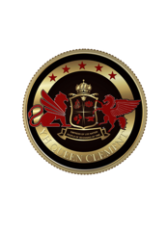
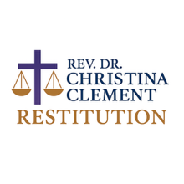
FOR IMMEDIATE RELEASE
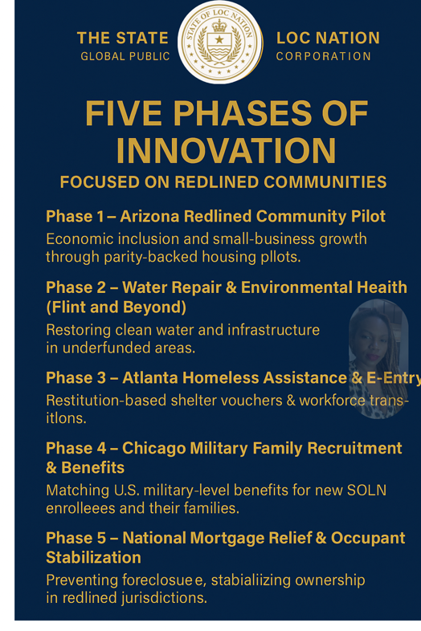

State of Loc Nation Global Public Benefit Corporation Launches Multi-Phase Restitution Sandbox to Advance Economic Justice and Sovereign Innovation

Atlanta, GA — October 13, 2025
The State of Loc Nation Global Public Benefit Corporation (SOLN GPBC) has formally activated its Restitution Sandbox Program, a sovereign public-benefit initiative designed to test and demonstrate parity-backed financial models that repair redlined, underfunded, and historically excluded communities.

The Restitution Sandbox operates under the authority of the State of Loc Nation GPBC-Trust & Central Bank, establishing Loc Nation Dollar (LND) as its functional currency of record, with the U.S. Dollar (USD) pserving only as an external disclosure reference. All projects record transactions in LND (1 LND = 750 USD per Annex B Functional Currency Policy).

Five Phases of Innovation

State of Loc Nation GL:

Phase 1 – Arizona Redlined Community Pilot
Targeting economic inclusion and small-business growth within Arizona’s historically underfunded ZIP codes through parity-backed housing and micro-grant pilots.

Phase 2 – Water Repair & Environmental Health (Flint and Beyond)
Financing water-infrastructure restoration, lead-line removal, and environmental health interventions in long-neglected communities.

Phase 3 – Atlanta Homeless Assistance & Re-Entry
Providing restitution-based shelter vouchers, workforce transitions, and rehabilitation funding for unhoused residents across Metro Atlanta.

Phase 4 – Chicago Military Family Recruitment & Benefits
Extending family-readiness and recruitment benefits for new Navy and Air Force enrollees and their families in South-Side Chicago.

Phase 5 – National Mortgage Relief & Occupant Stabilization Program
Delivering mortgage-relief credits to prevent foreclosures, protect homeowners, and stabilize occupancy in underfunded communities nationwide.

“The Restitution Sandbox proves that transparency, fairness, and faith can work together to restore balance,” said Rev. Dr. Christina Clement, President & Treasurer of SOLN GPBC.
“Every LND-based transaction strengthens local economies while honoring a higher standard of justice-driven finance.”

Each phase operates within the sovereign jurisdiction of the State of Loc Nation while remaining open for cooperative observation with public-sector and academic partners, including Arizona’s FinTech Sandbox initiative.

Transparency and Reporting

A consolidated ledger of pilot transactions, SOLN_Sandbox_Expanded_v2.xlsx, is publicly archived at stateoflocnation.com and archive.org/@state_of_loc_nation_court_docs.
Quarterly “Restitution Sandbox Public Reports” will summarize total LND issuance, USD equivalents, and measurable community outcomes.

Contact:
Office of the President & Treasury
State of Loc Nation Global Public Benefit Corporation
press@stateoflocnation.com www.stateoflocnation.com
