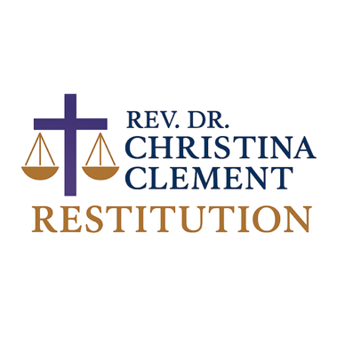
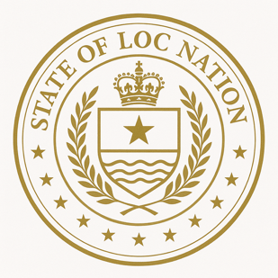
February 5, 2026

PUBLIC INVITATION FOR NATIONAL AND GLOBAL PARTNERSHIP

While I am currently in active discussions regarding a national initiative partnership in the range of $250,000 to $1,000,000, I paused to reflect on something important.

Our initiative builds upon seven years of engagement, including the completion of H.R. 40 research, offering a fully developed framework to guide national and international programs in education, governance innovation, and community development. The work we are advancing—across education, governance innovation, community development, and global cooperation—was never intended to exist within a single institutional relationship. It was built to serve people across all 50 United States and our international relationships, including Ghana and the global African diaspora.

Before formalizing any exclusive partnership, I believe it is both responsible and necessary to extend an open invitation to the broader ecosystem of institutions, universities, foundations, corporations, and global organizations that have historically worked alongside our communities.

This is not simply about funding.
It is about alignment, stewardship, and participation in building infrastructure designed to serve present and future generations.

Over the past seven (7) years, engagement with this work has included:

• Academic engagement, including Harvard framework submissions, Yale honorary degree requests and leadership certification, Georgia State University research engagement and law library usage, and related scholarly access

• Legal, policy, and governance outreach efforts across multiple jurisdictions, including correspondence, submissions, briefings, and community-facing engagement involving U.S. Senators Raphael Warnock and Jon Ossoff; U.S. Representatives Ayanna Pressley and Hank Johnson; members of the Congressional Black Caucus; FCA Authority; civil rights attorney Ben Crump; and engagement with Fulton County, the Cities of Atlanta, East Point, and Decatur, as well as multiple Georgia mayors and municipal offices; District of Columbia Courts; ICJ Practitioners Guide; Federalist papers; Arkansas sandbox; LEI; ISO compliant; Visa Fintech engagement; Secretary of State, Library of Congress, Internet Archive, etc

• Engagement with global educators, nonprofit leaders, and institutional advisors, including the National Action Network, the NAACP, and other national, regional, and community-based organizations

• Humanitarian and development initiatives, including healthcare support efforts serving families internationally through my foundation, with demonstrated implementation in Ghana

Policy and global leadership engagement, including participation in briefings, convenings, and outreach aligned with the U.S. Global Leadership Coalition (USGLC) and related global development and foreign policy forums.

We are now formally opening the opportunity for institutional partners to submit expressions of interest in participating in this national and global framework.

Partnership engagement may include:

• Institutional collaboration
• Strategic advisory participation
• Educational and research alignment
• National and international program implementation
• Financial sponsorship and infrastructure support

Initial partnership participation ranges are currently being evaluated in alignment with national implementation requirements.

Institutions wishing to be considered as founding or strategic partners may submit inquiries or partnership interest through:

www.stateoflocnation.com
or email info@stateoflocnation.com
Subject: SOLN Community Sponsorships

This invitation will remain open during the current partnership review period.

References to individuals and institutions reflect outreach, correspondence, research access, submissions, or independent engagement, and do not imply endorsement, authorization, or affiliation unless expressly stated.

https://archive.org/details/public-sponsorship-invitation

Respectfully,

Rev. Dr. Christina Clement
President
State of Loc Nation Global Public Benefit Corporation

