
Rev. Dr. Christina Clement — Professional Bio

Rev. Dr. Christina Clement is a civil and unalienable rights policy architect, ordained faith leader, author, and public-benefit executive advancing justice, economic accountability, and community empowerment. She is the Founder and President of the State of Loc Nation Global Public Benefit Corporation, a governance and policy framework dedicated to restitution, institutional reform, and equitable economic systems for historically marginalized communities.

Dr. Clement holds a PhD and is an ordained Reverend with a background in legal research, public policy, and civil and unalienable rights advocacy. Her work integrates faith-rooted leadership, legal strategy, and economic justice policy to address systemic inequities in education, housing, finance, governance, and public trust institutions.

She is the creator and host of “The Rev Dr Christina Clements Restitution,” a justice-centered media platform and radio program focused on civil, unalienable rights policy, restitution economics, and institutional accountability. Dr. Clement has authored multiple works on restitution, governance, and economic justice, with publications deposited in the Library of Congress.

Dr. Clement provides Life and Business Coaching, Civil/Unalienable Rights Organization Consulting, Research and Policy Advisory for Foundations and Boards, Civil/ Unalienable Rights Impact Assessments, and Federal Lobbyist Services. She works with organizations and institutions to design equity frameworks, compliance models, and restorative economic policies.
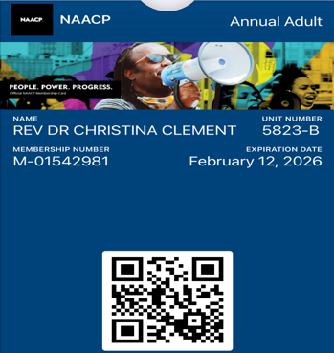
She is a member of the NAACP Georgia State Conference (Unit 5823-B) and is currently working to strengthen member engagement, branch governance participation, and civil/ Unalienable rights institutional capacity in Georgia.

Dr. Clement is a public leader and candidate for elected office, advocating for equity, restitution, and lawful public-trust governance through faith-rooted and policy-driven leadership.

Contact:
Rev. Dr. Christina Clement
cclement@stateoflocnation.com
Mobile: 770-647-3915
Linktree: https://linktr.ee/SOLNSupport
Authored works: https://www.amazon.com/dp/B0GG4MLQ8Q
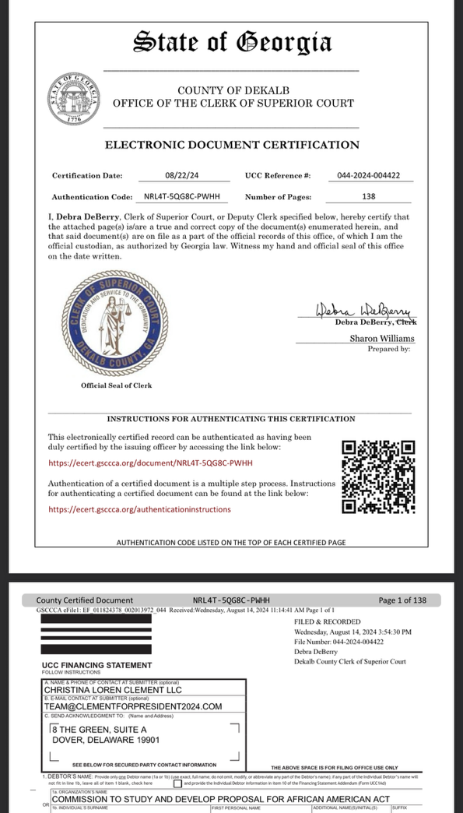
Current Services: http://stateoflocnation.com/about

