Lay Salvatorians, Inc.

April 27, 2020

Greetings:

We are experiencing some strange and difficult times at the moment. It is my prayer that you and your families are well. It seems so very different to be on “house arrest” and not be able to see our extended families and friends. But we are people of Hope and we know that this too, shall pass. We are truly saddened that the National Assembly had to be cancelled, but it is better for us to be safe. Hopefully, we can all be together at the Convocation next year.

Since our fiscal year began on January 1st, we have received $5,979.00 in donations which represents 24% of our budget of $25,000. Our total membership is 143 members and of this date a total of 37 members have contributed which represents 26% of the membership. A big thank you to all our faithful contributors

Presently, we are able to contribute $9,000 from our operating budget to the JLG. This money pays a portion of our share of the Joint Ministries that we support. We also contribute $600 to offset the cost of mailing Update to our members who do not have e-mail. Other expenses are maintaining our website, airfare for the Sector Reps to go to the LSNB meetings (although many of the Sector Reps do not accept reimbursement for this expense.) We also pay our share of dues to the International Community of the Divine Savior. We have come a long way since the days when the Society and Congregation had to support us.

As a reminder, we ask for $25 per month for each member but we understand that may not be possible for all. Many members give more, some less...whatever you can give is very much appreciated. All contributions are tax deductible.

Donations should be sent to Lay Salvatorian Stewardship Appeal, 2207 Shades Crest RD, Huntsville, AL 35801. Lots of folks are now using bill pay, which is an easy way to remember. You just have to set it up once online and then the bank sends the check each month. If that is not convenient, a check is always acceptable. If you need address labels please let me know and I will send them asap.

If you have any questions about the finances, please feel free to contact me. My contact information is in the Salvatorian Directory. I am always glad to hear from you and know that you are always in my prayers.

May our Savior continue to bless each of you.

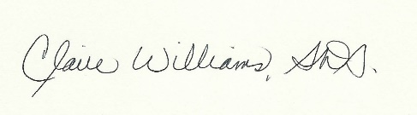

Claire Williams, S.D.S.
Treasurer

