**2021**

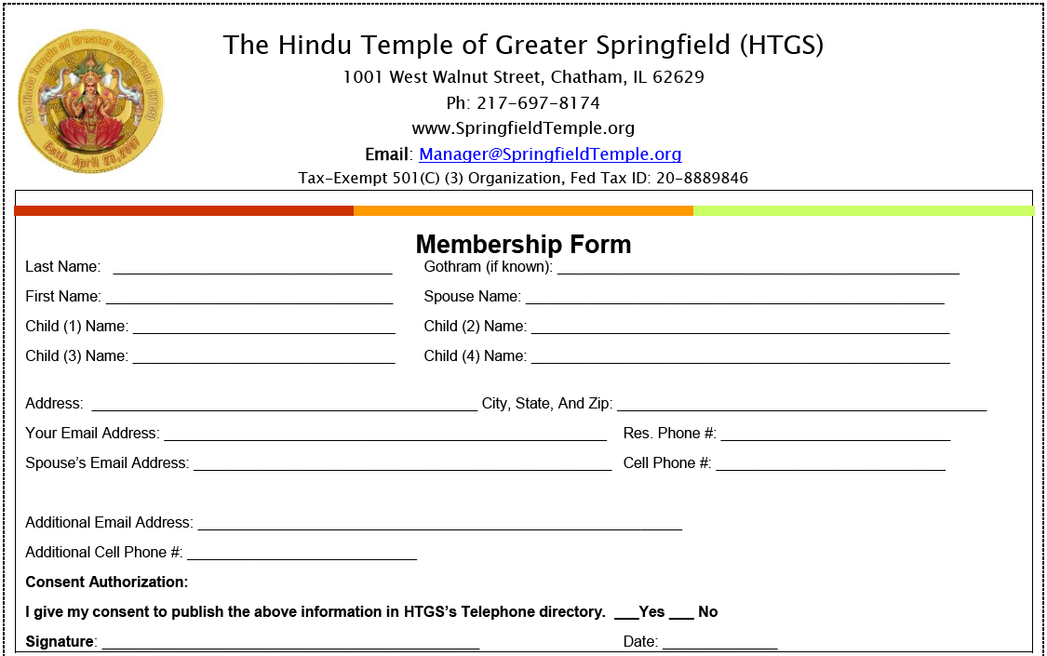



(Any person fulfilling the membership qualifications and has donated a cumulative amount of $ 3000 or more is a Donor member. The Donor members shall comprise of the following eight (8) categories

Life Member: requires a cumulative donation of $3,000 to $4,999 within two (2) consecutive years. Any member with a cumulative donation of $5000 or more is automatically considered a Life Member.)

**Life Member:** requires a cumulative donation of $3,000 to $4,999 within two (2) consecutive years.

Any member with a cumulative donation of $5000 or more is automatically considered a Life Member.

**Patron Member**: requires a cumulative donation of $5,000 to $9,999.

**Grand Patron Member**: requires a cumulative donation of $10,000 to $24,999.

**Benefactor Member**: requires a cumulative donation of $25,000 to $49,999.

**Grand Benefactor Member**: requires a cumulative donation of $50,000 to $ 99,999.

**Ambassador Silver Member**: requires a cumulative donation of $100,000 to $149,999.

**Ambassador Gold Member**: requires a cumulative donation of $150,000 to $199,999.

**Ambassador Platinum Member**: requires a cumulative donation of $200,000 or 249,999.

**Ambassador Diamond Member**: requires a cumulative donation of $250,000 to $299,999

**Regent Member**: requires a cumulative donation of $300,000 or more.

**NOTE:** Currently HTGS members would retain their previously earned Donor category. The donations will be counted in a cumulative manner for a member to achieve a particular Donor category. Only donations that have been actually received (not pledged) will count towards achieving any of the Donor categories. Any donations that receive a service back from the HTGS will not be counted towards above Donor categories. Some examples of such contributions are (but not limited to) annual dues, contributions for puja services, donations dropped in Hundi/Aarathi, Annadatha Program etc.