Get Organized
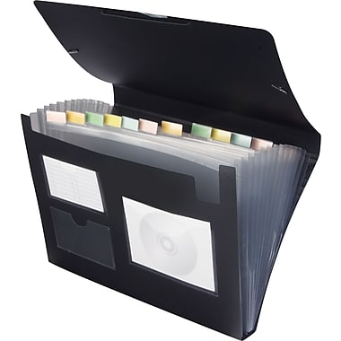
Purchase an Accordion File Folder like the one pictured here:

Label the tabs with the following labels:
- Services
  - Put copies of your service provider list here
  - Put service provider business cards here
- Evaluations
  - Put all medical evaluations here
- Discharge Summaries
  - Keep all discharge summaries from hospital stays and treatment facilities here
- Treatment
  - Put all treatment paperwork here (put options here is child has not yet been to a treatment center)
- Legal
  - Put all Guardianship, Adoption, Foster Care, and other legal documents pertaining to the child here
  - Put police reports here
- Resources
  - Put resources that you can call, are given, or things you plan to read here
- Therapy
  - Put all therapy notes and paperwork here
- Medications
  - Keep your medication list and log here
- Insurance
  - Put all insurance information including EOBs here
- School
  - Put all attendance and IEP information here
- Bills
  - Keep copies of all medical, therapy, and treatment bills here
- County
  - Keep all paperwork from the county here
- Appointments
  - Keep track of all appointments, including missed appointments, and appointments to make here

When the file folder gets too full place all past papers into files labeled the same as the folder in a drawer or box at home.

