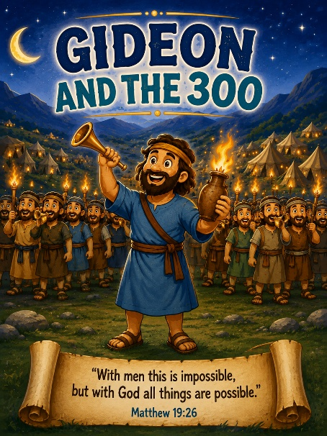
51 Gideon and the 300
Scripture: Judges 7
Memory Verse: "With God all things are possible."
Matthew 19:26
Big Idea: “God can do big things with small things when we trust Him.”

Opening Prayer
"Dear Jesus, thank You for loving us. Help us trust You, even when things seem impossible. Help us remember that You are stronger than anything. Amen."

Bible Story
Last week we learned that God chose Gideon to help His people.
Many, many soldiers came to help Gideon fight the Midianites.
There were 32,000 soldiers! But God said, "That's too many."
God wanted everyone to know that He would win the battle—not the soldiers.
First, God told everyone who was scared they could go home. Thousands left.
Then God took the remaining soldiers to a river. Some soldiers knelt down and drank.
Others scooped water into their hands while staying alert. God chose only THOSE 300 men to stay. Only 300!
That sounds impossible!
God gave each soldier:

- a trumpet
- a clay jar
- a torch inside the jar.

At night they surrounded the enemy camp. When Gideon gave the signal...
BLOW! They blew their trumpets.
CRASH! They broke their jars. The bright torches suddenly lit up.
Everyone shouted, "The sword of the Lord and of Gideon!"
The Midianite army became so confused that they ran away. God won the battle!
God showed everyone that He doesn't need a huge army. He just wants people who trust Him.

Ask the Children

How many soldiers did Gideon start with?
Did God keep all of them?
How many soldiers were left?
What did they carry?
Who won the battle?
Can God help us do hard things too?

Memory Verse Motions
“With God all things are possible.” — Matthew 19:26
Motions: “With God” ➡️ Point up
“all things” ➡️ Stretch your arms out wide.
“are possible.” ➡️ Make a strong muscle with both arms.

- marching version (March in place)
- whisper version
- kitten version
- mouse version

Activity Idea
1.Gideon/s Trumpet Craft / Supplies: Card Stock , crayons/markers, stickers. Decorate with stickers. Roll cardstock into a trumpet shape or use a paper towel tube with a paper cone attached. Write: “God can use me.” Judges 7
2. Torch Craft: Glue orange, yellow, and red tissue paper onto the end of a craft stick or paper towel tube.
Wrap the handle with brown construction paper.
Talk about how the soldiers hid their torches inside the jars.
3. Coloring Page

