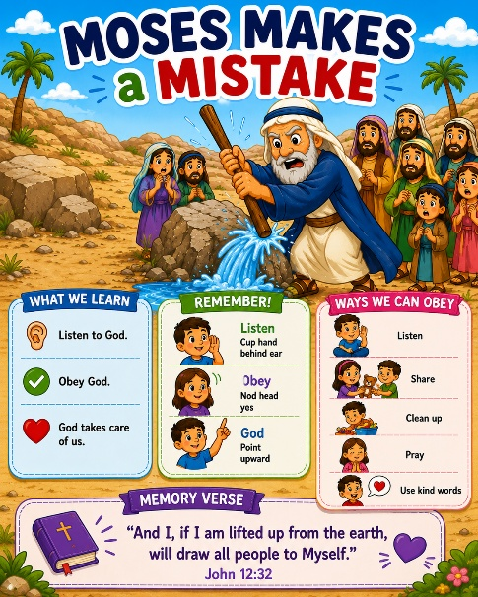
44 Moses Makes a Mistake
Scripture: Numbers 20, 1-12
Memory Verse: “I…will draw all men into Me.”
John 12:32
Big Idea: God still loves us when we make mistakes

Opening Prayer
“Jesus, thank You for loving us even when we make mistakes.
Help us listen, obey, and trust You every day. Amen.”

Bible Story
God’s people were traveling through the desert.
The people became very thirsty. They started complaining because they
wanted water. Moses went to talk to God.
God told Moses to speak to a rock, and water would come out.
But Moses became frustrated and angry. Instead of speaking to the rock, Moses hit the rock with his staff.
Water still came out, and the people got water to drink.
But Moses did not obey God exactly the way God asked.
This story teaches us that obeying God is important.
Even good people can make mistakes, but God still loves us and helps us learn.

Ask the Children

- Were the people thirsty?
- What did God tell Moses to do?
- Did Moses obey exactly?
- Did God still give the people water?
- Do we all make mistakes sometimes?
- Does Jesus still love us when we mess up?

Memory Verse Motions
John 12:32 says:
“And I, if I am lifted up from the earth, will draw all people to Myself.” gently simplify it into something like:
“Jesus draws us close to Him.” Or even: “Jesus wants us close to Him.”
“Jesus” Point upward
“Draws us” Motion hands inward toward chest
“Close to Him” Hug yourself

Activity Ideas
1. Rock and Water Craft: Supplies: gray construction paper rock shapes, blue tissue paper strips or streamers, crayons/markers. Let children glue blue paper “water” coming from the rock.
Optional. Write: “God takes care of us.”
2. Object Lesson: Bring:
- a rock
- cup of water
Ask: “Can water normally come from a rock?”
Explain: “God is powerful and takes care of His people.”
“God also wants us to listen carefully and obey.”
3. Coloring Page

