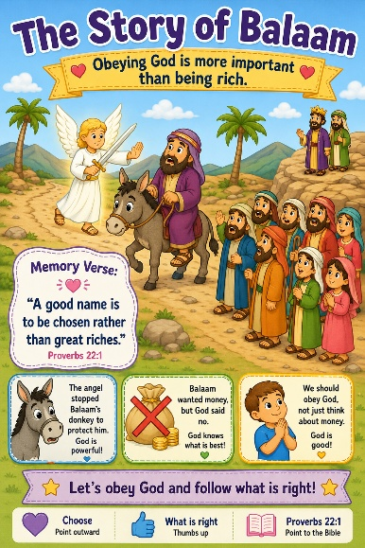
43 The Story of Balaam
Scripture: Numbers 22,23,24
Memory Verse: “A good name is to be chosen rather than great riches.”
Proverbs 22:1
Big Idea: Obeying God is more important than being rich.

Opening Prayer
Dear God,
“Thank You for loving us and helping us make good choices.
Help us listen to You and obey You today. Amen.”

Bible Story
A king wanted Balaam to do something wrong for money.
Balaam wanted the money very much.
So Balaam got on his donkey and started traveling.
But God sent an angel to stop him because God wanted to protect him.
The donkey could see the angel, but Balaam could not!
The donkey stopped walking and would not move. Balaam became angry.
Then God started talking through the donkey and this helped Balaam understand that the donkey was trying to keep him safe. Then God opened Balaam’s eyes in a special way, and he could see the angel. God reminded Balaam to obey Him and do what was right. Balaam learned that obeying God is more important than money.

Ask the Children

- What animal was Balaam riding?
- Could Balaam see the angel at first?
- Could the donkey see the angel?
- Was God helping Balaam?
- Should we obey God?
- Is being kind and obeying more important than money?

Memory Verse Motions
Proverbs 22:1 “A good name is to be chosen rather than great riches.”
Preschool Version:
“Choose what is right.”
“Choose”: Point outward like picking something
“What is right”: Thumbs up
Repeat: with normal voice, whisper voice, loud voice and donkey voice

Activity Ideas
1. Balaam’s Donkey Craft : Use a paper plate for the donkey’s body, clothespins for legs and construction paper for ears. (Optional) Write on it: “I can obey God.”
2. Object Lesson: Bring: coins or fake money, a Bible or heart cutout.
Ask: “Which is more important?”
(point back and forth to fake money/coins and Bible/heart cutout)
Teach: “Doing what is right is more important than money.”

3. Coloring Page

