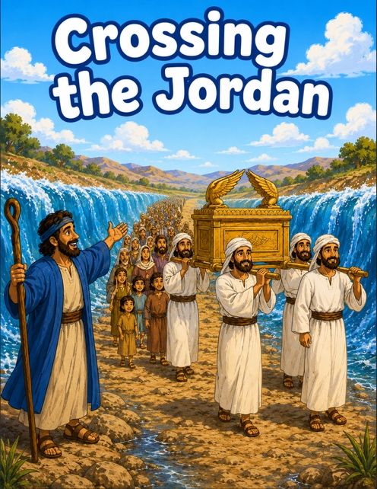
47 Crossing the Jordan
Scripture: Joshua 3; 4
Memory Verse: “Be strong and of good courage”.
Joshua 1:9
Big Idea: “Always trust God’s promises for God makes a way for us.”

Opening Prayer
“Dear Jesus, thank You for helping us and taking care of us.
Help us trust You even when things feel scary or hard. Amen.”.

Bible Story
Joshua was leading God’s people to the Promised Land.
But there was a big problem.
The Jordan River was full of rushing water, and the people did not know
how they would get across. God told Joshua to trust Him.
The priests carried the Ark of the Covenant and stepped into the river first.
Then something amazing happened!
God stopped the water so the people could walk across on dry ground.
Everyone crossed safely because God made a way for them.
Joshua and the people learned they could trust God.

Ask the Children

• Who was the new leader?
• What river did the people need to cross?
• Was the water big and scary?
• What happened when the priests stepped into the water?
• Did God help the people?
• Can we trust God when we feel afraid?

Memory Verse Motions
📖Joshua 1:9 “Be strong and of good courage.”
“Be strong” - ➡️ Flex muscles
“And of good courage” -➡️ Hands on hips like a superhero
Repeat:

- whisper voice
- lion voice 🦁
- giant voice
- grandpa voice

Activity Ideas
1. 🌊 Crossing the Jordan Craft / Supplies : blue construction paper, brown paper path, cotton balls for clouds, crayons/stickers. Glue the brown “dry path” through the blue river. Write: “God makes a way.”
2. Object Lesson: Bring: a cup of water and small rock and something waterproof, such as a glass baking dish. Rush the water into the rocks. Talk about how hard it is to walk through rushing water. Then explain:
“God helped His people cross safely.”
You can even place stones on the floor like the memorial stones Joshua used.

- God helps us
- God keeps His promises
- We can trust God
- God makes a way even when things seem impossible

3. Coloring Page

