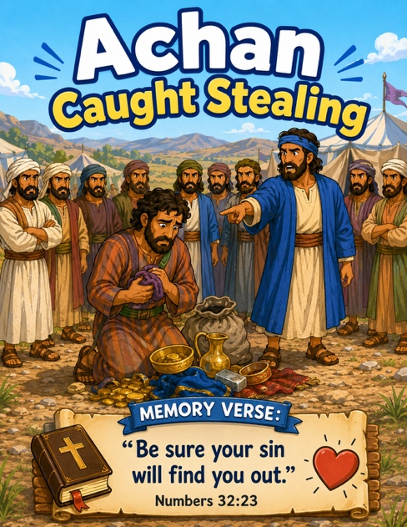
49 Achan Caught Stealing
Scripture: Joshua 7
Memory Verse: “Be sure your sins will find you out.”
Numbers 32:23
Big Idea: “God wants us to tell the truth and obey him.”

Opening Prayer
“Dear Jesus, thank You for loving us. Help us make good choices,
tell the truth, and obey You every day. Amen.”.

Bible Story
God had helped Joshua and the people win a great victory at Jericho.
God told the people not to take special things from the city.
But one man named Achan saw some things he wanted very much.
He took them and hid them.
Achan thought:
“No one will know.”
But God knew.
Later Joshua learned what had happened.
Achan should have told the truth and obeyed God.
We can remember that God helps us make good choices and tell the truth.

Ask the Children

- What was the man's name?
- Did Achan obey God?
- Did he hide things?
- Did God know what happened?
- Should we tell the truth?
- Can Jesus help us make good choices?

Memory Verse Motions
“Be sure your sins will find you out.” — Hebrews 32:23
Motions: “Be sure” ➡️ Point one finger out and nod your head yes
“your sin” ➡️ Point gently to yourself (keep this light for little ones)
“will find you” ➡️ Put hand above eyes like you're searching 👀
“out” ➡️ Open both hands wide toward the class like “There it is!”
You could repeat it:

- marching version 🎺 (March in place)
- whisper version 🤫
- giant version 🦶
- trumpet version 📯

Activity Ideas
1. Truth Heart Craft / Supplies: Paper Heart , crayons/markers, stickers. Decorate with stickers. Write: “I will tell the truth.”
2. Object Activity: Bring: a small toy and/or a blanket or something sparkly. Hide the toy. Have the children look for it. Ask: “Can I still see it?” say: “Even when things are hidden, God sees everything and helps us choose what is right.”
What We Learn

- God helps us make good choices
- We should tell the truth
3. Coloring Page

