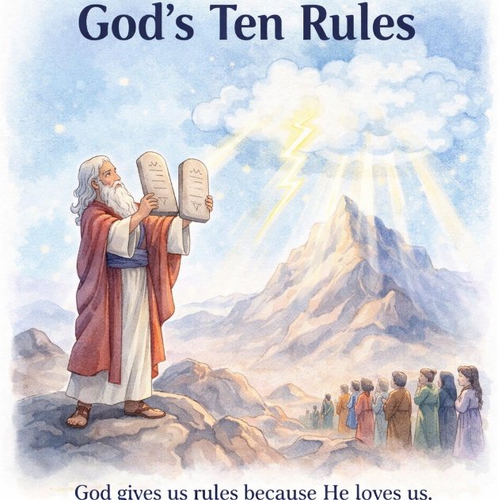
36 God’s Ten Rules
Scripture: Exodus 19–20
Memory Verse: “And this is love, that we walk after
His commandments.” 2 John 6
Big Idea: God gives us rules because He loves us.

Opening Prayer
Dear God, thank You for loving us and guiding us.
Thank You for giving us rules that help us know what is right.
Help us listen to You and follow Your ways. Amen.

Bible Story
After God helped the Israelites escape from Egypt, they traveled
through the desert and came to a large mountain called Mount Sinai.
God had chosen Moses to lead His people. One day Moses climbed up the mountain to talk with God.
God told Moses that He wanted the people to know how to live and how to follow Him. So God said He would give them special rules.
Before God spoke, something amazing happened. There was thunder, lightning, smoke, and the sound of a trumpet. The mountain shook, and the people knew that God was there.
Then God spoke and gave Moses Ten Commandments, which were ten important rules for the people.
Some of these rules taught the people to:

- worship only God
- respect God’s name
- honor their parents
- tell the truth
- treat others kindly

God did not give these rules to make life harder.
He gave them because He loved His people and wanted to help them live the right way.
Even today, God’s Word teaches us how to live and how to love others.

Ask the Children

• Where did Moses go to talk with God?
• What did God give Moses on the mountain?
• How many commandments did God give?
• Why do you think God gives us rules?
• What are some rules that help keep us safe?

Memory Verse Motions
“And this is love” — make a heart with your hands
“that we walk” — pretend to walk with fingers
“after His commandments” — point upward
Repeat three times: normal voice, whisper voice, and robot voice.

Activity Ideas –
1. Rule Sorting Game - Say different rules and let the children decide if they are good rules.

• Share your toys 👍 Look both ways before crossing the street 👍Push someone when you're mad 👎
Share more as necessary. Explain that rules help keep people safe and happy.
2. Mount Sinai Thunder
Have children sit quietly, explain that God showed His power when he spoke on the Mount. Then create the scene together: ○ rub hands together for wind, clap softly for thunder, stomp feet for earthquake
3. Stone Tablet Craft - Cut gray construction paper into the shape of two stone tablets.
Write: “God’s Rules Help Us Live Right.” Let kids decorate them with markers or crayons.

