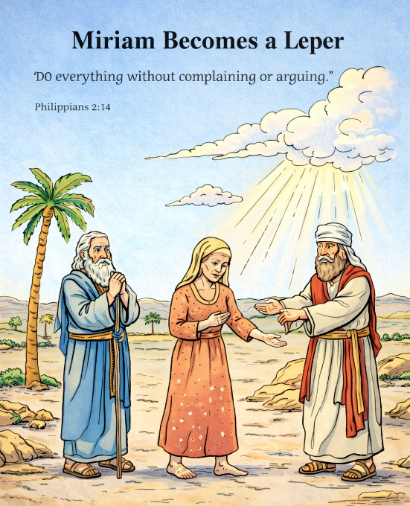
40 Miriam Becomes a Leper
Scripture: Numbers 12:1–16
Memory Verse:“Do everything without complaining or arguing.”
Philippians 2:14
Big Idea: God wants us to have thankful hearts and not complain.

Opening Prayer
Dear God, thank You for loving us and teaching us how to live.
Help us to use kind words and thankful hearts instead of complaining.
Teach us to respect the leaders You have chosen and to trust Your plan.
Amen.

Bible Story
Moses was the leader God had chosen to guide the Israelites through
the wilderness. Moses had a brother named Aaron and a sister
named Miriam.
One day Miriam and Aaron began complaining about Moses. They talked badly about him and questioned why he was the leader. But God had chosen Moses for that special job. God heard everything they said.
God called Moses, Aaron, and Miriam to come to the tabernacle. A cloud came down and God spoke to them. God reminded Miriam and Aaron that Moses was His chosen servant and that they should respect him.
Then something serious happened. Miriam suddenly became sick with a disease called leprosy. Her skin turned white and she had to leave the camp.
Aaron felt terrible and asked Moses to pray for Miriam. Moses loved his sister, so he prayed and asked God to heal her.
God answered the prayer. Miriam had to stay outside the camp for seven days. After that, God healed her and she was allowed to return.
Miriam learned an important lesson. God does not want us to complain or argue. He wants us to trust Him and use kind words.

Ask the Children

• Who were Moses’ brother and sister?
• What did Miriam and Aaron do wrong?
• Did God hear their complaining?
• What happened to Miriam when she complained?
• Who prayed for Miriam to be healed?
• What does God want us to do instead of complaining?

Memory Verse Motions
“Do everything” — spread arms wide
“without complaining” — shake head “no”
“or arguing.” — cross arms in front “Philippians 2:14”
Repeat three times: normal voice, whisper voice, and silly voice.

Activity Ideas –

1. Thankful or Complaining Game: Read sentences and let the children decide if they are thankful/complaining.

“I hate this food.” — complaining
“Thank you for my food.” — thankful
“Why do I have to clean my room?” — complaining
“I’m glad I get to help.” — thankful

Let kids give a thumbs up for thankful and thumbs down for complaining.

2. Thankful Hearts Craft: Give each child a paper heart.
Have them draw or write things they are thankful for inside the heart.
Explain that when we feel like complaining, we can remember the things we are thankful for instead.

3. Coloring Page

