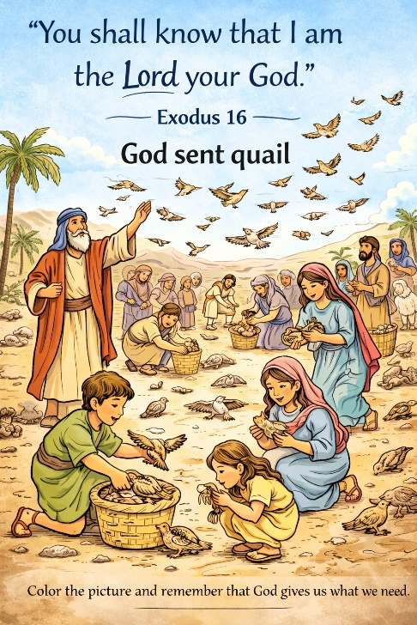
34 God Sends Quail
Scripture: Exodus 16:11–13; Numbers 11:4–35
Memory Verse:
"You shall know that I am the Lord your God."
— Exodus 16:12
Big Idea:
God wants us to be thankful for what He provides.

Opening Prayer
Dear God, thank You for loving us and taking care of us.
Help us to be thankful for the things You give us every day.
Teach us not to complain but to trust You. Amen.

Bible Story
The Israelites had been traveling through the wilderness for a long time.
God had already done many amazing things for them. He freed them from Egypt, parted the Red Sea, gave them water to drink, and sent manna from heaven to eat.
But the people began to complain again. They were tired of eating manna every day and wished they had the food they used to eat in Egypt.
God heard their complaining and told Moses that He would send meat for the people to eat.
The next evening a strong wind blew across the camp and brought thousands of quail (small birds). The birds filled the camp and the people gathered them for food.
God had provided what they asked for. But the people became greedy and gathered too many quail. They ate and ate until many became sick.
This story reminds us that God provides for us, and He wants us to be thankful instead of complaining.

Ask the Children
• What food had God already given the Israelites?
• Why were the people complaining?
• What did God send for them to eat?
• What are some things God gives us that we should be thankful for?

Memory Verse Motions
"You shall know" — point to your head
"that I am the Lord" — point up to the sky
"your God" — hands over heart
Repeat three times:
- normal voice
- whisper voice
- happy loud voice

Activity Ideas –
- Thankful Basket – Have children draw something God has given them. (family, food, pets, friends).
Place drawings in a basket and say together: “THANK YOU GOD!”
- Coloring Page.
- Quail Gathering Game – Scatter cotton balls or feathers around the room. Give each child a cup or bag. Tell them they can ONLY gather 3 quail. After everyone gathers, ask: Was it hard to stop? Why do you think God wants us to be thankful instead of greedy?

