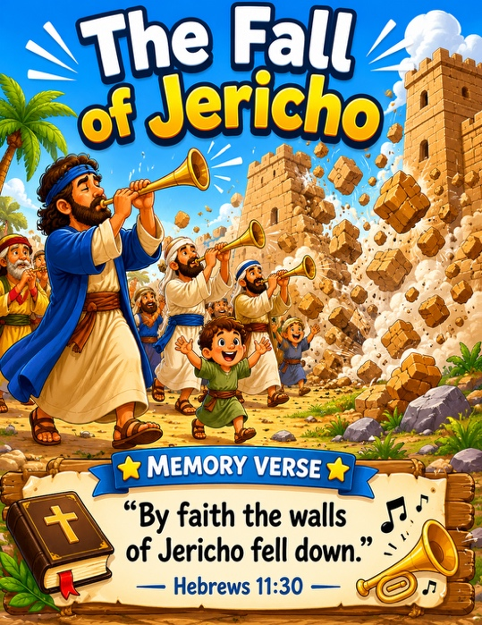
48 The Fall of Jericho
Scripture: Joshua 5:1, 10-15; 6
Memory Verse: “By faith the walls of Jericho fell down.”
Hebrews 11:30
Big Idea: “God will do great things for those who obey him”

Opening Prayer
“Dear Jesus, thank You for loving us and helping us every day. Help us
listen and obey You, even when we do not understand everything. Amen.”.

Bible Story
Joshua and God’s people came to a big city called Jericho.
Jericho had huge walls all around it.
God told Joshua to do something unusual.
Instead of fighting, God told the people to march around the city.
So every day they marched around the walls.
On the seventh day they marched around seven times.
Then the people shouted loudly and blew their trumpets.
Suddenly—
The walls of Jericho came crashing down!
God helped His people because they trusted Him and obeyed Him.

Ask the Children

• What city did God’s people come to?
• Were the walls big or little?
• What did God tell the people to do?
• What happened to the walls?
• Did God help them?
• Should we obey God?

Memory Verse Motions
“By faith the walls of Jericho fell down.” — Hebrews 11:30
Motions: “By faith”. ➡️ Put both hands over your heart
“the walls”. ➡️ Hold both hands up beside you like tall walls
“of Jericho” ➡️ Make a big circle in front of you with your arms (the city)
“fell down”. ➡️ Raise hands high and bring them crashing downward while squatting down
Then on the last part, have them all yell: “BOOM!” 💥
You could repeat it:

- marching version 🎺
- whisper version 🤫
- giant version 🦶
- trumpet version 📯

The marching version fits this lesson especially well because they can march in place while saying it.

Activity Ideas
1. 🧱 Jericho Wall Craft / Supplies: brown construction paper rectangles ("bricks") , glue, crayons/markers. Glue the bricks into a wall. Add: 🎺 little trumpets and 😊 smiling people. Write: “Trust God and obey.”
2. Movement Activity: 🎺 March Around Jericho Use: blocks, chairs, or pillows to make “walls”
Have children: march around the wall, clap softly, march again for seven times counting together. On the last round: “1…2…3…SHOUT!” and knock down the wall.
3. Coloring Page

