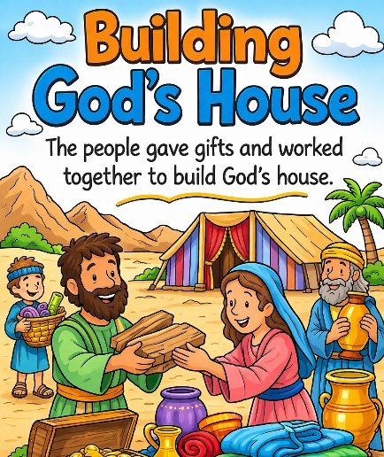
38 Building God’s House
Scripture: Exodus 25:1–9; 35:20–35; 36:3–7
Memory Verse: “Let them make Me a sanctuary; t
that I may dwell among them.” Exodus 25:8
Big Idea: When we love God, we are happy to give and serve Him.

Opening Prayer
Dear God, thank You for loving us and being with us.
Thank You for giving us ways to serve You and help others.
Help us give with joyful hearts and do our best for You. Amen.

Bible Story
God told Moses something very special. God said He wanted the people to build Him a sanctuary, a special place where He could dwell among them.
This special place would be called the Tabernacle, and it would be where the people could worship God.
God gave Moses instructions about how the tabernacle should be built. Moses then told the people what God had said.
The people were excited to help build God’s house.
Some people brought gold and silver. Others brought beautiful cloth, wood, oil, and precious stones. Many people used their special talents to help.
Some women spun cloth and sewed. Some men worked with wood and built furniture. Others helped decorate the tabernacle.
Everyone worked together to build a beautiful place for God.
The people were so happy to give that they kept bringing gifts again and again.
Soon there were more materials than were needed to build the tabernacle. Finally Moses had to tell the people to stop bringing gifts because there was already more than enough.
God was pleased because the people gave willingly and worked together.
This story reminds us that when we love God, we are happy to give, serve, and help others.

Ask the Children
• What special place did God ask the people to build?
• What was God’s house called?
• What kinds of things did the people bring to help build it?
• How did the people feel about giving their gifts?
• What are some ways we can help serve God today?

Memory Verse Motions
“Let them make Me” — point outward
“a sanctuary” — make a roof shape with your hands
“that I may dwell” — place hands over heart
“among them.” — open arms wide
Repeat three times: normal voice, whisper voice, and silly voice.

Activity Ideas –
1. Build God’s House Game: Give children blocks, cups, or small boxes and let them work together to build a “house for God.” Explain that the Israelites also worked together to build the tabernacle.
2. Carry the Gifts Game: Scatter small objects around the room. Have the children carry them one by one to a central “building area,” pretending they are bringing gifts to build God’s house.
3. Coloring Page

