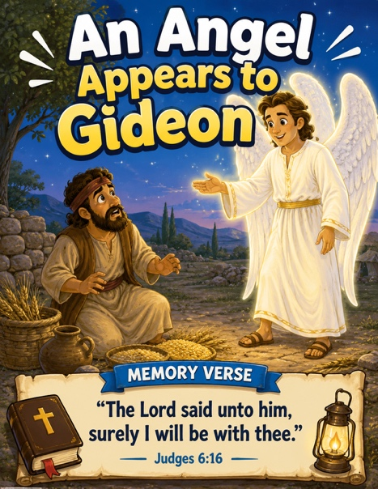
50 An Angel Appears to Gideon
Scripture: Judges 6
Memory Verse: “Surely I will be with thee.”
Judges 6:16
Big Idea: “God helps us when we feel afraid.

Opening Prayer
“Dear Jesus, thank You for loving us and helping us when we feel scared
or nervous. Help us trust You and remember that You are always with us.
Amen.”

Bible Story
Gideon loved God, but he was afraid.
The Israelites were having a hard time because enemies were taking
their food and animals.
One day Gideon was hiding while he worked so the enemies would not
take his food. Then an angel appeared to Gideon!
The angel told him: “God is with you.”
Gideon did not feel brave. He thought: “I’m just an ordinary person.”
But God chose Gideon to help His people. God promised Gideon: “I will be with you.”
And God helped Gideon do hard things.

Ask the Children

- Who appeared to Gideon?
• Was Gideon afraid?
• What did the angel tell Gideon?
• Did God help Gideon?
• Does God help us when we are scared?
• Can we trust God?

Memory Verse Motions
“Surely I will be with thee.” — Judges 6:16

Motions: “Surely I”. ➡️ Point upward
“will be with”. ➡️ Bring hands together
“thee”. ➡️ Point to yourself or to a friend

Repeat:

- whisper voice
- brave voice
- superhero voice 🦸
- tiny mouse voice 🐭

Activity Ideas
1. Ordinary People Mirror Craft / Supplies: small mirrors (possibly from dollar tree). Decorate with stickers. Write: “God can use me.” In permanent marker on the top. Because Gideon thought he was to ordinary to make a difference.
2. Movement Activity: 🦸 Brave Gideon March - Children march around the room pretending to be Gideon’s army. Every few steps stop and say: “God is with me!” Then flex muscles and smile big.
3. Coloring Page

