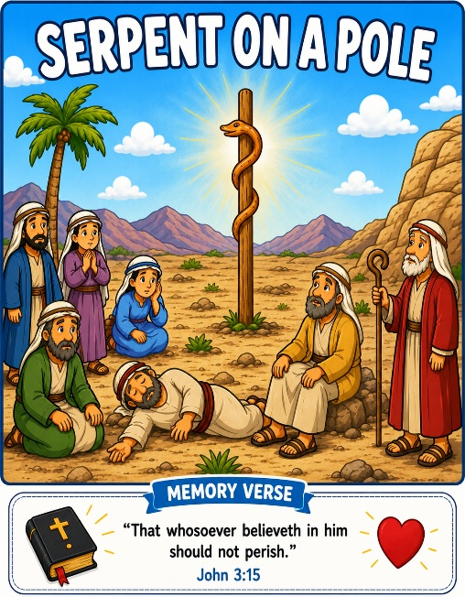
45 Serpent on a Pole
Scripture: Numbers 21:4–9
Memory Verse: “That whosoever believeth in him should not perish.”
John 3:15
Big Idea: “Jesus helps us when we trust Him.”

Opening Prayer
“Dear Jesus, thank You for loving us and helping us every day.
Help us trust You and look to You when we need help. Amen.”.

Bible Story
God’s people were traveling in the wilderness again.
The people became grumpy and complained.
They forgot how much God had already helped them.
Then poisonous snakes came into the camp, and many people became
sick and scared. The people told Moses they were sorry.
God told Moses to make a bronze serpent and put it on a pole.
When the people looked at it and trusted God, they were healed.
This story reminds us to look to Jesus and trust Him because Jesus helps us and loves us.

“Did you know doctors sometimes use a picture of a snake on a pole as a symbol for healing? Long ago in the Bible, God used a serpent on a pole to help heal the people and teach them to trust Him.”

Ask the Children

- Were the people complaining?
- What came into the camp?
- Were the people scared?
- What did God tell Moses to make?
- What happened when the people looked at the serpent on the pole?
- Who helps us when we are afraid?
- Can we trust Jesus?

Memory Verse Motions
📖 John 3:15 “That whosoever believeth in him should not perish.”
“That whosoever believeth” Fold hands over heart
“in him” Point upward
“should not perish” Make a motion as if you are calling someone safe on base.
Repeat: whisper voice, loud voice, and snake voice.😂

Activity Ideas
1. Serpent on a Pole Craft: Supplies: popsicle stick or straw, pipe cleaner or paper snake, crayons/markers Wrap the snake around the stick. Optional. Write: “Trust Jesus.”
2. Object Lesson: Bring:
- toy snake or picture of a snake
- cross picture
Say: “The people looked up and trusted God.”
Then point to the cross/picture of Jesus: “We can look to Jesus and trust Him too.”

3. Coloring Page

