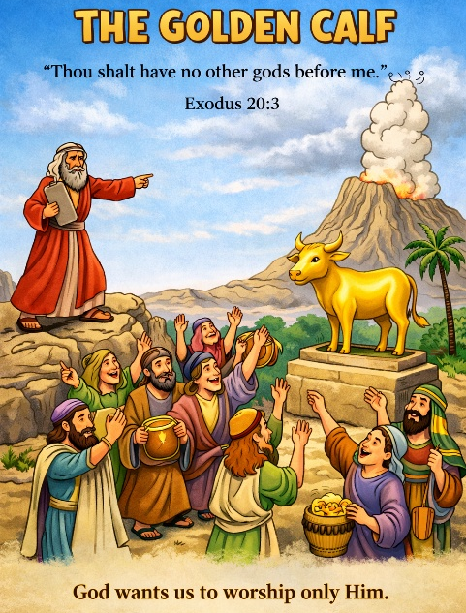
37 The Golden Calf
Scripture: Exodus 20:3–6; 31:18; 32; 34
Memory Verse: “Thou shalt have no other gods before me.”
Exodus 20:3
Big Idea: God wants us to love and worship Him above everything else.

Opening Prayer
Dear God, thank You for loving us and caring for us every day.
Help us remember that You are the one true God.
Teach us to trust You and always put You first. Amen.

Bible Story
Moses had gone up Mount Sinai to speak with God. The top of the mountain
was covered with a cloud showing God’s presence.
Day after day the people waited for Moses to return, but he did not come down right away. The people became impatient and worried.
They began saying, “We need a god we can see.”
So they went to Aaron, Moses’ brother, and asked him to make them a god. Aaron told the people to bring their gold jewelry. The people brought their earrings, and Aaron melted the gold in the fire. Then he shaped it into the form of a calf.
When the people saw the golden calf, they began celebrating. They danced and sang around the statue.
But this made God very sad, because He had already told His people that they should worship only Him.
God told Moses what the people were doing. Moses quickly came down the mountain carrying the stone tablets with God’s commandments written on them.
When Moses saw the people dancing around the golden calf, he was very upset. The people had forgotten about the true God who had rescued them from Egypt.
Moses prayed to God and asked Him to forgive the people.
God heard Moses’ prayer and gave the people another chance.
This story reminds us that God wants us to love and worship Him above everything else.

Ask the Children
• Where had Moses gone to talk with God?
• Why did the people become impatient?
• What did Aaron make out of gold?
• Why was God unhappy with what the people did?
• What did Moses do for the people?

Memory Verse Motions
“Thou shalt have” — point outward
“no other gods” — shake head “no”
“before me” — point upward
Repeat three times: normal voice, whisper voice, and grandpa voice.

Activity Ideas –
1. True God or Not Game: Show or say different objects and ask the children if they could be our god.
• A rock ❌• A toy ❌• Money ❌• God in heaven ✅ Explain that only God deserves our worship.
2. Waiting Game: Have the children sit quietly for a moment and pretend they are waiting for Moses to come down the mountain. Explain that sometimes waiting is hard, but we should still trust God.
3. Coloring Page

