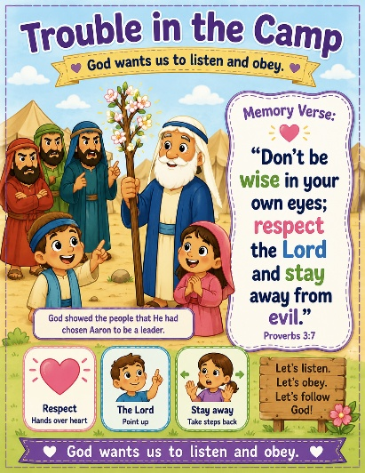
42 Trouble in the Camp
Scripture: Numbers 16,17
Memory Verse: “Don’t be wise in your own eyes; respect the Lord and
stay away from evil.” Proverbs 3:7
Big Idea: “God wants us to respect and listen to godly leaders.”

Opening Prayer
“Dear Jesus, thank You for loving us and guiding us. Help us learn how to
respect others and follow You with good hearts. Help us listen and obey even
when it’s hard. Amen.”

Bible Story
The Israelites were upset because they could not go into the Promised Land yet.
Moses had told them they needed to go back into the wilderness because the people had not trusted God.
Some men named Korah, Dathan, and Abiram became angry. They gathered many people together and complained about Moses and Aaron. They said, “Why should we listen to you?”
But Moses and Aaron were chosen by God to lead the people. Moses warned everyone to stay away from the tents of the men who were rebelling.
Then something amazing happened. The ground opened up and swallowed Korah and the others who refused to listen to God. The people learned that God wanted them to respect the leaders He had chosen.
Later, God told each tribe to bring a rod with their name on it. Aaron’s rod was placed with the others overnight. The next morning, Aaron’s rod had blossomed with flowers and almonds! This showed everyone that God had chosen Aaron to be a leader.
The people learned that God wants us to respect His leadership and trust Him.

Ask the Children
• Were the people listening nicely?
• Did God choose Moses and Aaron?
• What grew on Aaron’s stick?
• Do flowers normally grow overnight?

• Who should we listen to?
- Mommy?
- Daddy?
- Teachers?
- Jesus?

Memory Verse Motions
“Respect the Lord” — point upward
“Stay away” — Take two big step backward, or lean far back in your seat.
“From evil” — Shake head no. “Proverbs 3:7”
Repeat three times: Faster each time you say it.

Activity Ideas
1. Blooming Rod Craft: popsicle sticks or paper strips, markers/crayons, fake flowers/stickers,. tape/glue
Let each child decorate a “rod” like Aaron’s rod. Add flowers to the top to remind them that God chose Aaron.
“Just like Aaron’s rod bloomed, God showed the people who He had chosen.”
2. Movement Activity: Pretend to:
- stomp feet while “complaining”
- then stop
- fold hands
- listen quietly
This helps them physically practice the lesson.

3. Coloring Page

