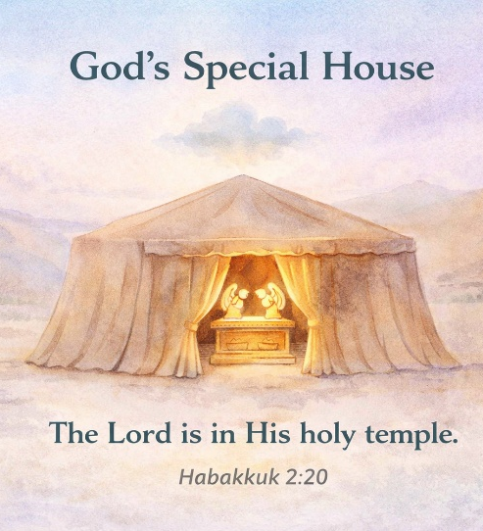
39 God’s Special House
Scripture: Leviticus 16; Hebrews 9
Memory Verse: “The Lord is in His holy temple.”
Habakkuk 2:20
Big Idea: God wants us to worship Him.

Opening Prayer
Dear God, thank You for loving us and wanting to be close to us.
Thank You for giving us places where we can worship You and
learn about You. Help us remember that we can worship You
every day. Amen.

Bible Story
After the Israelites finished building the Tabernacle, God’s special house was ready.
The Tabernacle was a place where the people could come and worship God. It was built exactly the way God had instructed Moses.
Inside the Tabernacle were special rooms. One room was called the Holy Place. In that room were special items used for worship, including a golden lampstand and a table with bread.
Behind a curtain was another room called the Holy of Holies. This was the most sacred room in the Tabernacle.
Inside the Holy of Holies was a golden chest called the Ark of the Covenant. In the Ark were special reminders of God’s promises. There were stone tablets with the Ten Commandments, a jar of manna, and Aaron’s rod.
Two golden angels were placed on top of the Ark.
Only the high priest could go into the Holy of Holies, and he could only go there once each year.
This special place reminded the people that God is holy and that He deserves our worship.
Today we know something wonderful. Because of Jesus, we can talk to God anytime and anywhere.
God wants us to worship Him every day.

Ask the Children
• What was the special place the Israelites built for God?
• What was the most sacred room in the Tabernacle called?
• What special chest was kept in that room?
• What were some things inside the Ark of the Covenant?
• Where can we worship God today?

Memory Verse Motions
“The Lord” — point upward
“is in His” — place hands over heart
“holy temple.” — make a roof shape with hands
Repeat three times: normal voice, whisper voice, and baby voice.

Activity Ideas –
1. Tabernacle Walk: Tape two areas on the floor labeled Holy Place and Holy of Holies. Let the children walk through the first area but explain that only the high priest could go into the second room.

The Ark of the Covenant Craft
- Give each child a small box and have them cover it with gold paper or color it gold.
- Cut out two small angel shapes or wings from paper - glue to the top of the box to represent the angels over the Ark of the Covenant.
- Let children decorate their ark with markers or stickers.
Explain that the Ark was kept in the Holy of Holies, the most special room in God’s house.
3. Coloring Page

