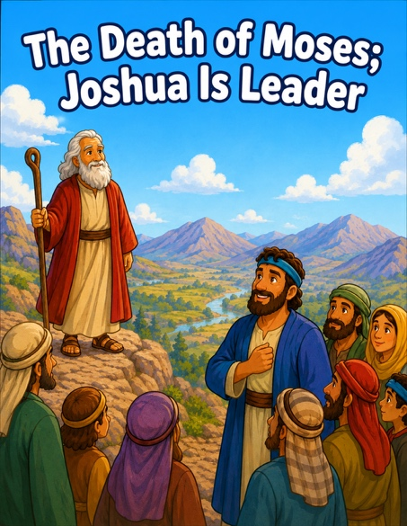
46 The Death of Moses; Joshua is Leader
Scripture: Deuteronomy 34:1-12; Joshua 1:1-11; Jude 9
Memory Verse: “Be strong and of good courage”.
Joshua 1:9
Big Idea: “God helps us be brave.”

Opening Prayer
“Dear Jesus, thank You for loving us and helping us when we feel
scared. Help us be brave and trust You. Amen”.

Bible Story
Moses had led God’s people for a very long time.
One day, God showed Moses the beautiful Promised Land from far away.
Then Moses died, and the people were very sad because they loved him.
But God already had a new leader ready. His name was Joshua.
Joshua may have felt nervous and afraid.
But God spoke to Joshua and said:
“Be strong and brave.”
God promised Joshua:
“I will be with you.”
Joshua learned that God would help him lead the people.
And we can remember that God helps us too.

Ask the Children

- Who had been leading the people?
• What was the new leader’s name?
• Do you think Joshua felt nervous?
• What did God tell Joshua?
• Does God help us when we feel afraid?
• What are some things that make you nervous?

Memory Verse Motions
📖Joshua 1:9 “Be strong and of good courage.”
“Be strong” - ➡️ Flex muscles
“And of good courage” -➡️ Hands on hips like a superhero
Repeat:

- whisper voice
- lion voice 🦁
- giant voice
- superhero voice

Activity Ideas
1. Craft Idea ⭐ Brave Joshua Shield - Supplies: Paper plate or cardstock shield, crayons/markers, stickers, foil pieces (optional) Write: Be strong and brave. Optional: Add a cross or heart sticker.
2. Object Lesson: Bring: a flashlight
Turn lights off slightly if possible.
Say:“Sometimes things feel scary in the dark.”
Turn on flashlight: “God helps guide us and stay with us.”
Then connect: “Joshua was brave because God was with him.”

• God helps us
• God is always with us
• We can be brave
• God gives us helpers and leaders

3. Coloring Page

