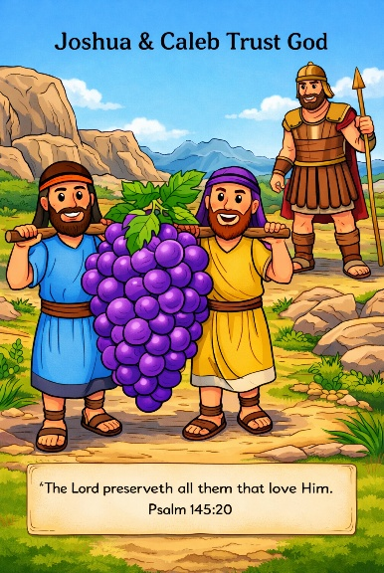
41 Afraid of Giants
Scripture: Numbers 13:1–3, 17–33; 14
Memory Verse: “The Lord preserveth all them that love Him.”
Psalm 145:20
Big Idea: God will take care of us, so we do not need to be afraid.

Opening Prayer
Dear God,
Thank You for always watching over us and protecting us. Help us
remember that You are bigger than anything that makes us afraid.
Teach us to trust You and be brave like Joshua & Caleb.Amen.

Bible Story
The Israelites had been traveling through the wilderness for a long time. Finally, they came to a place called Kadesh, which was close to the land God had promised them.
God told Moses to send twelve men to explore the land of Canaan. These men were called spies because they went to look around and see what the land was like. Moses chose one man from each tribe of Israel.
Moses told them to see what the land and people were like. Were they strong or weak? Were the cities safe?
The spies went into the land and explored it for many days. When they returned, they brought back fruit from the land. One bunch of grapes was so big that two men had to carry it on a pole.
The spies told the people, “The land is very good and rich.” But then ten of the spies began to talk about the problems. They said, “The people there are very strong. Their cities have tall walls. And there are even giants in the land. We looked as small as grasshoppers next to them!”
When the people heard this, they became very afraid. But two of the spies, Joshua and Caleb, trusted God.
They said to the people, “With God on our side, we can go into the land. God will help us win!”
Sadly, the people listened to the ten spies who were afraid instead of Joshua and Caleb. They cried and complained all night. Some even said, “Let’s choose another leader and go back to Egypt.”
Joshua and Caleb tried to encourage them again. They reminded the people that God was with them and would help them. But the people refused to trust God. Because they did not believe Him, God said the Israelites would have to wander in the wilderness for forty years.
But God promised that Joshua and Caleb, who trusted Him, would one day enter the promised land.
This story reminds us that when we remember how powerful God is, we do not have to be afraid.

Ask the Children

• How many spies went to explore the land?
• What big fruit did the spies bring back?
• What scared the people?
• Which two spies trusted God?
• What should we remember when we feel afraid?

Memory Verse Motions
“The Lord” — point upward
“preserveth” — wrap arms around yourself like protection
“all them that love Him” — make a heart with your hands “Psalm 145:20”
Repeat three times: normal voice, whisper voice, and loud brave voice.

Activity Ideas
1. Giant Grapes Craft 🍇Give each child a grape stem cut from green paper. Glue bigger purple circles under it to make a huge bunch of grapes.
2. Giant Foot: Cut a giant foot out of a piece of paper. Have the children decorate the foot. Write on the foot: “God is bigger than giants!”

3. Coloring Page

