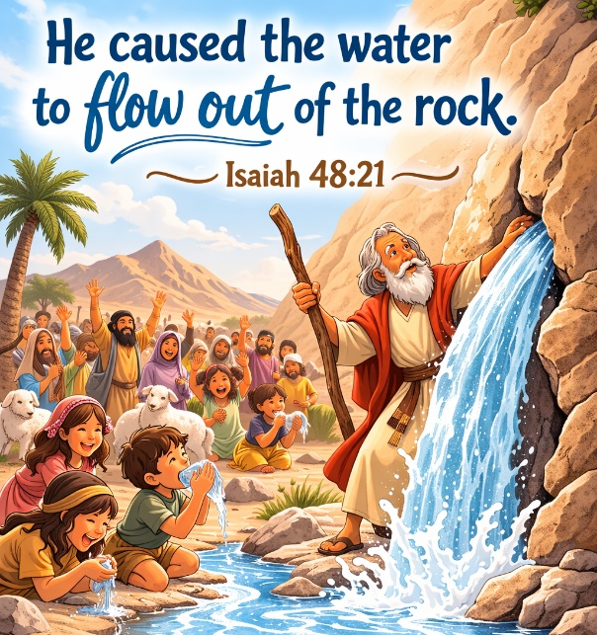
35 When Water Flowed from a Rock

Scripture: Exodus 17

Memory Verse:
“He caused the water to flow out of the rock.”
— Isaiah 48:21

Big Idea: God will take care of our needs.

Opening Prayer
Dear God, thank You for loving us and taking care of us.
Help us trust You when we worry or when things are hard.
Thank You for giving us what we need every day. Amen.

Bible Story
The Israelites were traveling through the hot, dry desert on their way to the land God had promised them. The desert was brown and dusty, and there was no water anywhere.
Soon the people began to worry because their water was almost gone. They were hot, tired, and very thirsty. The people began to complain and said to Moses, “Give us water to drink!”
Moses was worried, so he prayed to God for help.
God told Moses to take his staff and go to a large rock. God said that when Moses struck the rock, water would come out for the people.
Moses obeyed God. When he struck the rock with his staff, something amazing happened. Water came rushing out of the rock!
There was enough water for everyone to drink, including the people, their children, and their animals.
Once again, God showed the Israelites that He would take care of their needs.

Ask the Children
• Why were the Israelites worried?
• What did the people ask Moses for?
• What did Moses do when the people complained?
• What happened when Moses struck the rock?
• What does this story teach us about God?

Memory Verse Motions
“He caused the water” — wiggle fingers downward like falling water
“to flow out” — move hands outward
“of the rock” — make fists like a rock
Repeat three times:
- normal voice
- whisper voice
- grandma voice

Activity Ideas –
1. Water From the Rock Demonstration
Bring a sponge soaked in water and hide it behind a rock. When you squeeze the sponge, water flows out. Explain that normally rocks do not give water, but God performed a miracle for His people.
2. Thirsty Travelers Game
Have the children pretend to walk through the desert. Say: “It’s hot!” (wipe forehead) “I’m thirsty!”
Then shout: “God gave them water!” and everyone pretends to drink big gulps.
3. Coloring Page

