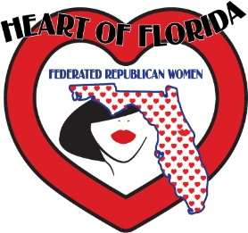

HEART OF FLORIDA FEDERATED REPUBLICAN WOMEN

Application for membership

Last Name:______________________________ First:____________________________________________

Address:_____________________________________City/State:_________________Zip:______________

Cell:__________________________ Email:______________________________ DOB:___________________

Spouse’s Name:_______________________________________ Active/Retired Military?: Yes No

Membership Type: NEW $50_____RENEWAL $50______MALE $25_______ASSOC $25______ IF applying for Assoc Mem - indicate which Federated Club you are active in:

_____________________________________________________________________________________________

What do you feel are the most important issues/topics facing our community today?:

_____________________________________________________________________________________________

What do you feel are the most important issues/topics facing our Nation today?:

_____________________________________________________________________________________________

What are your talents/areas of expertise to best contribute to our organization?

_____________________________________________________________________________________________

Would you be interested in: Legislation Historian Advocacy/Mentor

Community Engagement Political Action Membership Public Relations

Special Events Program/Speakers IT/Website Newsletter Campaign Activities

BY SIGNING THIS APPLICATION, I CERTIFY I AM A REGISTERED REPUBLICAN.

Signature:______________________________________________ Date:_____________________________

Make Checks payable to: Heart of Florida Federated Republican Women

Please return this completed and signed application and payment to:

Heart of Florida Federated Republican Women * 516 W New York Ave., DeLand, FL 32720

May 2022