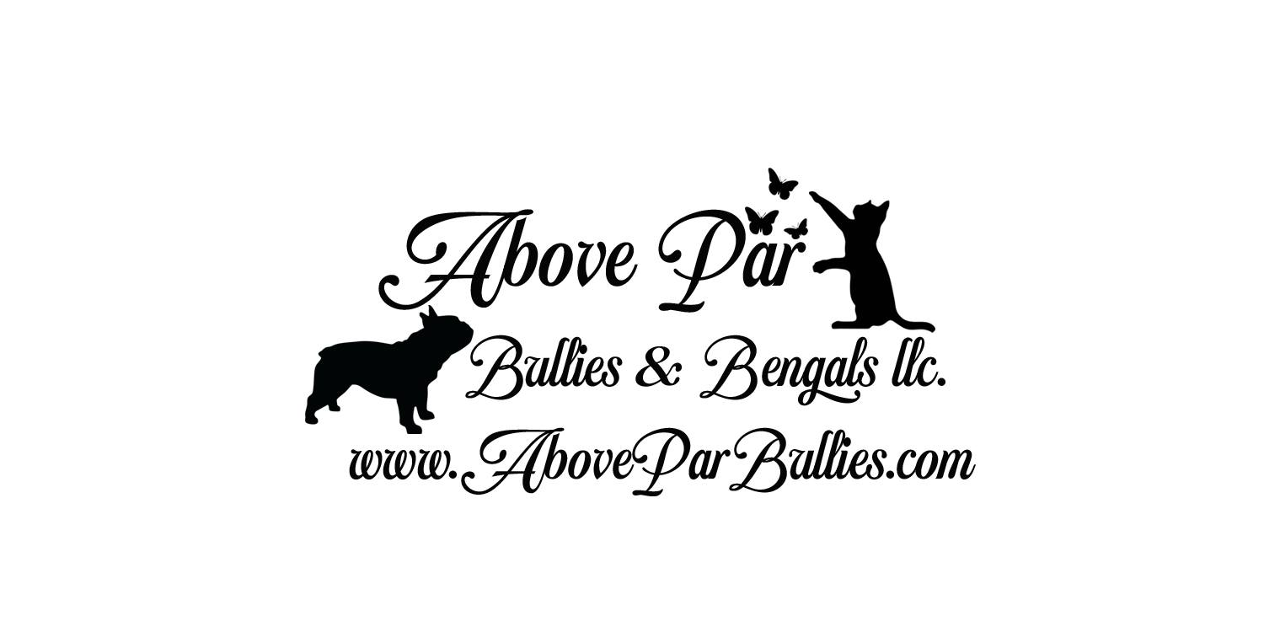
Danielle& Travis Weakley
Phone (573)590-2818
Email AboveParBullies@gmail.com
www.AboveParBengals.com

BENGAL KITTEN CONTRACT OF SALE
This Agreement (“Agreement”) is entered into between Danielle Weakley of Above Par Bullies &
Bengals LLC.
(“Seller”) and _________________(“Purchaser”). IN CONSIDERATION of the sum of
$___________ (“Purchase Price”), Seller grants, conveys and transfers the following kitten
(“Kitten”) to Purchaser.
DESCRIPTION OF BENGAL KITTEN
Breed: Bengal Color: _______ Sex: _______ Birth Date:_______
Sire:______________________of Above Par
TICA: _________yes_______________
Dam:_______________________of Above Par
TICA: _______yes_________________
Purchaser has paid a non-refundable deposit of $800.00 which is non refundable, however is
transferable to a future kitten, this deposit is to hold the kitten for the Purchaser.
The deposit shall be applied towards the Purchase Price, which is due and payable on or before
_________or when the Kitten is collected, whichever is earlier. In the event the Seller is
Unable to sell Kitten to the Purchaser, for reasons including, but not limited to, the Kitten’s mortality,
Seller has the option of refunding the deposit or replacing the Kitten with a kitten of similar
quality (Seller’s choice). Seller shall have 12 months to provide a replacement kitten to the Purchaser.
Purchase Price does NOT include the cost of shipping the Kitten. There will be a fee of $250 for us to
meet you or a ground shipper. Seller warrants that Kitten is healthy and in good condition at the time
he/she is shipped to Purchaser, as evidenced by the veterinarian’s health certificate, which shall
accompany Kitten. Seller is NOT responsible for any injury or damage to the Kitten after Kitten is left
with you or the ground shipper.
Seller guarantees that the kitten/cat is purebred and eligible for registration in the International Cat
Association (TICA)
All sales are final. No returns, refunds, or exchanges except what is outlined by the terms of this
agreement.
ALL REMAINING BALANCE AND SHIPPING FEES ARE DUE NO LATER THAN 14 DAYS
PRIOR TO SHIPPING DATE.
Buyers Initials_________

TERMS AND CONDITIONS
Above Par will be listed at the front of the cats name on any website or ad as his/her full
registered name is written.
Purchaser acknowledges that they have been provided with a copy of Above Par’s
Care Sheet and that Purchaser has read and understood the contents of the Care Sheet.
Purchaser further agrees that Purchaser will follow all the important guidelines and
suggestions outlined in the Care Sheet, since Purchaser’s failure to do so may lead to
adjustment issues with Purchaser’s Kitten. Purchaser further agrees that they will review the
care sheet prior to contacting Seller with behavior issues, since this issue may be covered by
the Care Sheet.

(1) Kitten shall live mainly indoors. Purchaser shall not allow Kitten to roam outside, unless
Kitten is harnessed and leashed or in a Cattery and accompanied by a responsible adult. See kitten care
sheet for harness recommendation

(2) Kitten is sold only as a pet. The kitten will be spayed/neutered prior to leaving the seller’s home.

(3) Kitten shall not be sold, leased, given away, abandoned to a shelter, pound, pet shop,
research laboratory, humane organization, or any similar facility. If Purchaser is unable to care
for the Kitten, Purchaser shall notify Above Par immediately. The kitten will be required to be returned
to Above Par, no monetary amount will be returned to Purchaser Seller.

(4) Purchaser agrees that it will feed Kitten the same food that Kitten was eating at the Seller's
premises, and any changes to the Kitten's diet will be done gradually. Any sudden changes to the
Kitten's diet may result in diarrhea.

(5) Purchaser agrees to never mutilate or declaw a Above Par cat including
tendonectomy and Ventriculocordectomy (ANY MUTLILATION other than dessexing voids all
health guarantees) If we find any Above Par kitten or cat to have been mutilated as said above, legal
action will be taken. You will be sued for a fine of $5000.00 and the removal of the cat from
your possession. All court fees and lawyer fees are to be paid by the purchaser.

(6) Purchaser agrees that they will feed the Kitten the same food that Kitten was eating at the
Seller's premises and any changes to the Kitten's diet will be done gradually. Any sudden
changes to the Kitten's diet may result in diarrhea.

(7) If, in Seller’s opinion, Kitten is neglected or mistreated, Purchaser shall surrender Kitten to Seller
unconditionally. “Neglect” or “mistreatment” shall include, but not be limited to, leaving Kitten alone
without human companionship for periods in excess of 72 hours, lack of proper sanitary facilities, lack
of proper veterinary/medical attention, lack of food or water, or physical abuse. Any and all fees
associated with the recovery of Kitten shall be paid by the Purchaser, including, but not limited
to, any and all court costs and attorney’s fees.

(8) Seller makes no guarantees as to the Kitten’s temperament. We pride ourselves on
socializing our kittens, but we cannot predict how the Kitten will act after it leaves the familiar
environment of our cattery and its litter mates. It is Purchaser’s responsibility to slowly
transition Kitten to its new home (see kitten care sheet). Purchaser acknowledges that some
kittens may take longer than others to adjust to their new surroundings. Purchaser must notify
Seller immediately if the kitten is not transitioning well into its new home (e.g. not using the
litter box, has diarrhea) so that Seller is made aware of any issues. If Purchaser has any Buyers
health or behavior concerns about the Kitten, Purchaser must notify Seller of its concerns
immediately. We cannot help you with these concerns if we are not aware of them. If more
than 2 weeks have passed before Purchaser notifies Seller of these issues, Seller disclaims any
liability of responsibility for these issues.

(9) Purchaser shall take the Kitten to the Purchaser's veterinarian at least once every 12
months for annual physical examinations. Purchaser needs to ensure that a full physical
examination (including, but not limited to, an eye exam, ear exam, auscultation) is undertaken.
Purchaser shall make all reasonable efforts to keep in contact with the Seller, and keep Seller
updated on Kitten's health. If you are going to put in a claim against the Health Guarantee you
must give access to ALL the Vet records with Danielle Weakley of Above Par Bullies & Bengals LLC.
No replacement kitten will be given without All vet recorders provided.

(10) Seller shall provide the registration papers for the Kitten to the Purchaser within a
reasonable time of Purchaser’s presentation of a veterinarian’s certificate of spaying or
neutering of the Kitten and the provided: Proof of Alter” form. (If seller has already Early
Spayed or Neutered the Kitten, the registration papers will be given within 30 days of purchaser
receiving the kitten.)

(11) This sale is final and there are no cash refunds.

(12) We take pride in our Bengals and we hope you do too. We would greatly appreciate it if
you would mention and tag “Above Par Bullies & Bengals” on your social media posts and if/when
people ask where you got your lovely Bengal from, this also insures that we see updates which we
greatly appreciate!
Buyers Initials_________
(13) Purchaser agrees to allow Danielle Weakley of Above Par to share photos Purchaser posts on
social media or sends to Above Par. No photos of people will be shared without faces blocked to keep
your privacy unless Purchaser states otherwise.

HEALTH RECORD
Purchaser understands that Above Par Bullies & Bengals LLC gives vaccines and deworming themselves.
Kittens are given dewormer at 4,6,8, and 12 weeks of age, they are given Baycox at 13 weeks of age for
3 days. We have made the choice to give our kittens the Feline UltraNasal FVRCP. FVRCP protects your
cat against feline Rhinotracheitis, Calicivirus, and Panleukopenia. It provides rapid immunity in both cats
and kittens with a single dose which we find to be a great feature to prevent over vaccination. Also it is a
intranasal vaccine which eliminates the worry of injection site sarcomas. It’s also given at 12 weeks
which is also comforting as it gives kittens time to mature a bit more

HEALTH GUARANTEE
ALL VET INFORMATION MUST INCLUDE MICROCHIP VERIFICATION/SCAN
Seller warrants that Kitten is sold in good health at the time Kitten leaves Seller's premises.
Seller further warrants that Kitten has undergone a physical examination by Seller's
veterinarian prior to Kitten leaving Seller (including, but not limited to, an eye exam, ear exam,
auscultation), and that Seller was not aware of any health issues (including, but not limited to,
upper respiratory infections, diarrhea) at the time Kitten leaves Seller's premises. However, the
stress from the change in environment (especially if the Kitten is shipped) may cause the
Kitten to “break” with an infection, even though the Kitten showed no clinical signs of an
infection when it left Seller’s premises. This is why it is important for the Kitten to be checked
within 72 hours of receipt.

INITIAL_________
Unless otherwise agreed between the parties in writing, the Purchaser has 72 hours of receipt of the
Kitten to have Kitten examined by Purchaser's veterinarian. Purchaser shall provide Seller with proof
of the examination upon Seller’s request. Further, any questionable findings by the veterinarian shall
immediately be reported, in writing, to the Seller. If the Kitten is found to be medically deficient with a
terminal or life-threatening problem, Seller shall refund the Purchase Price in full or replace Kitten with
another of like kind and quality (Seller’s choice), as soon as a replacement is available. All veterinary
expenses and return shipping-related expenses are the responsibility of the Purchaser. Seller’s health
guarantee shall be null and void if Kitten is exposed to other animals within the first fourteen (14) days
of Purchaser receiving the Kitten AND/OR if Kitten is not examined by Purchaser’s veterinarian within
72 hours.
INITIAL_________

Kitten is guaranteed against congenital defects for a period of twelve (12) months after
the date of birth. If the Kitten dies due to a congenital defect within these twelve (12)
months, Seller shall refund the Purchase Price (minus vetting fees of $500) or replace Kitten
with another of like kind and quality (Seller’s choice), as soon as one is available. Purchaser
must provide the veterinarian or specialist’s written report, confirming, in writing with a
Necropsy, a diagnosis of a congenital defect. Seller shall refund the Purchase Price (minus vetting
fees of $500) to Purchaser or replace Kitten with another of like kind and quality (Seller’s
choice), only if an appropriate necropsy is performed by a licensed veterinarian and a
veterinarian’s certificate showing the congenital defect being the direct result of the cause of a
congenital defect. Necropsy MUST include Microchip information. If you are going to put in a
claim against the Health Guarantee you must give access to ALL the Vet records.

INITIAL_________
Multi-cat households:
Seller’s guarantee only covers the health of the Kitten. If Purchaser has a multi-cat / multi- pet
household, and your other pets come down with health issues after Kitten is introduced, Seller,
is not responsible for any veterinary expenses for your other feline(s) and pets, as we are not
responsible for their health. Similarly, if Kitten comes down with health issue(s) after its
introduction to the multi-pet household, we will be responsible only if your vet certifies, in
writing, that Kitten’s health issues are congenital issues. It is Purchaser’s responsibility to
ensure that existing have been regularly checked by your veterinarian prior to introducing them to
Kitten. It is Purchaser’s responsibility to quarantine Kitten for at least fourteen (14) days of receiving
the Kitten, if Kitten is going to a multi-pet household. Unless otherwise agreed to by the Seller, in
writing, this provision of isolating the Kitten for at least 14 days is a strict requirement and Purchaser
will void all health guarantees under this contract if the Kitten is not isolated for at least 14 days.
INITIAL_________
IMPORTANT*** DO NOT LET YOUR VET use Ketamine as anesthesia. There have been reports
of Bengals dying with the use of Ketamine as anesthesia. Isoflurane has proved to be a much
safer anesthesia for Bengals. Please discuss this with your vet. Any use of Ketamine VOIDS
HEALTH GUARANTEE. Also do NOT Force your vet to use a cocktail they are not familiar with.
If your vet ONLY uses a ketamine formula or mixed ketamine formula then you must find a
different vet who is familiar with a cocktail that uses NO Ketamine at all.
INITIAL_________
RETURN POLICY
If for any reason the cat/kitten is returned to the Seller beside health-related problems, Purchaser
agrees to pay all expenses, including shipping costs, mileage and re-examination expense of Seller's
Veterinarian. This examination will include a complete 'viral panel' blood test for FELV, and FIV
viruses.
Seller warrants that Kitten was fully litterbox trained when Kitten left Seller's premises.
However, the new surroundings may confuse the Kitten and may result in improper urination.
Purchaser needs to ensure that Kitten knows where the new litter box is located, and Seller
recommends that Purchaser use the same type of litter box and litter used at Seller's premises,
to avoid confusing the Kitten. (see kitten care sheet)
INITIAL_________

GOVERNING LAW
If ANY part of this contract is broken, the FULL ownership, including signed registration, and
possession of the kitten will be returned to the breeder at the cost of buyer. The undersigned buyer
acknowledges that this is a legal and binding contract and will be bound by the laws of Missouri and
has received a copy. If this contract is broken and kitten is not returned to breeder with signed
registration papers the buyer will be liable for civil damages in the amount of $5000, and that any
dispute regarding this contract will be settled in the Missouri court at the cost of the buyer. This
contract here by gives the breeder permission to repossess said kitten if any part of this contract is broken. Buyer releases Seller, Above Par Bullies & Bengals LLC. and their estate from any and all liabilities, and/or damages by fault of this kitten at the time of sale. These damages include but are not limited to, destruction of property and/or physical damage to any person or group of people. Buyer agrees to the entire contract and any other contracts attached.

IN WITNESS WHEREOF, the Parties have executed and delivered this Agreement

Sellers Information
Danielle Weakley/Above Par Bullies & Bengals
LLC.
Address________________________________
City,State,Zip:___________________________
Phone:_________________________________
Seller's Signature and Date:
_______________________________________
_______________________________________

Buyers Information
Name:__________________________________
Address________________________________
City,State,Zip:___________________________
Phone:_________________________________

Buyer's Signature and Date:
_______________________________________
_______________________________________

