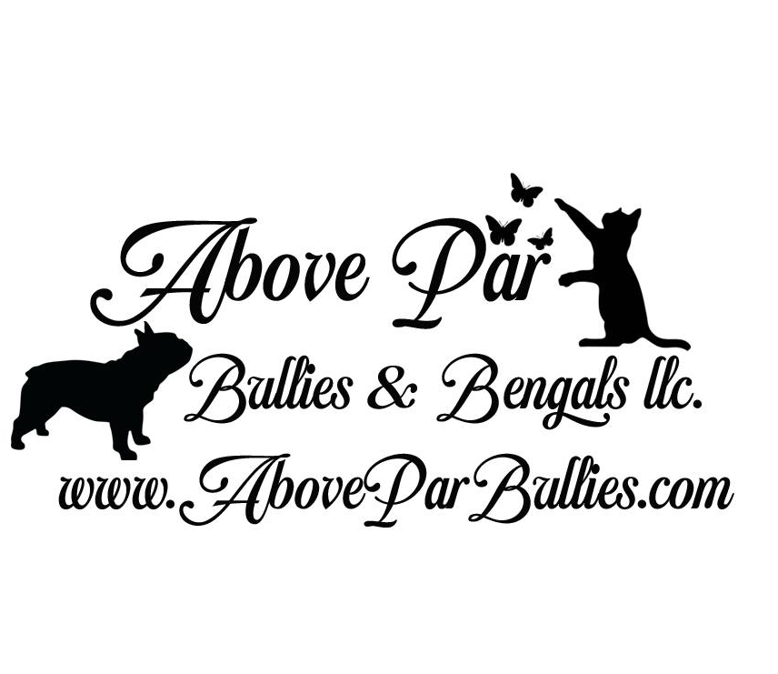
Danielle & Travis Weakley
Phone (573)590-2818
Email AboveParBullies@gmail.com
www.AboveParBengals.com

PUPPY DEPOSIT AGREEMENT

Payment of the Deposit constitutes acceptance by the Purchaser of the terms and
conditions of this Deposit Agreement.

DEPOSIT TO RESERVE KITTEN
We require a $1000.00 non-refundable and non-transferable PET deposit per puppy
and $1,500.00 non-refundable non-transferable if puppy is sold with Breeding
Rights, which shall be applied towards the Purchase Price for the puppy. The balance
shall be due and payable upon the release of puppy to Purchaser. If puppy is to be
shipped, the balance is due and payable at least 120-hours before the puppy is shipped to
the Purchaser.
We require a $250.00 non-refundable RETIRED PET deposit.
No hold shall be placed upon a puppy until the full deposit is received regardless if partial payments have been made.
The deposit will be put towards the purchase of the puppy and is non-refundable and can’t be
transferable if placed on a present particular puppy. Retired Pet deposits are Nonrefundable at all times.
Purchase price puppy does NOT include the cost of shipping the puppy by ground ($500.00).
Seller warrants that puppy is healthy and in good condition at the time he or she is shipped to
Purchaser, as evidenced by the veterinarian’s health certificate, which shall accompany
puppy. Seller is not responsible for any injury or damage to the puppy after puppy is
left with the shipper. All puppies must be paid for by the time they are 12 weeks old. The
puppy must be picked up or shipped no later than 13 weeks old, unless prior arrangements
have been made and agreed to by both parties. Any puppy left here after 13 weeks of age
without prior notice shall be charged $10.00 a day boarding fee. After 14 weeks old, the
puppy will be considered abandoned. The deposit will be forfeited and puppy shall be
resold

[Note: If the deposit is paid by PayPal, Paypal may charge a fee. 3% If this fee
is taken out of the amount we receive, the fee will be added to the balance
owed.]
The purpose of the Deposit is to ensure the Purchaser’s intent to purchase the puppy. The
Deposit is non-refundable, should the Purchaser, for any reason, change his/her mind and
decide not to buy a puppy. This is because the puppy is being held only for the Purchaser
and shall not be sold to any other buyer. A breach of this Agreement either verbal, written
or through neglect or failure to communicate by the Purchaser can jeopardize the chances
of placing the puppy in a new home, as quickly as possible. For this reason, the Deposit is
non-refundable, to ensure Purchaser’s commitment to purchase the puppy, pay the
balance by the date indicated above and accept delivery of the puppy by that time or pay
the boarding fee set forth below. However, the deposit may be applied towards a future
puppy. The deposit stays valid and may be used towards the purchase of another puppy
from the Seller while the Seller remains in business. The Deposit shall be refunded to
Purchaser if the Seller fails to make the puppy available to the Purchaser for reasons
including, but not limited to, the puppy mortality. However, Seller has the option of
offering a replacement puppy of similar quality, which Purchaser may accept or decline.

PURCHASE PRICE
Purchaser may be given a price range for the puppy upon payment of the deposit.
Purchaser understands that the final price may not be set until puppy is at least 4 weeks
old. Once the final price has been determined, Seller will send Purchaser the Seller’s
contract for review. A copy of the Contract will be available for signature once Purchaser
collects his/her puppy. If the puppy is being shipped, we require that the Contract be
signed and sent back to us (via email is acceptable) prior to the puppy being shipped.

SELLER’S RIGHT OF REFUSAL
Seller reserves the right to refuse to sell the puppy to the Purchaser at any time prior to
the puppy’s pickup or shipment, if, in Seller's opinion, the puppy will be better suited at a
different home or if Seller believes that Seller and Purchaser have a personality conflict.
In that instance, Seller shall notify Purchaser in writing of its decision, the reasons for
this decision, and Seller shall thereupon refund Purchaser's deposit, at which time, all
agreements are null and void. Seller's decision to cancel the sale shall be motivated solely
by the best interests of the puppy and Seller’s potential relationship with the Purchaser. In
addition to ensuring that our puppy will be going to the home best suited for him/her, our
priority is also to have good relationships with our clients, and it is very important that
we are able to communicate well with our clients and vice versa. Many of our clients end
up being good friends, and we hope that you will be one of them.

GOVERNING LAW
This Agreement shall be final and binding upon the Purchaser and Seller and shall be
governed by the laws of the State of Missouri. Parties shall submit all their disputes
arising out of or in connection with this Agreement to the exclusive jurisdiction of the
Courts of Maryland. In the event of a dispute between the parties, the prevailing party
shall be entitled to his/her attorney’s fees and all costs and expenses associated with the
dispute.

A Signed Copy of this contract is to be emailed to AboveParBullies@gmail.com
upon submission of deposit for any dog/puppy(s). Please include a color photocopy of
a Drivers License or State Issued Non Drivers Identification Card for every person
signing this contract.

SELLER NAME:______Danielle Weakley_______ Address: _______________________________
___________Auxvasse, Missouri 65231_______

SIGNATURE:____________________________
DATE:_______________________________

BUYER NAME___________________________ Address: _______________________________ _______________________________________
PHONE:________________________________
EMAIL: _________________________________

Signature:_______________________________

