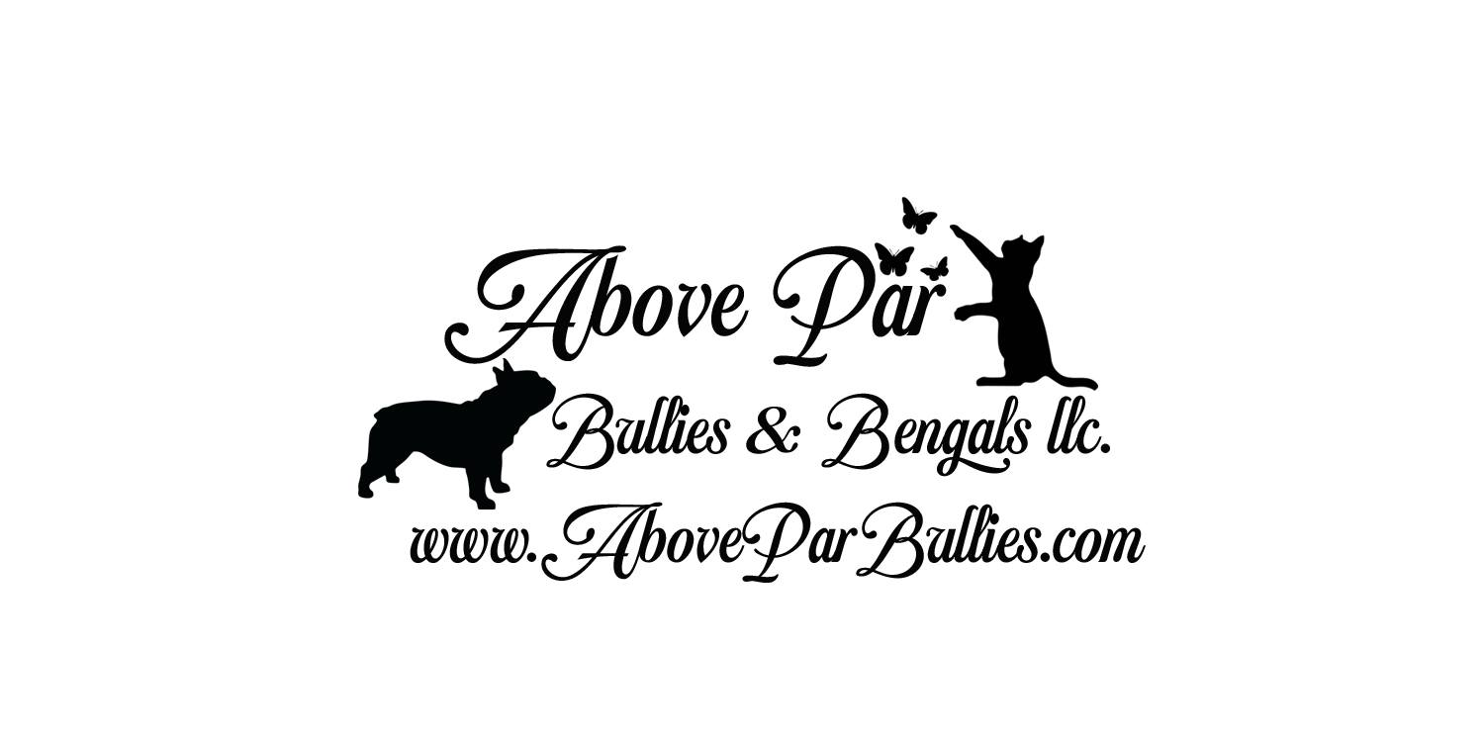
Danielle& Travis Weakley
Phone (573)590-2818
Email AboveParBullies@gmail.com
www.AboveParBengals.com

CONTRACT AND BILL OF SALE
This is to certify the Bill of Sale of a Great Dane Puppy from Danielle Weakley owner of Above Par
Bullies & Bengals to _____________________________________________

PUPPY BEEING PURCHASED
Sex of Puppy: _______________
Birthdate: _____________________________
Color of Puppy: ___________________
Sire- UKC CH & APRI Ch Truman’s Double Shot of Morgan
Dam: APRI CH PDK’s Belle of The Ball of Double D
COST
For the sum of: _______________________________
Co-Own- NO
Pet__YES_____ Breeding Rights____NO_____

Cost/Payment
1. Cost, as indicated above is due before the dog is shipped or received.
2. If the dog is not paid in full by the above time they will be placed back for sale and the deposit will
NOT be refunded but may be transferred to another pup of equal value.

Seller's Responsibility:
1. The seller guarantees that the puppy is in good health (minus potential intestinal parasites) and has received the following:
A. Age-appropriate immunizations
B. Subcutaneous microchip
D. Deworming
E. Seller guarantees the said dog is a purebred and is the offspring of the previously mentioned Sire and Dam.

2. The Seller provides warranty against debilitating congenital defects for a period of one (1) year after the date of sale.
A. Seller guarantees all possible steps have been taken with the sire / dam selection and breeding to prevent hereditary issues.
B. Debilitating congenital defects are defined as those present since birth that are either life-threatening or would prevent the puppy from fulfilling the intended purpose for which it was purchased.
C. Any suspected debilitating congenital defect must be confirmed by a licensed veterinarian (including necropsy if the dog dies).
i. Buyer must supply any requested veterinary records related to the dog’s condition to the seller within seven days of diagnosis.
ii. Seller has the right to require a second opinion from a veterinarian and/or veterinary specialist of the Seller’s choice at the Seller’s expense.
iii. If necropsy is performed and results in undetermined or inconclusive diagnosis, warranty is void.
D. If a congenital defect is identified within the warranty period, the Buyer has the option to obtain a replacement puppy from the Seller of equal or lesser value from the next available litter.
i. Original puppy need not be returned, provided there is proper documentation of congenital issue.
ii. Breeder determines which puppy (of equal or lesser value) will be used as a replacement and the wait may be as long as 6-12 months.
iii. Color or gender is not guaranteed
iv. Shipping fees will not be refunded, and any costs associated with the shipping replacement puppy are to be covered by Buyer.
E. If the puppy is euthanized or in any way disposed of, without a second opinion from the seller’s veterinarian, the buyer waives all rights to a replacement puppy.
F. This warranty does not include viral illnesses, infections, improper bites, stress-related illness, hernias, hypoglycemia, parasites (including Giardia or Coccidiosis), cancer or endocrine disorders. It also does not include any illness due to the ingestion of foreign objects, food, chemicals or physical injury.
G. No warranties or guarantees, expressed or implied, are made under this contract except as stated.
H. This warranty is non-transferable.

3. It is to be clearly understood, that the Seller does NOT, under any circumstances, accept responsibility for any veterinarian and /or health care expense.
4. We do NOT guarantee that the above dog is of show or breeding quality.
Buyer's Responsibility:
1. The Buyer agrees to pay the Seller a total sum of $ __$800.00__. This fee does not include shipping. If shipping is required, the Buyer agrees to pay $_________ for shipping, which includes a travel crate and a health certificate if needed.
2. The Buyer bears all costs relating to the sale of the above animal, including transportation. The risk of loss or injury to the above animal is on the Buyer at all times after the puppy leaves the Seller.
3. The Buyer agrees to have the puppy examined by a licensed veterinarian within two (2) business days of taking possession. Buyer agrees to email a copy of the vet report to the seller within 24 hours of vet visit.
A. If the puppy is found to be in poor health, the Buyer has the option of returning the puppy to the Seller, at the Buyer’s cost, for a full refund.
B. The Buyer will provide a written statement from a licensed veterinarian clearly stating the defect or illness.
C. If the puppy is not taken to a licensed veterinarian within three business days of taking possession, the health warranty is void.
D. Please ensure that the puppy is kept in a kennel or held in the waiting room of a veterinary office, and that the exam room is properly disinfected before the appointment.
E. Do not let the puppy walk on the floor in the veterinary office and ensure the room was cleaned prior to putting your puppy on the table. I recommend bringing a clean towel or blanket with you to be safe.
4. The Buyer is responsible for all medical expenses associated with the treatment of intestinal parasites if the puppy is diagnosed, even if the puppy has parasites present when sent home.
A. If you are not willing to treat puppy parasites (sometimes more than one treatment is needed), then please do not buy a puppy.
B. It is common for puppy parasites to flourish after joining their new family (stress and change accommodate this).
C. Most parasites can be contagious, and it is possible that other dogs in the house can get them.
D. Do not let your other dogs eat the puppy’s feces and clean it up immediately using proper cleaning chemicals.
5. The buyer agrees to provide the best possible care for their puppy for the duration of his or her life. This includes but is not limited to:
A. Housing the puppy indoors
B. Maintaining their puppy at a healthy weight
C. Having their puppy seen by a licensed veterinarian for a wellness exam annually
D. Taking their puppy to the licensed veterinarian if he or she gets sick or is injured
E. Keeping all immunizations current according to the guidelines of the American Veterinary Medical Association
F. Administering heartworm preventative medication (if living in an area of concern)
G. All puppies sold by Above Par Bullies & Bengals are required to remain on NuVet Supplements for a minimum of 1 year. We have added this to on contract to ensure that puppies are given the best start to life. This is required to receive our health guarantee.
6. The Seller highly recommends the Buyer provide basic obedience training with their puppy within the first year of owning their dog.
7. The Buyer agrees to postpone strenuous, forced exercise until after their puppy is over one (1) year of age to minimize joint damage as puppies develop.
8. The puppy is not to be Co-owned, given, or shared ownership with anyone without signing and
agreeing to this contract of sale and with written permission from seller.
9.If the dog is ever picked up by animal control or any form of law enforcement the dog must be
returned to the breeder at cost of new owner.
10. If buyer decides they can no longer keep the above dog, it must be offered back to the breeder first. This is for the life of the dog regardless of how much money has been spent on the dog. There will be no monetary funds given to the buyer. The dog must be returned to the seller along with all registration and ownership.
11. The Buyer agrees to never place their puppy with a rescue group, in a shelter, pound, or similar facility or research laboratory.
12. The Buyer allows the Seller to use any pictures of the dog that the Buyer posts on social media for the purposes of reposting and sharing on Facebook, Instagram, their website, Twitter, YouTube, etc. or in any manner they choose.
Should you choose to spay/neuter:
1. Spaying/neutering/gonad sparing surgery (GSS) must be performed by a licensed, reputable veterinarian after the above puppy reaches 18 months of age. If the pup is altered before the age of 18 months, the warranty will become null and void.
2. It is understood that the above animal is not to produce offspring. If it does, the pups will not be eligible for AKC registration.
3. The above animal is a representation of its breed, and it is structurally and temperamentally sound. We do not guarantee any future titles or placements
4. Ability to breed the above dog will only be offered/allowed if buyer titles the dog in the conformation ring of AKC, UKC, APRI or IABCA or in a obedience title offered in UKC or AKC

No other warranties are expressed or implied other than that which is stated above, if you choose not to take your puppy to a licensed vet in the time stated above this guarantee is void. If ANY part of this contract is broken, the FULL ownership, including signed registration, and possession of the dog will be returned to the breeder at the cost of buyer. The undersigned buyer acknowledges that this is a legal and binding contract and will be bound by the laws of Missouri and has received a copy. If this contract is broken and dog is not returned to breeder with signed registration papers the buyer will be liable for civil damages in the amount of $2500, and that any dispute regarding this contract will be settled in the Missouri court at the cost of the buyer. This contract here by gives the breeder permission to repossess said dog if any part of this contract is broken. Buyer releases Seller, Above Par Bullies & Bengals and their estate from any and all liabilities, and/or damages by fault of this dog at the time of sale. These damages include but are not limited to, destruction of property and/or physical damage to any person or group of people. Buyer agrees to the entire contract and any other contracts attached.

Sellers Information
Danielle Weakley/ Above Par Bullies & Bengals
330 Country Rd 245
Auxvasse, Mo 65231
(573) 590-2818
Seller's Signature and Date:
_______________________________________

_______________________________________
Buyers Information
Name:__________________________________
Address________________________________
City,State,Zip:___________________________
Phone:(_____________) ___________________
Buyer's Signature and Date:
_______________________________________

_______________________________________

