Standard Application for Employment

It is our policy to comply with all applicable state and federal laws prohibiting discrimination in employment based on race, age, color, sex, religion, national origin, disability or other protected classifications. Please carefully read and answer all questions. You will not be considered for employment if you fail to completely answer all the questions on this application. You may attach a résumé, but all questions must be answered.

Position applying for | Your email address
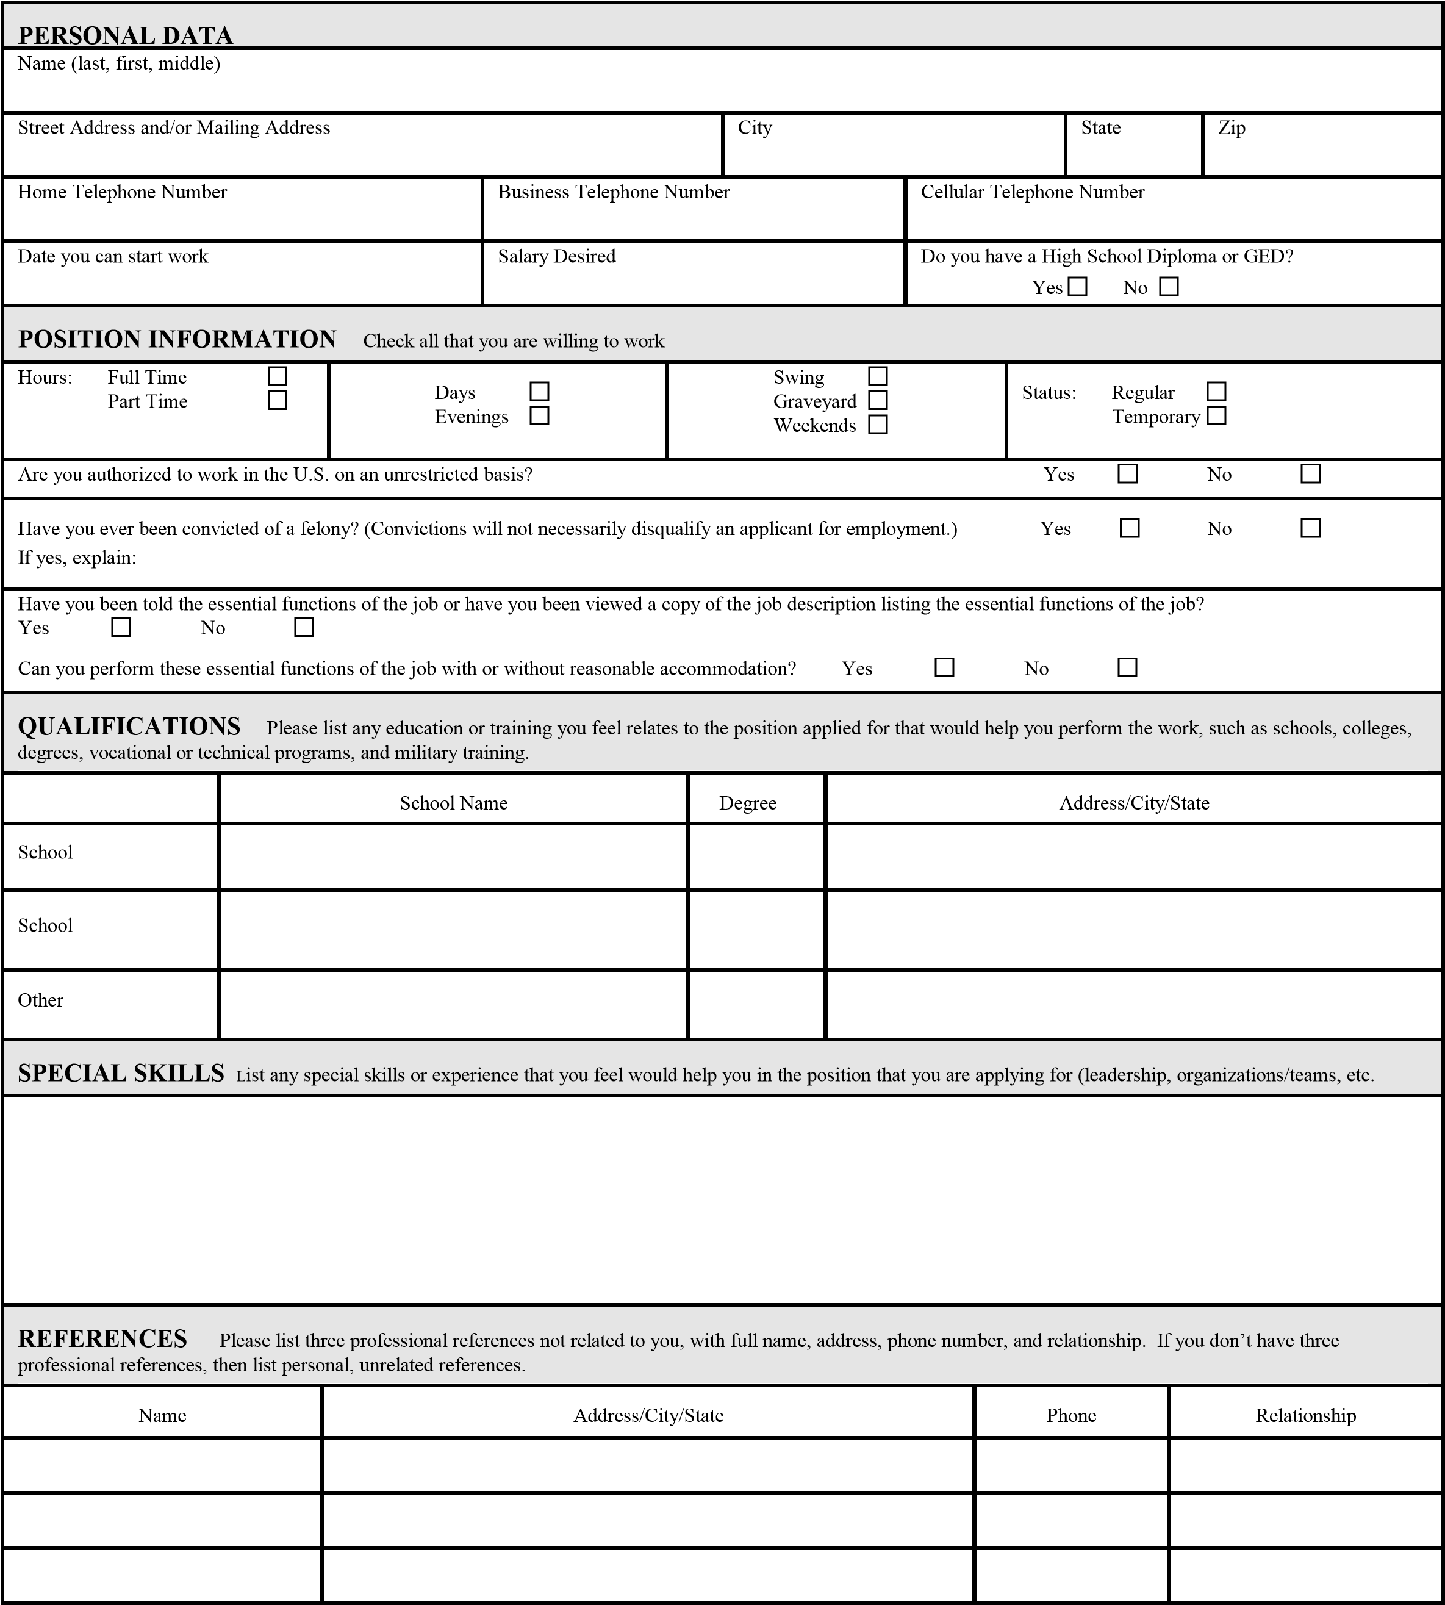

May we contact your present employers? Yes No N/A

WORK HISTORY Start with your present or most recent employment and work back. Use separate sheet if necessary. (INCLUDE PAID AND UNPAID POSITIONS)
Job Title #1 | Start Date (mo/day/yr) |  | End Date (mo/day/yr)
Company Name | Supervisor’s Name |  | Phone Number
City | State |  | Zip
Duties:
Reason for Leaving |  | Starting Salary | Ending Salary

Job Title #2 | Start Date (mo/day/yr) |  | End Date (mo/day/yr)
Company Name | Supervisor’s Name |  | Phone Number
City | State |  | Zip
Duties:
Reason for Leaving |  | Starting Salary | Ending Salary
Job Title #3 | Start Date (mo/day/yr) |  | End Date (mo/day/yr)
Company Name | Supervisor’s Name |  | Phone Number
City | State |  | Zip
Duties:
Reason for Leaving |  | Starting Salary | Ending Salary
Job Title #4 | Start Date (mo/day/yr) |  | End Date (mo/day/yr)
Company Name | Supervisor’s Name |  | Phone Number
City | State |  | Zip
Duties:
Reason for Leaving |  | Starting Salary | Ending Salary

I certify that the facts set forth in this Application for Employment are true and complete to the best of my knowledge. I understand that if I am employed, false statements, omissions or misrepresentations may result in my dismissal. I authorize the Employer to make an investigation of any of the facts set forth in this application and release the Employer from any liability. The employer may contact any listed references on this application.
I acknowledge and understand that the company is an “at will” employer. Therefore, any employee (regular, temporary, or other type of category employee) may resign at any time, just as the employer may terminate the employment relationship with any employee at any time, with or without cause, with or without notice to the other party.

Applicant Signature_______________________________________________ Date _______________________________________

