Why This Matters
Feral cat populations can grow rapidly. A single unspayed female may have multiple litters each year, and her kittens can reproduce within months. Without intervention, colonies expand quickly, impacting wildlife and communities.
When cats are removed, other cats often move into the same area. This is known as the “vacuum effect.” Sterilized cats continue to occupy their territory, helping prevent new cats from moving in while no longer reproducing.
Uncontrolled populations lead to:
• Sick or starving kittens
• Fighting and injury
• Increased wildlife impact
• More community complaints
TNR helps break this cycle.

Low-Cost Spay/Neuter Clinics
(this is not an exclusive list)
Santa Rosa County Animal Services 850-983-4680 | Milton, FL - Provides animal control services, shelter for stray animals, and support for community cats. Humane traps are available for loan to assist with TNR.

Accessible Veterinary Care
(850) 463-4242
3802 Hwy 90, Milton
Snip Happens Spay & Neuter Clinic (A HOPE)
(850) 795-2287
Milton
Emerald Coast Animal Hospital
(850) 243-5080 Fort Walton
This document was prepared by a concerned citizen using publicly available information from Santa Rosa County Animal Services and is not an official county publication.
Community Cats in Our Neighborhood
Working Together for Humane Population Control
A neighbor-supported approach using Trap-Neuter-Return (TNR)
• Reduces overpopulation
• Improves cat health
• Reduces nuisance behaviors
• Protects wildlife
• Humane and effective
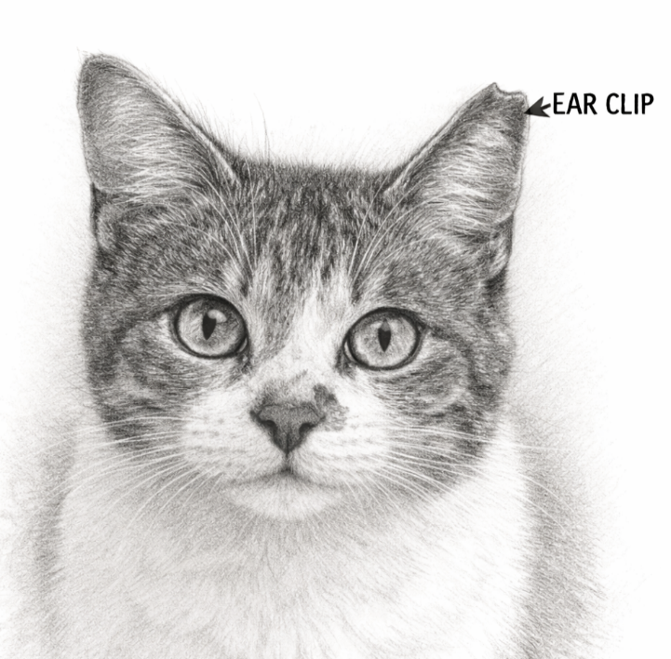

Dedicated to Nosey, and to all community cats who deserve care and compassion.

What is Trap-Neuter-Return (TNR)?
TNR is a humane method of managing community cats.
Cats are:
• Humanely trapped
• Spayed or neutered
• Vaccinated
• Ear-tipped (a small clip on left ear for identification)
• Returned to their territory
Once sterilized, cats no longer reproduce, nuisance behaviors decrease, colonies stabilize, and populations gradually decline.
Wildlife impact is a concern. According to the Smithsonian Conservation Biology Institute and the U.S. Fish and Wildlife Service, free-ranging domestic cats kill an estimated 1.3–4.0 billion birds annually in the United States. Trap-Neuter-Return (TNR) helps reduce long-term population growth and limit this impact over time.
What Santa Rosa County Recommends
Santa Rosa County Animal Services refers to these animals as “community cats,” defined as “outdoor, unowned, free-roaming cats.”
The county recommends Trap-Neuter-Return (TNR), where cats are humanely trapped, sterilized, vaccinated, ear-tipped, and returned to their territory.
The county ordinance states that community cats are exempt from certain licensing and at-large provisions.
This approach stabilizes colonies and gradually reduces population growth.
Many of these cats are part of our neighborhood, and with care, they can live healthier, more stable lives.

How You Can Help

You can assist with TNR by helping trap when needed and taking a feral cat to a veterinarian who will sterilize, vaccinate, and ear-tip the cat before returning it to the area. Efforts like this, shared among neighbors, can make a meaningful and friendly difference in stabilizing the population.
Consider being a Community Cat Caretaker. They provide food, monitor health, and assist with Trap-Neuter-Return efforts.
Shared responsibility helps make this effort successful.
Thank you for helping support humane population control in our neighborhood.

