2022 HHBRA Awards Banquet

Please take a moment to thank all of these people. Let them know how much we appreciate them. We could not have such outstanding awards without their awesome donations!

Youth Breakaway Saddle  Uvalde County Fairplex  County of Uvalde  Wendy Speer  215 Veterans Lane  Uvalde, TX 78801 |  | 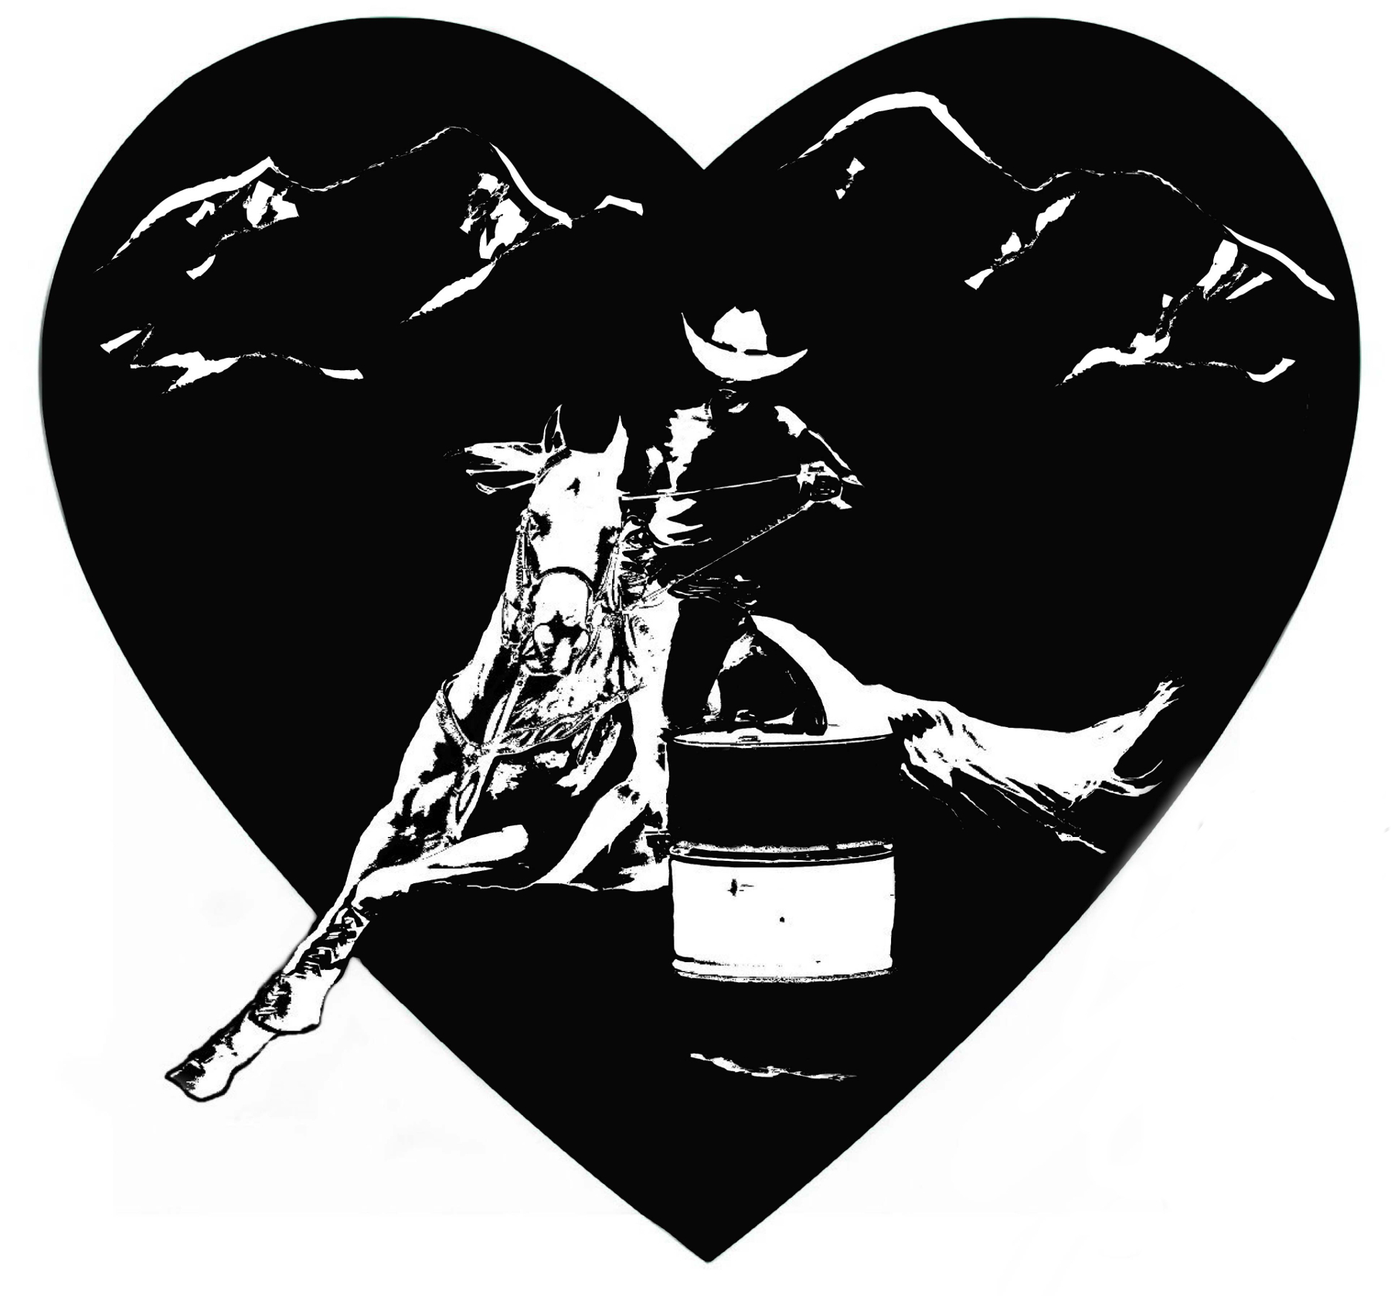  Saddle Sponsors |  | Open Breakaway Saddle  W4 Ranch  Forrest & Cindy Wheeler  110 N Milam, NO 113  Fredericksburg, TX 78624
8 & Under Pole Saddle:  Schneider Brahmans  O.W. & Donna Schneider  1571 Alfred Petsch Rd  Fredericksburg, TX 78624 |  | 9-11 Pole Saddle  Clark Plumbing  Chris & Mendy Clark family  294 Canyon View Drive  Kerrville, TX 78028 |  | ½ 12-14 Pole Saddle  Solomon Cattle Co  Mike & Brooke Solomon  385 East CR 401  Falfurrias, TX 78355
½ 12-14 Pole Saddle  Lochte Feed  Scott Crenwelge  509 Longhorn St  Fredericksburg, TX 7862 |  | 15-19 Pole Saddle  Security State Bank & Trust  Laurie Hartmann  P.O. Box 471  Fredericksburg, TX 78624 |  | ½ 20 & Over Pole Saddle  Del Rio’s Chiro Connection  Katie Turcotte Flores  501 W Cantu Rd Ste 500  Del Rio, TX 78840
½ 20 & Over Pole Saddle  Rothlisberger Horses  Jace & Rebecca Rothlisberger  3188 Viggio Rd  Beeville, TX 78102 |  | ½ Novice Pole Horse Saddle  Five K Services, LLC  Ronald & Melinda Korczynski  1005 S Getty St  Uvalde, TX 78801 |  | ½ Novice Pole Horse Saddle  Diamondback Maintenance & Services  Pam & Hugh McClaugherty  PO Box 115  Tilden, TX 78072
1D Pole Saddle  Alamo Saddlery  Leisha Ashley  PO Box 1407  Del Rio, TX 78840 |  | 2D Pole Saddle  Law Office of George Scharmen  George & Allison Scharmen  315 Dwyer Ave  San Antonio, TX 78204 |  | 3D Pole Saddle  Pumphouse Car Washes  Alan Bohlen  P.O. Box 468  Hondo, TX 78861
4D Pole Saddle  Wyatt Veterinary Services  6992 State Hwy 97 E  Floresville, TX 78114 |  | 8 & Under Barrel Saddle  MKM River Place Ranch  Matthew May  24165 IH 10 West Str 217-740  San Antonio, TX 78257 |  | 9-11 Barrel Saddle  Texas Prime Country Real Estate  1900 South Bridge St  Brady, TX 76824
½ 12-14 Barrel Saddle  M3 Performance Horses  Morgann Crawford  301 Saunders Lane  Uvalde, TX 78801 |  | ½ 12-14 Barrel Saddle  Arrowhead Bank  Tony Klein  502 South Adams St  Fredericksburg, TX 78624 |  | 15-19 Barrel Saddle  Gillespie County Wild Game Dinner  Tony Klein / Lester Meier  501 W Main Street  Fredericksburg, TX 78624
20-49 Barrel Saddle  The Kusenberger Family  622 Rodeo Trail  Del Rio, TX 78840 |  | ½ 50 & Over Barrel Saddle  Boone Ranch  Karla Boone  4602 KC 442  Harper, TX 78631 |  | ½ 50 & Over Barrel Saddle  Barker Ranch  Benny & Darla Barker  2053 KC 4732  Harper, TX 78631
Novice Barrel Horse Saddle  Pedernales Veterinary Center  Patrick O’Neil, DVM  P.O. Box 109  Fredericksburg, TX 78624 |  | 1D Barrel Saddle  Thousand Hills Cowboy Church  1000 Hills Cowboy Church  292 Peterson Farm Rd  Kerrville, TX 78028 |  | 2D Barrel Saddle  The McBryde Ranch  Rick & Lauren McBryde  P.O. Box 1099  Fredericksburg, TX 78624
3D Barrel Saddle  3D Ranch  Elgin Pape Family  2180 Fiedler Rd  Harper, TX 78631 |  | 4D Barrel Saddle  Friendship Veterinary Center, Inc  2087 S. US Hwy 87  Fredericksburg, TX 78624 |  | ½ 5D Barrel Saddle  Dragon’s Bar & Grill  PO Box 3  Panna Maria, TX 78144
½ 5D Barrel Saddle  Smart Fencing  Nicky Bryan |  |  |  | HHBRA Raffle Saddle  HHBRA  1310 Triple D Ranch Rd  Harper, TX 78631
Membership Awards  Capital Farm Credit, FLCA  Leslie Wallendorf  P.O. Box 488  Hondo, TX 78861 |  | Class / Buckle Sponsors  W4 Ranch  Forrest & Cindy Wheeler  110 N Milam, NO 113  Fredericksburg, TX 78624 |  | Membership Awards  Speer Ag, LLC  Justin & Bethany Speer  HCR 34 Box 970  Uvalde, TX 78801
Lehne Construction, Inc.  Brian & Shawn Lehne  2309 Knopp School Rd  Fredericksburg, TX 78624 |  | County of Uvalde/Fairplex Dept. Fund  Joni Deorsam  Uvalde County Treasurer  Uvalde, TX 78801 |  | Hill Country Telephone Co.  Ryan Fellts  PO Box 768  Ingram, TX 78025
Teddi Harllee  Premier Equine Sports Therapy  Redstone Cattle Company  The Denny Family  Fawn Schott  The Phillips Family  Judy Teal |  | Buckle Sponsors:  The Zarazua Family  April Conner  Julie Conner  Josh & Ava Mueller  Elisa Morales (Larena Smart) |  | Wendy Ullman  Lily Valentine  Carle Rae Colvin  Hailey & Leslie Kinsel  SG Equine Therapeutic Adjustments Nickes Ins & Mortgage Loan Services
If you sold the most raffle tickets you have a wonderful surprise coming! Congratulations on a job well done!
Over the years Serena Walston has donated many fine pieces of hand-drawn western art to HHBRA. Look for another this year. Thank you, Serena.
Jeff Lavender of Mr. Lavender Photos (www.mrlavenderphotos.com) has been our photographer at most shows. He will also be the photographer at the Awards Banquet. Thank you, Jeff!
The awards banquet is catered by Hilda & Bernardo Ayala. They also run the concession stand at the shows. Thank you for all you do for HHBRA!
The following people drive a tractor or work in the office or help run the show. Most of them also put in many hours between shows and before the awards banquet – all of it with no pay but your thanks. Please tell them “thank you.“
Steve, Diane, & Crystal Wetz  1310 Triple D Ranch Rd  Harper, TX 78631 | Lauren McBryde  PO Box 1099  Fredericksburg, TX 78624 |  | Andrea, Kenny, & Kelan Bode  1473 Bode Rd  Harper, TX 78631 |  | Sissie & Nikki Sandidge  PO Box 2322  Bandera, TX 78003
Darla Barker & Wanda Kay Wright  2053 KC 4732  Harper. TX 78631 | Kathy Durst  1848 Cain City Rd  Fredericksburg, TX 78624 |  | Rebecca Rowell  Point Secretary  5312 Mt Olive Rd  Adkins, TX 78101 |  | Stewart Rowell  (announcer)  5312 Mt Olive Rd  Adkins, TX 78101

Thank you for making this an outstanding 2022 season!
Looking forward to 2023!

Check our webpage: www.hhbra.com or follow HHBRA on Facebook

