A
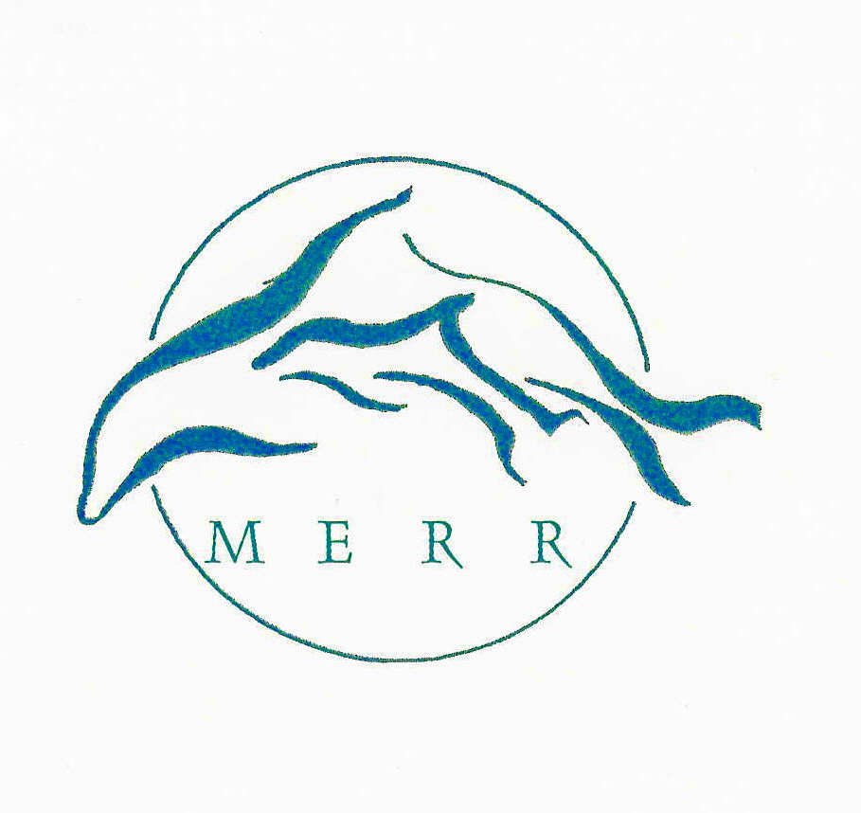

Marine Education, Research & Rehabilitation Institute, Inc.
801 Pilottown Rd. Lewes, DE 19958
(302) 228-5029 merrinstitute@gmail.com
www.merrinstitute.org
_______________________________________________________________

… …dedicated to the conservation of marine mammals and sea turtles and their ocean habitat

March 1st, 2018

Jennifer Cohan
Secretary
Delaware Department of Transportation
P.O. Box 778
Dover, DE 19903

Dear Ms Cohan,

I am writing to you in regard to your role on the Anti-Littering and Anti-Dumping Task Force. As the founding Director of MERR, the non-profit organization that responds to marine mammal and sea turtle strandings in Delaware, I can attest to the myriad of ways in which marine debris contaminates the marine environment, and directly impacts the lives and welfare of marine animals such as whales, dolphins, seals and sea turtles.

I wish to specifically address the detrimental impacts of balloon releases and the harmful and often fatal effects they have on marine wildlife and ocean health. Latex and Mylar balloons make up a substantial portion of the marine debris that is found in the ocean and waterways, and litters the shore. All balloons, whether released in mass quantities as in a balloon release, or individually when they escape a child’s hand or blow free from a car dealership or real estate open house sign, will ultimately rise into the atmosphere and make their way to the ocean. Some balloons will remain virtually intact, while others will burst into numerous pieces of colorful shreds, both of which when in the water column, resemble jellyfish and other tempting food sources for marine animals. When animals ingest these balloons that they mistake for food, the material impacts their stomach and esophagus, causing slow and gruesome starvation, as the animal can no longer ingest actual food. Sea turtles are most commonly affected, making up 58% of the animals that are fatally impacted by balloon ingestion. Delaware enjoys 4 different species of sea turtles in our waters from May-November. Two of these species are endangered, making it all the more imperative to protect their habitat from the unnecessary deadly presence of balloons.

In addition to the horrific effects of balloon ingestion are the painful and fatal entanglements from the ribbons that are often attached to the balloons. These ribbons constrict limbs and airways causing strangulation, and can become attached to underwater objects, causing the animal to drown.

The materials and the production of balloons are toxic. Latex balloons contain plastic and chemicals that contribute to the toxicity of the marine ecosystem, degrading water quality and leaching into the tissues of fish and other organisms that may ultimately be consumed by humans, as well as dolphins, whales and seals. Latex balloons can take up to 4 years to degrade, posing threats to marine life that entire time. Mylar balloons are highly toxic due to their composition, production, and inability to biodegrade. The Environmental Protection Agency and the US Fish and Wildlife Service have denounced the use of balloons, and specifically balloon releases, due to their significant adverse impacts on the state of the environment and wildlife.

It is ironic that balloons have been associated with celebrations of life’s milestones, when in reality they are the causes of needless death for so many species of animals, including already endangered species. I am providing photos from some of the many animals that we have responded to that have been injured or succumbed to ingestion and entanglements caused by balloons(Please see attached). It is important to convey the fact that balloons travel great distances from their point of origin. Balloon releases that occur in Delaware can travel more than 1,000 miles to impact animals all along the eastern seaboard from Maine to Florida. Added to that daunting expanse of the impact range is the fact that most of the marine creatures that we strive to protect migrate and travel hundreds and thousands of miles every year. The interconnectedness of these waters that comprise their habitat, and the marine debris that we are responsible for contributing on a regional, national, and international basis is cause for Delawareans to make more responsible choices in regard to our role in protecting the environment from something as non-essential as balloons.

MERR applauds the efforts of the Anti-Littering and Anti-Dumping Task Force to address the problems associated with balloon releases, and the harm that their presence causes in the marine environment. MERR represents many members of the public who share the concerns of protecting the environment from the ill effects of balloons, so on behalf of their interests, and those of the marine animals who are helpless to defend themselves against our human made pollution, I thank you for considering solutions to this important issue. Please do not hesitate to call on us if we can be of any assistance.

Sincerely,
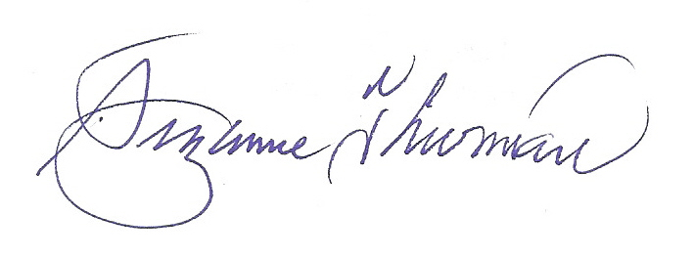

Suzanne Thurman
Executive Director

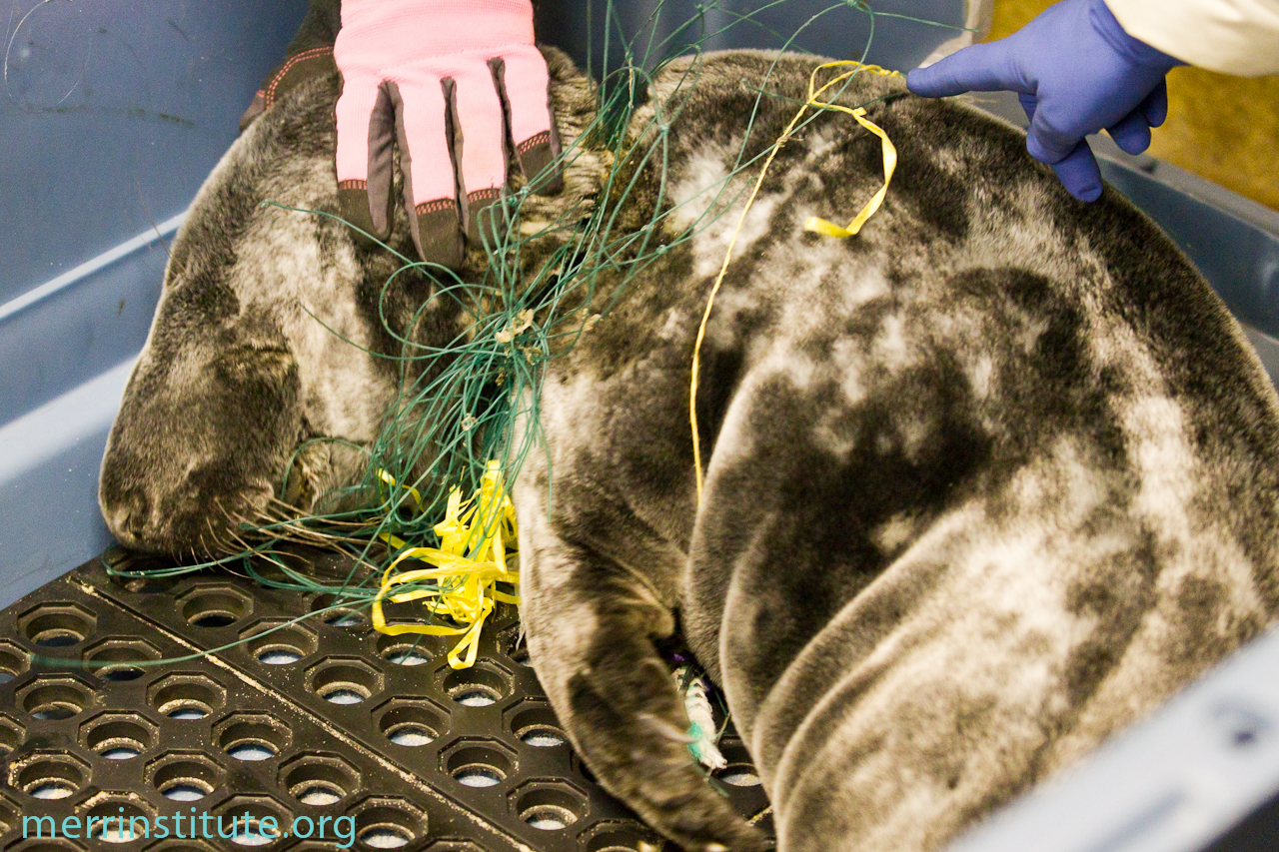
Balloon and balloon ribbons entangling a 2 month old gray seal pup. The seal was gasping for breath when rescued at the south side of Indian River Inlet, and was beginning to become comatose. In addition, the ribbons and netting had cut a 3-inch gaping wound into the back of the neck.
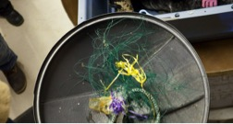
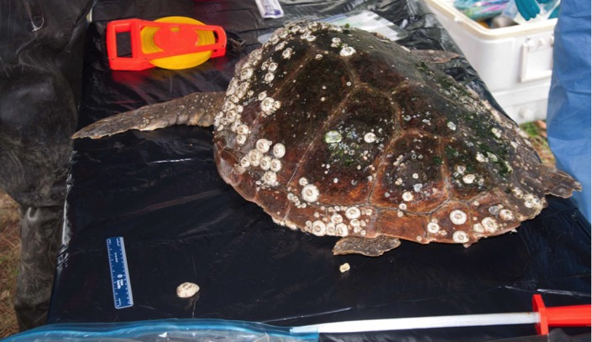
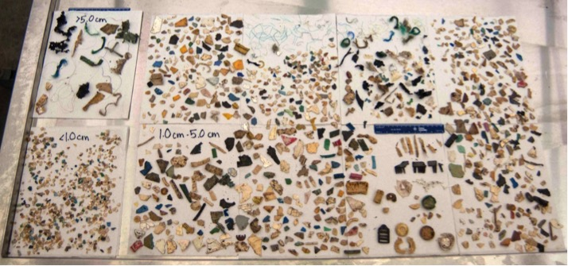
This loggerhead sea turtle that stranded at Slaughter Beach, DE was nicknamed “Plastic Turtle” due to its ingestion of copious amounts of marine debris including balloons. The result was fatal for this animal.

