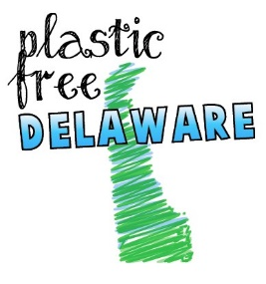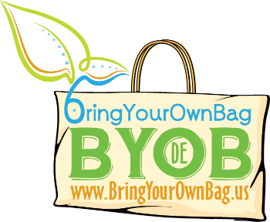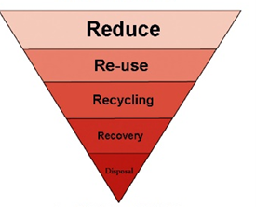
PLASTIC FREE RESTAURANT INITATIVE
Plastic pollution has become a crisis in our time. It impacts marine life, domesticated animals, and humans. Plastics are not biodegradable and break down into tiny particles which attract toxic particles and are assimilated into our very own food chain. Less than 10% of plastic bags and bottles are properly recycled or reused. PLASTIC FREE DELAWARE (PFD) is committed to addressing the root causes of single-use plastic pollution in our communities and environments, and to change human behavior to reduce the use of single-use plastics.
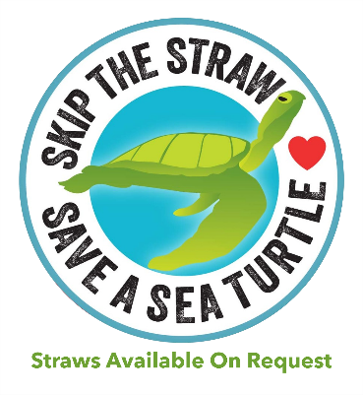
Food establishments can voluntarily be a large part of the solution. PFD would like to recognize restaurants who meet the following criteria and can provide free promotional material to help spread the message. Be aware that “bioplastics” are unregulated and often misleading in their claims. Many “green” plastic products are still just that: plastic made from natural gas and oil. It is anticipated that the money saved by distributing less plastic by an Opt-In Only philosophy will more than offset any potential increased cost in compostable or reusable alternatives. Please contact us for more information.
PLASTIC FREE RESTAURANT CERTIFICATION PROGRAM
GOLD STATUS
- Straws provided only upon request, preferably paper or other biodegradable straws only by request
An opt-in, not out approach saves the establishment $$$ and reduces litter/pollution.
- No plastic bags for take-out orders or “doggy bags” for leftovers
- No Styrofoam (expanded polystyrene foam) use for take-out or leftovers
We recommend paper or cardboard whenever possible.
- Follow Delaware law regarding commercial recycling (as per Delaware law)
- Single-use utensils are provided only upon request
Most people are headed home with their meals
PLATINUM STATUS
- Only reusable silverware (or wooden chopsticks!) and tableware is used for onsite dining
- No take-out beverages sold in plastic bottles
- No plastic stirrers or plastic lid plugs (bamboo and other alternatives are available)
If you own or manage a restaurant or food establishment which meets these criteria, we want to know so we can promote your sustainability efforts on our web site and social media! Kudos to you! And/or if you would like additional information, please email or call: info@bringyourownbag.us 302-981-1950
www.BringYourOwnBag.us

PLASTIC STRAWS SUCK
Americans use 500 MILLION drinking straws every day. Why? We don’t generally use them at home. They are typically made of polypropylene which is made from natural gas or oil. As shown below, they are one of the most common items found every year in the Coastal Cleanup, and other watershed cleanups.
Restaurants can save hundreds of dollars each month by switching to paper straws only by request, while also eliminating landfill/disposal costs and reducing environmental impact. Grain Kitchen + Bar estimates it is saving 1.5 MILLION straws from the landfill and environment each year by switching to By Request Only.
COASTAL CLEANUP STATS FOR DELAWARE
 | 2009 | 2010 | 2011 | 2012 | 2013 | 2014 | 2015 | 2016 | 2017
TOTAL WASTE COLLECTED OF ALL TYPES | 9.6 tons | 9.5 tons | 10.7 tons | 7.8 tons | 4 tons | 3 tons | 7.8 tons | 6.1 tons | 3.8 tons
Plastic Bags | 825 | 1,224 | 3,056 | 1,875 | 2,296 | 2,777 | 2,433 | 1,014 | 1,066
Straws | 2,445 | 1,130 | 4,106 | 1,895 | 2,385 | 2,346 | 1,657 | 1,845 | 1,953
Cig butts | 15,876 | 11,093 | 9,817 | 14,478 | 22,779 | 18,877 | 20,410 | 13,569 | 16,294
Balloons | 1,093 | 270 | 636 | 395 | 451 | 1,214 | 458 | 676 | 1,071
Plastic bottles | 5,384 | 1,437 | 7778 | 2,688 | 3,267 | 3,760 | 3,785 | 3,089 | 2,948

Be wary of “compostable plastic.”
- Read the fine print. They are often still just plastic which breaks down more quickly rather than being truly biodegradable. It is often not recyclable and actually contaminates other plastics that are.
- It still poses a health hazard in our oceans to wildlife and humans
- It is not regulated.
- They cannot be composted at home, but rather require industrial facilities with high temperatures.
- Will still likely end up in the landfill for 1,000s of years
Greenwashing - still plastic in sheep's clothing
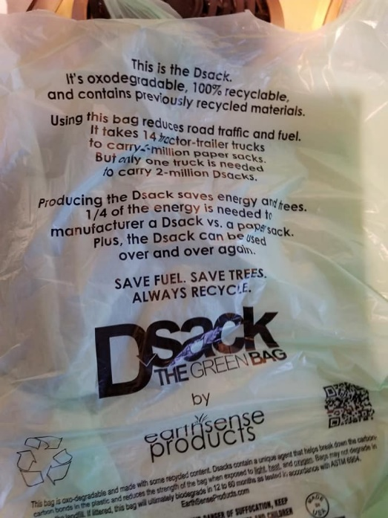
See also:
www.beachapedia.org/bioplpastics
http://www.surfrider.org/programs/ocean-friendly-restaurants
http://www.dnrec.delaware.gov/dwhs/recycling/pages/recycling.aspx
Paper straw supplier: https://www.aardvarkstraws.com/restaurants/

