Cape Gazette 4-29-18

http://www.capegazette.com/article/big-chill-beach-club-says-so-long-plastic-straws/155673

Big Chill Beach Club says so long to plastic straws
Venue partners with Delaware Surfrider Foundation to protect ocean and beaches
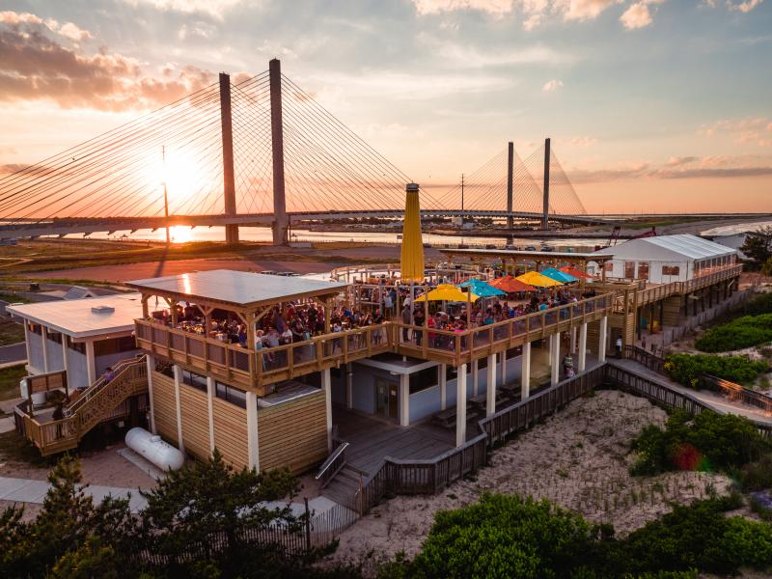
Along with spectacular 360-degree water views of the Atlantic Ocean, Indian River Bay and Inlet, Big Chill Beach Club in Bethany Beach serves food and beverages – without plastic straws. The family-friendly oceanfront venue is working with the Delaware Chapter of the Surfrider Foundation in its environmental efforts to protect and preserve the world’s oceans and beaches. Biodegradable paper straws are available upon request. SUBMITTED PHOTO
April 29, 2018

“I’ll have two tacos and a freshly squeezed crush. And hold the straw, please.” That’s music to Mother Nature’s ears as Bethany’s Big Chill Beach Club is implementing a new menu trend to benefit three of its next-door neighbors: the Atlantic Ocean, Indian River Inlet and Indian River Bay.
For its second season, the Big Chill Beach Club is opening with a commitment to eliminate plastic straws to help protect the glistening waters which attract hundreds of thousands of visitors to Delaware Seashore State Park each year. “For our first summer season last year, we welcomed over 200,000 guests who enjoyed our unique beach food and beverage menu, and of course, the spectacular oceanfront views just steps away from the water,” said Jason Bradley, Big Chill Beach Club general manager. “Forgoing plastic straws is the right thing to do.”
Located at the corner of the Atlantic Ocean and the Indian River Inlet, the Big Chill Beach Club comprises two deck structures, each approximately 4,000 square feet, with sweeping views of Delaware Seashore State Park’s south side and spectacular coastline. One offers family-friendly beach-style restaurant services, and the second is designed as an event venue for weddings, musical events and corporate meetings accommodating up to 200 people. Its popular Upper Deck Umbrella Bar provides unparalleled 360-degree water views. Big Chill Beach Club appeals to all who embrace life at the Delaware beaches.
But large numbers of visitors can also create large problems for the environment. The Plastic Pollution Coalition in Berkeley, Calif., estimates that 500 million plastic straws a day are used in the United States alone. Their campaign The Last Plastic Straw is part of the group’s mission is to educate the public about the perils of single-use plastic, and its effects on health, the environment and the world’s oceans.
“We’ve come to learn that so many of those plastic straws end up on our beaches and in our ocean,” said Mike Ridings, a local lifelong surfer, and owner of Big Chill Surf Club and Rehoboth’s Liquid Board Shop. “For us, that’s just too close to home.” Both of Ridings’ businesses have strong connections to the ocean and its beaches. “My passion is surfing,” said Ridings. “We’re hopeful that with everyone’s cooperation, we can fast-track the solution to this growing problem.”
The Surfrider Foundation, founded in 1984, is a nonprofit environmental group committed to transforming passion into protection and preservation of the world’s oceans, waves and beaches. "Our team is proud to be working with the Delaware Chapter of the Surfrider Foundation on raising awareness and promoting efforts to keep our ocean, waterways and beaches clean,” said Ridings.
Surfrider’s 2017 International Coastal Cleanup report revealed that straws were one of the top 10 items collected globally on Earth’s coastlines. One of the problems with plastic is that it’s photodegradable, not biodegradable. That means it degrades into smaller and smaller pieces which get ingested by marine and land animals, and therefore get into the human food chain. Although straws amount to a tiny fraction of ocean plastic, their size makes them one of the most insidious polluters because they entangle marine animals and are consumed by fish. In 2015, a video of scientists removing a straw embedded in a sea turtle’s nose went viral, serving as a graphic wakeup call-to-action.
So are straws now a thing of the past? “Well, we no longer offer plastic straws. But as a hospitality business, we recognize that some guests may require a straw, so to accommodate them we have paper straws available upon request,” said Josh Grapski, co-owner of Big Chill Beach Club and managing partner of La Vida Hospitality. “Along with demonstrating respect for these incredible bodies of natural water, we also want our guests to enjoy their experience here. He thinks if this minor change can create the big impact Big Chill Beach Club envisions, the beach life everyone enjoys will continue for generations to come. “It’s really a win-win for everyone concerned!”
On the East Coast, Surfrider’s Charleston, S.C. chapter has achieved huge success with the Strawless Summer campaign, convincing more than 70 restaurants to go free of plastic straws. In San Francisco and San Diego, the organization continues its public awareness efforts and has created a groundswell of support for strawless legislation in those cities. For individuals who still think straws are needed in their daily lives, there are several environmentally friendly options. Washable and reusable drinking straws are available in stainless steel, glass, paper or bamboo.
The Surfrider Foundation also encourages the public to spread the word by requesting “no straw” wherever straws are still in use, and by requesting that businesses serve beverages with straws only upon request. They also invite people to share their individual “last plastic straw moment” on their Facebook page.
“We’re thrilled to be back for our second year,” said Grapski. “Big Chill Beach Club is a place like no other where visitors and locals alike are always welcome to stop in, relax and chill out. Join us to share the joy of beach life. Without a plastic straw.”
Big Chill Beach Club is now open from 11 a.m. to 10 p.m., Friday to Sunday. For more information and menus for 2018, go to www.bigchillbeachclub.com or call 302-402-5300.
For information about scheduling an event at the Beach Club Event, contact Emily Hare at 302-278-0100.

