Greene Turtle chain says goodbye to plastic straws
Patricia Talorico, The News Journal Published 10:00 p.m. ET May 17, 2018 | Updated 8:19 a.m. ET May 18, 2018
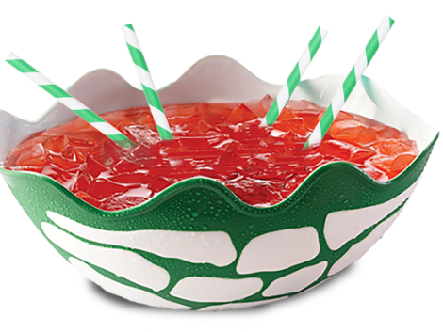
(Photo: Submitted)
CONNECTTWEETLINKEDINCOMMENTEMAILMORE
Don't be surprised if the drinking straw you request at a Greene Turtle Sports Bar and Grille restaurant after Wednesday is made of biodegradable paper.
The casual restaurant chain announced it will be going plastic straw free in an effort to protect marine life.
The Greene Turtle Sports Bar and Grille chain says by abandoning the practice of handing out plastic straws at all its restaurant, it will be saving more than 7 million straws from possibly ending up in oceans, polluting the water and harming sea life.
The restaurant chain, founded in Ocean City, Maryland, in 1976, now has 46 locations in markets across Maryland and extending into Washington, D.C., Virginia, West Virginia, Delaware, Pennsylvania, New Jersey and Long Island, New York.
The May 23 date was chosen because it's World Turtle Day.
“The Greene Turtle Sports Bar & Grille values protecting marine life,” said Senior Director of Marketing Layla Nielsen. “We are excited to do our part by skipping the straw and helping reduce the number of plastic straws in the ecosystem.”
A nationwide ban or limit on plastic drinking straws in eateries has been picking up steam over the past year. Several cities, including Miami and Seattle, have adopted the policy.
Several Delaware restaurants have begun a straws-by-request-only approach to help combat plastic pollution. Restaurants such as Dogfish Head Brewing & Eats in Rehoboth Beach, Home Grown Cafe in Newark and the Grain restaurants in Newark, Bear and Kennett Square, Pennsylvania, only give out straws when requested. Locally, the charge is being led by advocacy group Plastic Free Delaware.
At Greene Turtle, durable, biodegradable paper straws, provided by Aardvark straws, will be available for certain beverages and upon request. According to Aardvark, companies that offer straws on demand reduce straw consumption by 40 percent.
Want to use the straws at home? Aardvark paper straws can be found at Party City stores.
For more information, go to thegreeneturtle.com or The Greene Turtle Sports Bar & Grille’s Facebook page.

Contact Patricia Talorico at (302) 324-2861 or ptalorico@delawareonline.com and on Twitter @pattytalorico

